

Central Manchester Clinical Commissioning Group

5 Year Strategic Plan 2014-19

Contents

1. Foreword 3
2. Our population, challenges and vision 4
Our Population 4
The Economic Challenge 5
Our Vision 7

3. Realising the Vision 10
Citizen Participation and Empowerment 11
Integrated Care and Wider Primary Care provided at Scale 15
Primary Care Development
Living Longer, Living Better: Delivering Integrated Care 16 Access to high quality urgent and emergency care 22
A step change in productivity of elective care 23
Specialist and Acute Services Concentrated in Centres of Excellence 23
Acute Services 23
Specialist Services 25

4. Central Manchester CCG – Citywide Commissioning Priorities 27
Mental Health Improvement across the CCG:
Achieving Parity of Esteem 27
Strategic priorities for children 28
The Manchester Early Years New Delivery Model 28
Personal Health Budgets (PHBs) 28
PBH: Transition to adults 28
Special Educational Needs and Disabilities (SEND) 29
Child and Adolescent Mental Health Services 31
Strategic priorities: Continuing Healthcare and Funded Nursing Care 31
Personal Health Budgets (PHBs) and Personalisation 32
End of Life (EoL) Care Pathway Development 33
NHS Continuing Healthcare (NHS CHC) Redress and Restitution Claims 34
Joint Working Agreement (JWA) 34
Safeguarding Children and Vulnerable Adults 35

5. Working in Partnership 37
Working across Greater Manchester 37
Working Across the City 37
Working within Central Manchester 38

6. Quality and Safety 41
Quality 41
Responses to Francis report, Transforming Care: A national response to
the Winterbourne View Hospital, and Berwick Review on patient safety 40
Patient safety 44
Patient experience 45

7. Finance and Activity 46

8. Organisational Development 50

1. Foreword from Chief Officer and Chair
1.1 Our first year as a CCG has been both challenging and rewarding as we have begun our mission to make significant improvements to the health and wellbeing of our population. Central Manchester has some of the poorest health outcomes in the country despite the City of Manchester having excellence in the areas of education, commerce, culture and, indeed, healthcare facilities. This inequity is something we are determined to address.
1.2 The next five years gives us many opportunities but we recognise that this will not be an easy plan to deliver. Over the last year we have laid the foundations, working with partner agencies to identify and develop the key programmes of work which we will be prioritising over the lifetime of this strategic plan. They are as follows:
- We will develop primary care as the cornerstone of our health system in terms of its role in delivery of healthcare and promoting good health but also as a key means of directing people to the right service within the health and care system.
- We will ensure that care is more joined up between health and social care organisations to ensure that people get the best community based integrated care possible especially for those who are vulnerable or have complex health and care needs.
- We will ensure that hospital care is effective and strongly endorse the Healthier Together programme to improve the outcomes in our population when they use our hospital services.
- We will focus upon improvement in mental health services both in terms of the services we commission but also how peoples’ mental and physical healthcare is managed more holistically.
- We will focus upon high quality, consistent care with good access to services for all people, and in delivering this ensure that as an organisation we set clear goals, create the environment for their achievement, and ensure progress.

1.3 Whilst stating this level of ambition, we recognise that there are a number of key challenges we will face in the next five years. Although the financial outlook for the country is starting to improve, the funding for public services is set to be challenging for the duration of this plan. Not only will this affect ourselves as an organisation, it will impact considerably on the other public sector organisations we work with. There will be a general election in May 2015 which may set a different policy direction for public services. So with this, and our ever changing population, our services will need to be flexible to adapt to the challenges ahead. For example, we must seize the opportunities brought about by the advances in medicine and technology that have already shaped our everyday lives.
1.4 Finally, we know that this plan cannot be delivered by the CCG alone. The improvements we seek will rely upon the engagement of partner organisations, health and social care professionals, unpaid carers, voluntary organisations and each and every resident in Central Manchester. Yes our plan is both ambitious and challenging but it is only right that we set the bar high as we continue to develop the best services possible for the people we serve.
Dr Mike Eeckelaers – Chair & Ian Williamson – Chief Officer

2. Our Population, Challenges and Vision

Our Population

2.1 Central Manchester is a vibrant, dynamic part of the city of Manchester and at the centre of Greater Manchester. It can boast world class industry, commerce, culture, sport, educational institutions and healthcare facilities. The city continues to advance in these areas. Central Manchester is an area of contrast and diversity, containing both highly sought after residential locations, such as Chorlton, and neighbourhoods with concentrations of deprivation, such as Ardwick.

2.2 Our population suffers some of the worst health outcomes in the country. Life expectancy in Manchester for both men and women is lower than the England average. There are high levels of age specific chronic disease and high rates of mortality for cardiovascular disease, cancer and respiratory disease. In 2013 Manchester was ranked bottom in terms of early deaths from cancer, heart disease and stroke lung disease and liver disease.

  - Over the next 10 years, the resident population of Central Manchester is projected to increase by 5.9%. Central Manchester is also projected to continue to have the largest population in terms of the total number of people living in the area, compared to North and South Manchester.

  - Central Manchester has significant numbers of children and young people and a significant student population who bring their own health challenges. For example, the birth rate has significantly increased over the last 5 years which is placing significant pressure on the education system in having sufficient capacity across the city. The largest level of projected growth will be among the younger demographic which provides us with the opportunity to make a real difference in focusing on the prevention of chronic diseases for the future. However, that said, we do still follow the national trend of an ageing population and with this comes an increasing number of age specific chronic disease (with multiple long term conditions, frailty and dementia), associated with deprivation in Central Manchester which will create significantly increasing pressure on health and care services over time.

2.5 Central Manchester has many areas of deprivation with some of the most economically deprived wards in the country. Life expectancy is lower for men and women in the most deprived areas of Manchester, than in the least deprived areas. 47% of people living in Central Manchester are from BME backgrounds which means that our services need to be tailored to meet needs effectively and there will be a different emphasis of health needs in different communities.

2.6 As described above Central Manchester’s health outcomes are often below the England average and also below areas which could be considered comparable demographically. Central Manchester falls short on key indicators such as life expectancy, quality of life, levels of emergency hospital admissions and some aspects of patient experience. We do perform well in some areas such as lower levels of hospital acquired infections and patient experience of some surgical procedures. These measures have improved over the years but often only to the same extent as the rest of the country. The gap remains and as a result there remains an inequality.

2.7 In developing this strategic plan we have used analysis from a variety sources including national and local data. For example we have used the Manchester Joint Strategic Needs Assessment as a primary source of health needs analysis supported by a local intelligence hub. The JSNA approach in Manchester is also to do mini research topic pieces on priority areas. Key areas of these have supported developing our services e.g. long term condition management, dementia, cancer have become key planks of our strategy going forward. Our poor life expectancy has led to our first strategic goal relating to improving life expectancy by one year.

2.8 Commissioning for values has shown key areas of improvement which have been built into our 2 year operational plan around COPD, prescribing, cancer and neurological service to give some examples. The improvement opportunities in these areas are congruent with the strategic vision.

2.9 We have used benchmark information to develop our goals around hospital activity. Again, Central Manchester has high utilisation of secondary care and we have set goals to achieve England national average for emergency admissions, Outpatients and Elective services within five years.

2.10 Central Manchester CCG cannot address all health inequalities in isolation. It is estimated that only 15-20% of inequalities in mortality are directly influenced by health interventions. Population level shift in health inequality will only be achieved through partnership working with organisation across our health and social care economy. Other issues such as employment and housing are key factors. TB is an example of how we will work with partners to address the challenge. Although TB cases have fallen in 2012 and 2013 in Manchester, probably due to demographic changes, it remains a common problem and an important challenge for Manchester, particularly in Central CCG's population. Initiatives to address this problem include raising the level of earlier BCG vaccination in infants, improving the screening, for latent TB, of new entrants to Manchester who come from high TB-incidence countries, and ensuring adequate staff capacity for specialist TB services. These issues are, in part, being addressed from a GM level, but Central CCG is working with our providers in all of these areas.

  - We have a good understanding of the distribution and impact of premature mortality, ill health and disability in Central Manchester. Around 80% of deaths from the major diseases that contribute to low life expectancy and ill health are attributable to lifestyle risk factors – alcohol, smoking, physical activity and diet. We are working closely with Public Health Manchester to address these lifestyle factors.
The Economic Challenge

2.12 The Planning document ‘The NHS belongs to the people: a call to action’ says the NHS could face a funding gap of £30 billion by 2020-21, as a result of the growing gulf between flat funding and rising demand, driven by an ageing population living with a growing burden of chronic disease.

2.13 In a statement on its website, NHS England states that this gap “cannot be solved from the public purse, and that the NHS and the public will instead have to accept radical changes, freeing up NHS services and staff from old style practices and buildings.”

2.14 Over the course of the 2010 Spending Review, local government funding will have reduced by 33 per cent in real terms. A further real term cut of 10 per cent is confirmed for most local government services for 2015/16, and a similar trajectory is projected for the period beyond.

2.15 In June 2013, the Institute for Fiscal Studies expressed the view that government spending cuts will continue until 2020. For local authorities the updated funding outlook model reveals that the financial black hole facing local government is widening by £2.1 billion a year and will reach £14.4 billion by 2020. It is in this financial context, that both national and local policy drivers are determinedly focussed upon making the most effective use of resources across health and social care services, by integrating services wherever possible to enable local commissioners and providers to work collaboratively to resolve the financial pressures in their local systems.

2.16 A key enabler of the national policy is the creation of local ‘Better Care Funds’ from 1st April 2015. In the city of Manchester (encompassing the City Council and three Manchester CCGs) the Better Care Fund, through a formal pooled budget arrangement, will see a combined transfer of £25.4m of CCG resources to this pooled fund. This funding will support the continued implementation of the Manchester wide integration programme, ‘Living Longer, Living Better’, as well as a range of key local and national conditions.

2.17 For Central Manchester CCG, the transfer to the Better Care Fund will mean that although combined two year growth of £8.9m has been announced for 2014/15 and 2015/16 (2.14% and 1.7% respectively), only £0.3m of this (or 0.1% growth on 2013/14 baselines) will be retained directly by the CCG in 2015/16, representing a reduction in funding in real terms of 1.5%.

2.18 This explicit efficiency challenge will require strong, cross organisational leadership to drive through better returns for each pound of investment – not only by releasing cashable savings but also, ensuring that efficiency savings are generated through improved productivity and that these are reinvested in better quality, more effective and more efficient services for patients.

2.19 The efficiency challenge across the health and social care commissioners in Manchester, together with the three main acute providers, is in the region of £250m for the five year planning period:
- £70m local authority (to 2016/17);
- £16m for Central Manchester, and £40m for the Manchester CCGs (2014/15 to 2018/19); and
- £160m for the three main acute providers (2013/14 to 2017/18 – (source: Healthier Together).

2.20 The significant task of reducing and managing the City’s financial pressures is being addressed through the three overlapping and inter-dependent programmes of work at a Greater Manchester level, as shown pictorially in figure 1, namely:
- Healthier Together
- Integration (Living longer, living better (LLLB) for Central Manchester CCG)
- Primary Care Strategy
- Other ‘Quality, Innovation, Prevention and Productivity’ (QIPP) schemes

Figure 1: Greater Manchester Strategic Change programmes
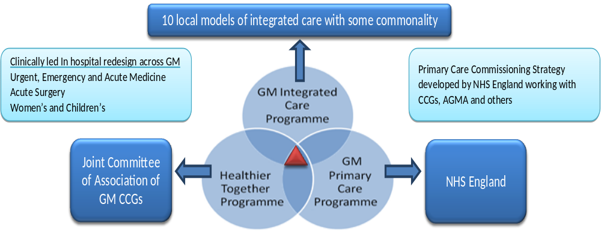

2.21 It is clear that the LLLB programme in isolation will not entirely address this significant challenge. Efficiencies must also be delivered through all of the programmes, as well as other cost improvement plans across all partners.

Our Vision

2.22 Central Manchester CCG’s mission, vision and strategic aims are focused on improving the health and well being of our population. Our Mission is ‘Informed by the views of local people and working closely with other health and social care professionals, Central Manchester Clinical Commissioning Group will design and develop health services which are high quality, safe and affordable and which will support communities to be the healthiest they can be.’
2.23 Our Vision is to:
- Create healthier, more resilient communities in Central Manchester actively managing their own health
- Lead a network of health and social care providers who promote, measure, monitor and improve quality over quantity
- Create a better balanced system for Central Manchester by shifting hospital care to services delivered in the community
- Create, with our practices and our partners, affordable and sustainable health services in Central Manchester

2.24 Our goals are described as follows:-

- To improve life expectancy by one year
- To improve quality of life for people with long term conditions by increasing identification of conditions and optimising treatment
- Ensuring effective recovery from ill health and injury by reducing hospital emergency readmissions by one third
- Improving patient experience in primary care and at the end of life
- Reducing avoidable harm by improving reporting and reducing incidence
- Delivering a balanced budget each year and shifting resource into out of hospital care.

2.25 The way in which our strategic goals align with the NHS England Ambitions is illustrated in Table 1. We have also linked all of our work programmes for the next 2 years to the NHS outcomes ambitions and strategic objectives (Appendix 1). This process will incorporate the strategic programmes of work over the next 5 years. Our plan on a page for 2013/19 is summarised in Appendix 2.

Table 1: Alignment of our Strategic Goals and the NHS England Ambitions

NHSE Ambitions | CCG strategic goals
Securing additional years of life for people with treatable mental and physical health conditions | - Improve life expectancy by one year  - Improving identification and optimising treatment of long term conditions (Including dementia)
Improving health related quality of life for people with one or more long term conditions, including mental health | - Improving identification and optimising treatment of long term conditions (Including dementia)  - Reducing serious untoward incident
Reducing the amount of time people spend avoidably in hospital through better and more integrated care in the community | - Improving identification and optimising treatment of long term conditions (Including dementia)  - Reducing emergency readmissions.  - Shifting resource to out of hospital care
Increasing the proportion of older people living independently at home following discharge from hospital | - Improving identification and optimising treatment of long term conditions (Including dementia)  - Reducing emergency admissions  - Shifting resource to out of hospital care  - Patient experience of primary care
Increasing the number of people with mental and physical health conditions having a positive experience of hospital | - Improving identification and optimising treatment of long term conditions (Including dementia)  - Reducing serious untoward incidents  - Reducing non elective readmissions
Increasing the number of people with mental and physical health conditions having a positive experience of care outside of hospital, in general practice and in the community | - Improving identification and optimising treatment of long term conditions (Including dementia)  - Reducing serious untoward incidents  - Patient experience of primary care
Making significant progress toward eliminating avoidable deaths in our hospitals caused by problems in care | - Reducing serious untoward incidents

2.26 Our Operational Plan provides the foundations for our 5 strategy to be realised. It is based upon the strategic vision of the CCG. Early focus in terms of delivery is upon those population groups who have complex health needs and are high users of non elective care. This is not to the exclusion of the standards of care we commission for the full population but this is for a number of reasons:-
- These people have the most pressing need for improvement in service and outcomes.
- They relate to areas where our outcomes require most improvement
- They consume significant resource in comparison to population size which can be released to invest in new delivery models in out of hospital care for them and the wider population.
- An impact on these population groups will create the space for commissioners and providers to focus upon longer term sustained improvement for the full population.

2.27 Our three key strategic programmes are evident throughout the actions in this strategy. Moving forward we will be drawing together our integrated care strategy and primary care development into one ‘community based care’ programme (Figure 2).

Figure 2: Central Manchester CCG Strategic Change Programmes

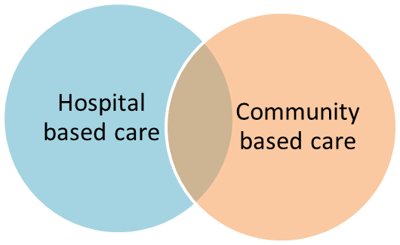

2.28 We will also be drawing in other key programmes into these two connected programmes. The most prominent of these are:-

- Mental Health Improvement programme: Redesigning mental health care in the city around the needs of patients and carers
- MacMillan Cancer Improvement Partnership: Improving cancer care with a focus on out of hospital care
- Healthy Lifestyles services: Redesigning services which help people get, and stay, healthy
- CCG grants scheme: Grants being awarded to voluntary sector organisations for projects to address social isolation
- Primary Care Development: Our vision is to make a difference for our whole community, through ensuring access to consistent high quality primary care.

2.29 Our strategy has been supported by our key partners in Central Manchester, namely:

- Central Manchester Foundation Trust
- Manchester City Council
- Northwest ambulance service
- Manchester mental health and social care trust
- Central Manchester General Practices
- Central Manchester Patient and Public Advisory Group

2.30 We also have had strong engagement with partners in the city including

- Manchester Health and Wellbeing Board
- Our neighbouring CCGs in North and South Manchester
- University Hospitals of South Manchester NHS Foundation Trust
- Pennine Acute Hospitals NHS Trust
- The Carers Forum
- Manchester Alliance for Community Care
- Healthwatch

3 Realising the Vision

3.1 We recognise that to realise the vision, strategic aims and improve health outcomes for our population will be challenging. We will address this challenge in a number of ways and in doing so will including our population, membership and partners across the health and social care economy.

3.2 We know that engagement across the board is key. As a CCG we are a membership organisation which means:
- We have GP and other clinical membership on the Board and all committees of the CCG.
- We have four localities where we work with the grass roots general practice.
- We engage with partners through the Clinical Integrated Care Board which is chaired by the CCG Chair. This Board includes executive and senior clinical representation from the CCG, Central Manchester Foundation Trust, Manchester mental health and social care trust, North West Ambulance Service, Manchester City Council and Primary Care Manchester Ltd.
- We also engage across Manchester with the Living longer, living better clinical reference group, CCG Forum and the Health and Wellbeing Board.

3.3 The ‘Everyone Counts: Planning for Patients 2014/15 to 2018/19', identified six characteristics as essential for the delivery of any high quality, sustainable health and social care system in England. These are:
- Citizen participation and Empowerment
- Wider primary care provides at scale
- A model of integrated Care
- Access to the highest quality urgent and emergency care
- A step-change in the productivity of elective care
- Specialised services concentrated in centres of excellence

3.4 Through working with our partners in delivering the strategic change programmes described in this plan and focusing on delivering the essentials for our population, Central Manchester CCG will be able to say that the health and system that our population exhibit all of these characteristics. This section will outline the approaches and interventions that we will be undertaking over the next 5 years aligned to these characteristics, and in doing so will bring out the consistent thread that exists between our 2 year operational plan, 5 year financial plan, and our Better Care Fund Plan.

Citizen Participation and Empowerment

3.5 As a commissioning organisation we are committed to enabling patients and citizens in taking control over their own care. To support this and build capacity over the next 5 years we will:
- Continue to roll out the Personal Health Budget support application with budget holders so they can co-produce their support plan online.
- Continue to co-design personalised care plans with patients and carers as part of the city-wide integration work and develop case studies to measure the impact of this ongoing work programme.
- Use our existing engagement mechanisms of the city-wide Patient and Public Advisory Groups to scrutinise developing clinical pathways to ensure they meet the needs of patients, carers and the public.
- Enable and support self-management and understanding of long term conditions by offering self care courses such as Expert Patient Programme or diabetes educational course as a key component of their clinical pathway.
- Ensure through our contracts that all of our providers involve and engage with patients and carers and actively collate patient experiences to demonstrate improvements in their services.
- Continue to monitor Friends and Family Test results collected by our providers as one indication of satisfaction of a service we commission.
- Continue to engage with patients, carers and the public through a range of mechanisms to gather their experiences to inform the commissioning cycle of the Clinical Commissioning Group for example focus groups, structured interviews and patient diaries.
- Continue to develop the relationship between the Patient and Public Advisory Groups and the GP Patient Participation Groups in Manchester. There are currently members of the GP Patient Participation Groups sitting on the Advisory Groups and provides a stronger patient voice for each of the Clinical Commissioning Groups.
- Commission voluntary and community sector groups to engage with patients and carers around a specific clinical pathway such as mental health or learning disabilities.
- Undertake needs assessments and Equality Impact Assessments to ensure all communities have equal access to health services commissioned by the Clinical Commissioning Groups.
- Continue to use information from Patient Services to inform quality and patient safety of our commissioned services and continue to develop case studies and patient stories to demonstrate the impact our commissioned services have on patients and carers.

3.6 We know that we need to reflect patients and citizens voices at the heart of decision making, particularly given the significant transformational change programmes taking place over the next 5 years. To make this happen, we will:
- Continue to map all available patient experiences and use them to inform business cases, specifications and developments of clinical pathways.
- Use referral data to understand existing patients’ preferences and choices for services.
- Continue to use social media to engage with patients, carers and the public and use experiences to inform developments and quality monitoring of services.
- Continue to input all patient experiences into the Datix system to build a picture of quality and patient satisfaction of a particular service or provider.
- Continue to develop relationships through our Communities of Interest work and co-design initiatives and targeted responses to ensure equitable access to healthcare services.
- Continue to provide a generic online survey for gathering patient, carer and public experiences of NHS services and use this information to inform ongoing commissioning decisions.
- Commission engagement activities through the voluntary and community sector to ensure we are engaging with diverse communities and seldom hear groups.
- Work with existing and emerging structures such as the Health and Wellbeing Board and Health Watch Manchester.

3.7 It is vital that the participation we have from our patients and citizens is authentic and representative in the design of our plans moving forward. To ensure this we will:
- Continue developing and supporting our Patient and Public Advisory Groups and who are part of the governance arrangements in place Manchester Clinical Commissioning Groups.
- Continue with the development of our virtual Expert Panel members. This panel allows patients, carers and the public who have a specific interest in an area of work or health condition to get involved through a range of ways and at their choosing, such as taking part in design workshops with clinical staff, completing a survey, invitations to a themed event.
- Continue to include Patient and Public Advisory Group members in ‘walk arounds’ of our acute hospital providers.
- Continue to involve Patient and Public Advisory Group members in the development CQUINS.
- Continue to involved Patient and Public Advisory Groups members in mystery shopper audits, such as same day access to GP appointments.
- Continue to communicate effectively through a variety of ways our ongoing strategic and operational plans and developments, giving patient, carers and the public opportunities to be informed and involved.
- Continue to develop a range of mechanisms to ensure there are participation choices available to people to be informed, involved and engaged in the work of Clinical Commissioning Groups.
- Build on our social media platforms and encourage innovative ways that people can participate in the design work.
- Commission research work to engage with patients and the public in the design of new and ongoing work programmes, such as the Neighbourhood Teams.
- Continue to use a variety of ways to collect patient, carer and public information such as focus groups, online and paper surveys, discovery interviews, case studies, information stalls and public events.

3.8 In order to get real engagement we know that transparency is key to gaining trust and entering into dialogue with our citizens. In order to promote transparency in our local health services we will:
- Hold public events to feedback on our work and learning from developments and service redesign.
- Continue to promote the NHS Constitution both online and in the all publications developed by the Clinical Commissioning Groups.
- Build on our existing relationships with our stakeholders to share information and learning from our engagement work.
- Continue to use a range of communication mechanisms to share learning, feedback, decision making from the Clinical Commissioning Groups.
- Further develop and continue to use the Talking Health website to share feedback from engagement work, such as “We asked, You said, We did”.
- Publish engagement reports sharing patient and carer experiences and actions / recommendations taken by the Clinical Commissioning Groups.
- Publish feedback from Health Watch Manchester and actions / recommendations taken to address issues raised.

Case study 1 describes an example of how we have engaged with the public and how this has changed practice / shaped services.

3.9 Our system, with partners across Manchester (including North and Central CCGs), have for some time been working on a number of programmes of work to address the challenges the NHS face over the next 3 – 5 years. These include Healthier Together, Living Longer, Living Better and Primary Care development work which will be described in more detail in the section below. Rather than a separately branded Call to Action engagement programme (which would confuse audiences familiar with our ongoing work), we have used engagement within these programmes as an opportunity to discuss challenges and collect feedback to inform the CCG’s strategies going forward. This engagement involved work with patients and the public, the voluntary sector, CCG members and local councillors.

3.10 This work is ongoing and we are currently in the midst of a stakeholder ‘conversation’ about what the future NHS will look like as a preliminary exercise prior to the Healthier Together formal consultation planned for. A full ‘you said, we did’ as well as Q & As will be finalised after this process and will support future engagement work which will continue after the Healthier Together consultation as services continue to develop and change. As well as active engagement, we have used existing data we have about local stakeholders’ preferences and needs to inform our work. This latter approach is supported by local people’s feedback that they often feel over consulted and asked similar things. We have, in Manchester, been engaging with the local population in numerous ways for a number of years now and use of this data is just as important as gathering new information

3.11 In terms of themes which have emerged, there are many, some general, some specific to areas of care. These include:
- A recognition of the challenge facing public sector agencies with demand increasing above resources
- General support for integrated care and the development of joined up services in the community.
- The importance of supporting people to self care and look after their own health
- The need for access to GP practices to be improved
- A need to ensure that resources shift into the community, including primary care, to support the work
- The importance of the voluntary sector in supporting communities

Case Study 1: Public Engagement with the Mental Health Improvement Programme
Mental Health Improvement Programme
As part of the CCGs mental health improvement programme, a detailed public engagement exercise was carried out to seek people’s views on the future of mental health services in Manchester. An initial short survey was undertaken seeking people views on the CCGs proposed move towards a more outcome based mental health service. In total 52 people responded, the majority of whom (72%) supported the approach. Results from the survey were used to begin developing new care pathways for supporting people with mental health problems. Before the wider public engagement, the proposed pathways were further tested at two events – a voluntary & community sector event and an event for patients and carers.
Following on from these two events, the wider public engagement work began, supported by a multi-agency steering group made up of CCGs, City Council, Health-watch and Manchester Alliance for Community Care (Macc). The engagement work resulted in following:
- A total of 250 people from diverse communities attended one of the 22 engagement events that were held across the City. These events were run by independent facilitators from the voluntary and community sector
- A series of information stalls were held across the city to engage with members of the public and local communities.
- 120 clinicians from NHS, voluntary and independent providers attended one of the 8 clinical engagement events held across the City.
- Macc worked with a local media company to train four community reporters who then produced four short films about the experiences of mental health services users. These films were shown at the engagement events
- A Patients Charter for mental health services in Manchester has also been developed by Macc and it is currently out for consultation with mental health services users.

Feedback from all the above was used to further develop the care pathways for mental health services users. Below are some examples of what we did as a result of the engagement work.
You Said | We Did
Outcomes should be culturally sensitive, strengthen friendships and increase social activities. Also smoking and obesity should be monitored as outcome measures | We have added these to the outcome framework, noting that instruments should be culturally appropriate where possible.
Do Not Attend (DNA) rates should be considered an indicator of engagement, and therefore a form of outcome indicator | This would clearly be a proxy rather than an actual outcome indicator, but we agree it is an indicator of engagement, and adopted it within our framework
Services should decrease stigma. | We have asked the provider to monitor patients’ perceptions of this issue.
More emphasis should be placed on the roles of carers, family and friends | This has been developed further within the care planning section
Prevention / health and wellbeing are as important as treatment services | The requirement to maintain good links with those services has been written into all of the pathway specifications
There should be more recognition of dual diagnosis (substance misuse) within common mental health problems | We have added requirements for all services to be in a position to manage substance misuse problems as part of routine care.
Services should demonstrate empathy and compassion | This has been included in the care planning specification, including reference to the “6 Cs”
Staff should be sensitive to cultural and community differences; cultural and religious needs should be considered | This has been included in the overarching care planning specification
Peer support should be explicitly encouraged | We have done so within the care planning framework

Integrated care and wider primary care provided at scale

Primary Care Development

3.12 In 2013/14 Central Manchester secured the Primary Care Demonstrator Programme which aimed to deliver high quality consistent primary care. This focused around four domains:-
- Access
- Long term condition management
- Specialist primary care
- Patient voice

3.13 In 2014/15 the CCG has implemented much of this, commissioning additional GP hours from 8-8 and access at weekends, this service being provided by Primary Care Manchester. Case Study 2 describes this service in more detail and the outcomes to date of how we are improving access to primary care. We have also this year commissioned responsive access from our practices, meaning that now 95% of CCG patients will be seen within 2 hours in an emergency, or within 6 hours if they have an urgent need. Initial evaluation from the programme has shown that offering extended GP hours is making a difference to the patient experience of primary care and also impacting on urgent care activity. Care for people with Heart failure and diabetes is becoming more consistent and high quality. Primary care is now more accessible to homeless people and people who live in care homes

3.14 We seek to sustain these changes and build upon them as part of our community based care vision making primary care the heart of out of hospital care. Interventions that are planned to sustain this are clearly outlined in our operational plan, and form part of the BCF investments schedule for 14/15 (para. 5.7).

3.15 We will be working with NHS England to develop and transform primary care moving forward. Integral to this, will be supporting the implementation of the Greater Manchester wide Primary Care Strategy including the community based care standards which focus on 5 key themes:
- Quality and safety
- Wellness and prevention
- Self care, independence and choice
- Care planning and Multidisciplinary care
- Access and responsiveness

3.16 Following the recent offer from NHS England inviting expressions of interest in co-commissioning primary care services, the CCG is working closely with North and South Manchester CCGs to develop a citywide submission for level 3. This will focus on scaling up our current commitment to co-commissioning together with aligning more formally plans and resources to support delivery of improvements in general practice. In addition, it will provide the opportunity to influence infrastructure including the development of plans for premises resources, primary care workforce and IM&T.

3.17 The development of primary care, incorporating these standards will provide us with a mechanism for reducing variation across Primary Care and measuring quality. It also supports the alignment of Primary Care and Integrated Care into a coherent offer for community based services that our population will understand. Across the wider health economy, the adoption of these standards will provide a consistent approach across with our primary care colleagues. We will be working to develop the Medicines Optimisation prototype dashboard to support our practices to optimise medicines use in primary care.

3.18 The evaluation of primary care transformation is will be done as part of the wider evaluation of the community based programme which includes both primary care and integrated care (Living longer, living better).

3.19 The metrics outlined in the community based standards are already in place to measure the impacts of the demonstrator programmes and also Living longer, living better, and are being reported to the Clinical Integrated Care Board through a score card and dashboard reporting framework.

Living Longer, Living Better: Delivering Integrated Care in Central Manchester

3.20 The Living Longer, Living Better programme is Manchester’s programme of reform for delivering integrated care. It is a partnership of three CCGs, Manchester City Council, three acute trusts and the mental health trust. The aim of this is to provide high quality co-ordinated care to individuals and families.

3.21 The Living Longer, Living Better Programme is our means of achieving the requirements set out against the better care fund, and forms the basis of our Our Better Care Fund Plan which has been submitted. This has been developed in conjunction with North, South and Central CCGs, and the city council. The Manchester Health and Wellbeing Board have responsibility for this work, signing off the direction of strategy and specific plans and implementation since 2012. Provider representation on the HWB includes Manchester City Council (MCC), Central Manchester Foundation Trust (CMFT), Pennine Acute Hospital Trust (PAHT), University Hospitals South Manchester (UHSM), Manchester Mental Health and Social Care Trust (MMHSC) and the Manchester Alliance for Community Care (MACC).
3.22 This programme focuses the design of out of hospital care on 9 population groups rather than focussing upon disease groups or organisational structures. Each of these population groups will have a care model which determines the outcomes, key components of the future service model and the resources to deliver upon them. These will then be developed into detailed New Delivery Models on a phased basis over the next five years. Early focus is on the following population groups with implementation of new service models commencing from April 2014:-
- Frail older people and those with dementia
- Adults with long term conditions
- People at the end of their lives
- Complex adults

3.23 These population groups have been chosen as they are those people who use our services most often and, due to levels of illness and complexity of their needs, would benefit most from agencies, and their professionals, coming together to manage their care.

Case Study 2: Improving Access in Primary Care

Improving Patient Access in Primary Care

Improving access to primary care is a central aim for the CCG. To achieve this, the CCG commissioned Primary Care Manchester Ltd (a federation of the 35 GP Practices in Central Manchester) to provide an ‘Additional Availability’ service.

This service offers additional GP appointments to patients on weekday evenings and weekends from four host practices across Central Manchester. Patients therefore have access to full primary care services from 8am to 8pm during the week and availability during the weekends.

The objective of this service is to manage urgent care demand, where appropriate in Primary Care and to offer wider choice of appointments times for people who are not able to during normal working hours.

The service commenced in December 2013 and since then, over 3,500 patients have been seen. Analysis from a survey of 100 patients showed that almost all of them found the service convenient and 20% stated that they would have gone to A&E if they were not offered an appointment. Below is a quote from one of the patients surveyed.

‘I visited the practice at 7.10pm. Today’s appointment was convenient for me because I needed a quick appointment and it was close to home. If the appointment today hadn’t been available, I would have gone to A&E.’

A GP saw a 20 week old baby with wheezing on a Friday. The GP felt that if the child was seen the next day to check progress, it might avoid a hospital appointment. The doctor prescribed steroids and an inhaler. The next day (Saturday) the baby was seen and his condition was improving.

There has been a 23.7% decrease in Central Manchester patients attending the Primary Care Emergency Centre (PCEC) from December 2013 – March 2014, compared to the same period in the previous year. Whilst this reduction may in part by due to the new Additional Availability service, it is not possible to demonstrate a direct cause and effect. There has also been a 50% drop in the number of people attending PCEC who give their reason for attendance that they cannot wait for an appointment with their GP. More significantly, A&E attendances for Central Manchester patients have reduced by 2.3%.

The service has been extended to run until March 2015 to allow for full evaluation and to extend the scope of the service to include bookings from other agencies such as A&E and NHS 111. The service will be reviewed in the context of the Urgent Care First Response system which is a vision for a partnership of providers to deliver the urgent care front end services in a collaborative, efficient and effective way.

3.24 Services already developed towards these population groups are:
- Practice Integrated Care Teams: Multidisciplinary teams identifying, care planning and case managing people at high risk of admission.
- Intermediate Care Assessment Team: Offering rapid response as alternative to hospital admission.
- Community IV Service (case study 3)
- Extended primary care services for heart failure and diabetes.
- Support to end of life care planning in residential care homes.
- Focussed primary care to people who are homeless

3.25 Our plans are to grow from these more robust and scaled up community services focussed upon keeping people well and keeping people out of hospital. Plans in the short term focus upon:
- Developing a hospice model for end of life care
- A proactive elderly care team, building on the PICTs supporting management of people between secondary care and community based care. Supporting their physical/mental health and social care needs.
- Developing a high standard and consistent offer of chronic disease management across primary care.

3.26 Interventions in 2014/15 that will compliment and contribute to this integrated approach include the Social Isolation Grants Scheme and the Macmillan Cancer Improvement Programme.

3.27 The Macmillan Cancer Improvement Partnership aims to support the delivery of the world class cancer care in Manchester which includes:
- Commissioning services that emphasise treatment of patients and people with cancer and not just the cancer itself;
- Developing the commissioning of complete cancer pathways from primary prevention, through early detection and diagnosis, screening, treatment, survivorship and end of life care;
- Implementing commissioning priorities that bring greater focus to the early (primary prevention, detection and earlier diagnosis) and latter parts of cancer pathways (aftercare/survivorship and end of life care).

Case Study 3: Community IV Service
Delivering a new community IV service
Issue
In 2011/12, urinary tract infection was identified as the most common reason for emergency admission and re-admission of patients’ aged 65 and over in Central Manchester. Patients were often admitted for diagnostics tests and received intravenous (IV) treatment as an in-patient. Many of these patients were frail, often elderly, with multiple health problems and a high risk of frequent admissions. The CCG supported the need for an innovative approach to IV service provision to reduce avoidable hospital admissions, re-admissions and to improve patient care.

Research demonstrates that IV therapy can be delivered safely and effectively in patients’ homes. Such treatments are offered nationally in community however, historically there had not been any investment to support the provision of a community IV service. Two key factors of success were identified:
- rapid access to diagnostics including an interface with the assessment and observation units in the local acute hospitals
- access to, and provision of, IV and subcutaneous fluids following diagnosis to prevent admission or lengthy hospital stays.

Solution
The CCG invested in a pilot seven-day community IV service for 12 months. This project aimed to provide specialist care in the community for patients requiring IV antibiotics or subcutaneous fluid, as an extension to the existing CMFT community nursing services.
Objectives for the project are to:
- deliver acute care closer to home and give patients the choice to have IV therapies and subcutaneous fluids in their own home or community clinic
- prevent re-admissions and new admissions to hospital, and reduce length of stay
- improve the patient and carer experience
- deliver safe and effective clinical outcomes.

The service runs seven days a week from 8am until 10pm with referrals taken between 9am and 5pm. District nurses are available for advice after 10pm supported by the local out-of-hours provider.

Outcomes
The project, which went live for hospital referrals in October 2013 and for GP referrals in November 2013, is already seeing significant results (data up to the end of February 2014): 85 patients have been treated; 46 admissions avoided; 39 expedited discharges; and 906 bed days saved.
Exemplary feedback from patients, carers and referrers demonstrates that the service is highly valued. Improving the quality of care for patients is making a crucial difference to peoples’ lives. The community IV team has built strong relationships with GPs and hospital staff, boosting referral numbers. A&E is also well engaged.
Collaborative working with North and South Manchester CCGs has resolved initial boundary issues. A local agreement is now in place so the IV team can treat patients from these areas. The CCG attributes success to:
- an internal desire to succeed and the sense of ownership through the steering group, which has driven motivation
- the importance of networking and integration with other services, which has been key, as has flexibility and adaptability within the governance structure
- the involvement of highly respected healthcare professionals.

The project has been funded for a further 12 months through the Better care fund investments.
The service has now started to train district nurses for day-to-day delivery so the IV team can focus on exploring additional options to expand the remit of the service. This may include increasing service capacity to deliver IV therapy up to three times a day to patients and developing additional clinical pathways for more complex patients.

2

3.28 The improvement programme has been designed in 2 Phases. Phase 1 invests £2.35m in primary, palliative, community and end of life care. It includes enhanced training for the health and social care workforce and the development of new palliative care services. Phase 2 invests a further £1.1m into local redesign work and is focused on reviewing and improving breast and lung pathway
3.29 The Social Isolation Grants Scheme is a city wide scheme in which North, South and Central CCGs have jointly awarded a range of grants totalling £600k to voluntary sector organisations to address social isolation for the older people in Manchester.
3.30 The Living Longer, Living Better programme will contribute to the activity shifts out of hospital planned over the next 5 years. Further detail is provided in section 5 regarding the level and time scales associated with the activity shifts. Given the scale of shift required, close evaluation and monitoring of the programme will be needed.

3.31 The will be evaluated at a programme level against an overall programme goal, aims and measurement areas outlined in figure 3 below.

Figure 3: Living Longer Living Better Programme Goal
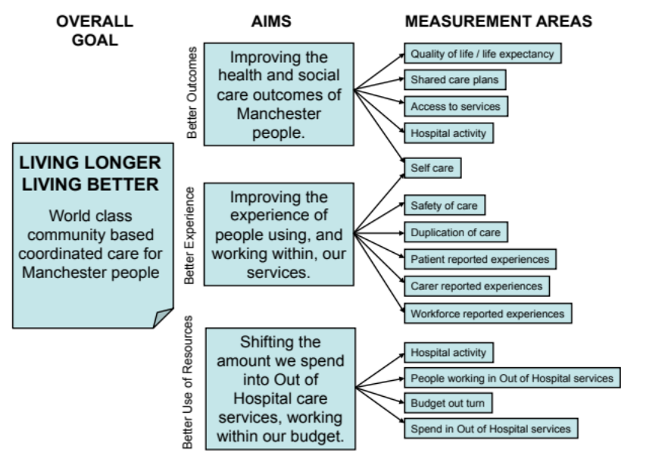

3.32 To support the delivery of LLLB in Central Manchester we have put in place new contractual arrangements between commissioners and health and social care providers for the pre-alliance phase in the delivery of urgent care in Central Manchester. The aim of the pre-alliance is to bring closer contractual alignment between partners to facilitate the delivery of integrated care and achieve the targets to secure the Better Care Fund. In particular, we want to move away from the current situation where providers have individual contracts for their specific services, to one where providers sign up to a single, shared contract covering the whole system. In this way, providers have contractual and financial incentives for working together to deliver shared outcomes.
3.33 This will take time to implement fully and we are developing a phased approach. Alliance partners have agreed to a pre-alliance contract for urgent care in 14/15 that includes: (i) an agreed set of principles for working together; (ii) a shared performance framework; and (iii) some form of financial incentives to reward the alliance if shared performance targets are met. The aim of this is to provide a contractual and financial mechanism which encourages integrated working, whilst balancing the need for financial stability, not putting any partner at undue financial risk. Increases in risk and reward will then be phased as our understanding (and confidence) of delivering through an alliance contract increases.

3.34 We anticipate developing the model through a shift to a full alliance in 15/16 and beyond if the evidence and learning demonstrate success, moving from separate MCC and CCG contracting arrangements within the alliance to a single contract.

3.35 The overall governance structure for the LLLB programme is illustrated in Figure 4. Governance structures are now in place to oversee and manage the delivery of LLLB in the pre-alliance:
- The Clinical Integrated Care Board (CICB) is made up of Executive level management/clinicians from all parties to the arrangements i.e. commissioners and providers. Whilst the commissioner(s) determine the direction in terms of outcome goals and the overall resource package the CICB is a key engagement mechanism where the system as a whole forms a consensus on the strategic direction and the high level means of getting there. The CICB will also be responsible for ensuring the alliance works to the principles and objectives of the contract. All organisations within the pre-alliance arrangements will be members of the CICB.
- The Central Provider Partnership Board is a provider led body which, at a senior level is responsible for delivery of the outcomes of the LLLB. It has representation of the key stakeholders. It will prioritise the work streams, ensure development of the remaining delivery models and drive progress. It will also oversee the delivery against a pre-alliance contract in relation to the BCF projects as well as the shared performance framework which has been agreed between all alliance partners.

Figure 4: Living Longer, Living Better Programme Governance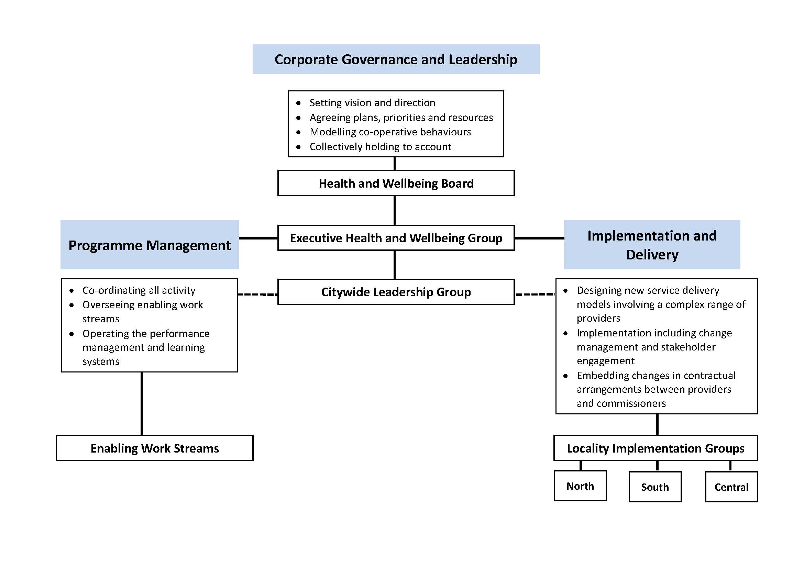

3.36 In order to realise the benefits of this change programme, progress must be made and monitored over the next 5 years to ensure quality improvements are made and planned activity shifts are made. We have set up the frameworks to monitor progress, reporting through score card and dashboard systems suing BCF metrics to monitor. As part of this we have set baselines and projected targets against key priorities, some of which were submitted to NHS England as part of this process. We know however that we need to go further. We have linked all of our work programmes for the next 2 years to NHS outcomes ambitions and our strategic objectives as outlined in our 2 year operational plan, and are in the process of doing the exercise over the next 5 years.

Access to high quality urgent and emergency care

3.37 We have two key aims within our urgent care strategy. The first is to develop effective urgent care responses from self care, through community based care to acute urgent care where necessary. The second is to develop service models which manage people more effectively to either keep people well or manage them at a lower level of acuity through earlier intervention. Our urgent care strategy has a number of key themes:

Self care and early intervention is about improving advice and support to patients and improving self care services that support patients to live more independently, such as the Minor Ailment Scheme offered by Community Pharmacists.

Access to and navigation around the urgent care pathways are the first stages in a patient’s journey. It is the first contact with the urgent care system, either face to face, via telephone or other methods. This element of the strategy aims to ensure that access is responsive and appropriate to patient needs and that clear navigation of patients into and through the urgent care system is in place.

Urgent ‘planned’ pathways refer to improvements in pathways that meet the full needs of patients who have entered an urgent care episode. Urgent planned services deliver services to patients that can prevent high intensity care or once a patient has entered an acute phase to aim for self / planned care.

Community responsiveness focuses on the patient pathway from access, through assessment, to intervention and handover to self / planned care which requires all commissioned providers to work in a more responsive integrated manner. This will ensure that primary, community and social care services offer a truly urgent care response in a way that can provide a reasonable alternative to A&E.

Children’s urgent care - Central Manchester CCG has a high proportion of children registered and children’s services in Manchester are unique with a local children’s hospital and children’s community services provided by the Acute Trust.

3.38 Much of this strategy fits with the recommendations of the review of urgent and emergency care by Sir Bruce Keogh and we will refresh it accordingly. Key recommendations relating to hospital networks and specialist centres will be managed on a Greater Manchester basis as part of the Healthier Together programme. The process for the designation of facilities within the Greater Manchester Urgent and Emergency network will be undertaken through the Greater Manchester arrangement.

3.39 The interventions that will deliver urgent care strategy, and ensure access to high quality urgent and emergency care over the next 2 years are outlined in our operational plan. They span the workstreams across LLLB, primary care and the redevelopment of pathways within the acute sector.

3.40 We will be reviewing the Urgent Care First Response received in Central Manchester. Two significant parts of the urgent care system are scheduled for procurement during 2014/15; NHS 111 and GP Out of Hours. Whilst the specification for NHS 111 is likely to be set nationally it should allow for local variation. This brings an opportunity to make links between all of the urgent care first review services such as NHS 111, Out of Hours, Additional Availability, Responsiveness LCS, Primary Care Emergency Centre, Alternatives to Transfer and Intermediate Care Assessment Team. This would be in line with the key recommendation of the Keogh review “we must help people with urgent care needs to get the right advice in the right place first time”. Other actions have been or are being addressed on a wider scale, such as Greater Manchester reconfiguration of major trauma care, and the development of a Greater Manchester wide urgent care system, through the Healthier Together programme.

3.41 In terms of activity our five year ambition is to reduce A&E attendances by 10% and Non Elective admissions by 20% bringing the latter to the England average.

A step change in productivity of elective care
3.42 We have made a commitment to shift out planned care activity levels to the England average level as@ 2014. This will mean a reduction of 8% of elective care and 16% in outpatients. Our priority areas for achieving this are:
Service development and redesign - developing and redesigning pathways that improve or maintain the quality of care patients receive whilst in many cases improve efficiency and access. We want to continue to focus our work around the development of services for people with Long Term Conditions as we recognise the importance of quality and timely care for people with a Long Term Condition. Effective management of people with Long Term Conditions is a key means to reducing the escalation of the severity of disease and therefore reducing the burden on limited resources.
Managing demand – whilst having a significant impact on the quality of care, service development and redesign does not have a significant impact on demand. To achieve our aim to reduce elective activity we need to reduce inappropriate demand. The CCG will continue to increase the scope of the Manchester Integrated Care Gateway and work with our GP’s to address variation in referral patterns.
Understanding and managing activity – some activity continues to grow so we need to work with providers to understand and address some types of activity and improve efficiency. Our priorities will continue to be Consultant to Consultant referrals, out-patient follow up appointments, procedures of low clinical value and optimising community services.
Competition and Choice – as well as engaging with our current local providers we will continue to seek to utilise competition within the healthcare market to meet the needs of our population, increase choice, improve quality and access.

Specialist services and acute services concentrated in centres of excellence

Acute Services
3.43 The Healthier Together programme is part of the Greater Manchester (GM) Programme for Health and Social Care (H&SC) Reform, which aims to provide the best health and care for Greater Manchester. It is the largest and most ambitious health and care reconfiguration programme in the country.
3.44 The programme is responsible to the 12 Clinical Commissioning Groups across Greater Manchester, with the CCGs exercising our statutory responsibility for commissioning through a shared decision-making body, the Healthier Together Committees in Common (formally a sub-committee of each CCG). This is described in Figure 5.
Figure 5: Healthier Together Governance Structure
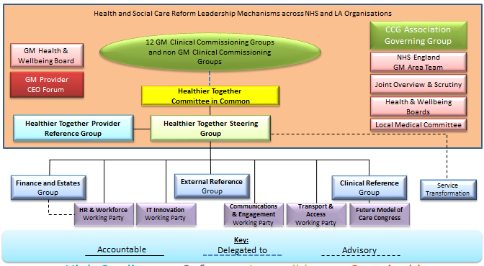
3.45 It is widely recognised that the different parts of the health and social care system are inter-dependent, and that major changes to services in the community are required before significant hospital changes can take place. The wider Healthier Together programme brings together the locality programmes developing Community-based Care (Integrated Care and Primary care) with the reform of “In Hospital” care across Greater Manchester for the “in-scope” services (these are: Urgent, Acute and Emergency Medicine; General Surgery; and Women and Children’s services).
3.46 This has led to variations in the range and quality of services available in different areas, resulting in inequality of access to services in different areas. For example, the mortality of patients who undergo Emergency General Surgery varies from 23.1 to 51.7 per 1,000 spells across Greater Manchester, depending on where people are treated. This needs to change, with everyone entitled to the best outcome wherever they live, and yet we have a limited number of specialist clinicians, rising demand and serious financial pressures. The potential quality improvement in closing the gap in outcomes could save 1000 lives over 5 years.
3.47 An analysis by Mott McDonald has forecast the financial gap between expected activity in acute trusts and available funding across Greater Manchester over the next 5 years at £742 million, with a further £333 million gap in social care funding – a total system-wide pressure of over £1 billion. Doing nothing is not an option.
3.48 As more people receive appropriate treatment at home or in the community, those patients that do need to be admitted into hospital, especially in an emergency, are likely to have more complex needs. They are most in need of very specialist care and being assessed by a senior doctor will improve their chances of recovery. Senior doctors are not available in all specialities on site 24 hours a day, 7 days a week due to the large spread of services across Greater Manchester. This means that Greater Manchester has an inequity of provision out of hours and at weekends often leading to poorer outcomes for patients.
3.49 Over the last 24 months, over twenty clinical congresses involving hundreds of clinicians have considered the issues facing our health system. They have explored the potential solutions to ensure services remain high quality, safe and cost effective for future generations. This work, which has been based on evidence and best practice from around the world has developed and contributed to this case for change.
3.50 The proposals arising from these congresses are for services to be shared across a number of defined hospital sites, with clinicians working across those sites to provide seamless care, with the teams delivering the “once-in-a-lifetime” specialist care on a designated site. These “single services” are shared across the geographical footprint, and the clinical teams benefit from being part of a wider, sustainable and better supervised team, raising standards in the “routine” work in the District General Hospital as well as meeting the clinical standards at the specialist site, a “win-win” for patients. This should also significantly improve efficiency at all the sites (as routine activity would no longer be interrupted by emergencies), and it is expected that that the Trusts would share the financial risk to avoid the perception of “winners and losers”.
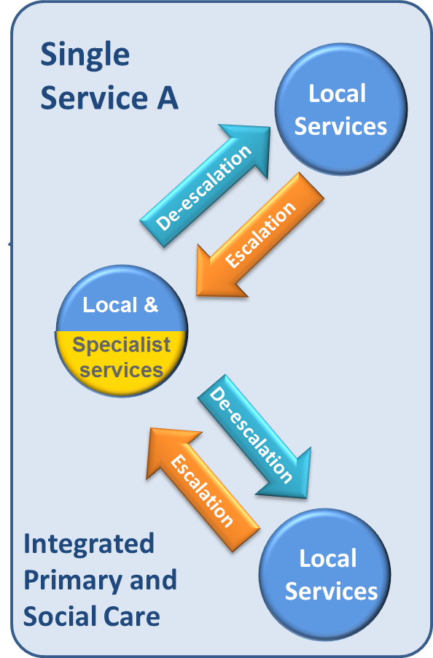
Combined medical and senior nursing workforce
Locally developed services to meet Standards
A single performance management framework
Local enhanced provision based upon JSNA
Single clinical leadership and governance
Building upon existing pathways (PPCI/ Stroke/ Major Trauma)
Combined training and education arrangements
Greater flexibility of existing staff

3.51 The proposals to change hospital services will be subject to statutory public consultation, and must pass the requirements of the NHS Assurance process. Clinical assurance has already been secured for the model via the National Clinical Advisory Team (NCAT) – “We unanimously support the Programme to proceed to Consultation. This is the most ambitious and well thought out work we have come across. We are highly impressed”.
3.52 Following extensive pre-consultation engagement, including with key partners such as the Association of Greater Manchester Authorities (AGMA) the Committees in Common of the CCGs will decide to proceed to consultation in April 2014. Subject to NHS Assurance, it is planned that formal consultation will take place in the summer of 2014, with a final decision at the end of 2014. There are considerable risks in a programme of this size and complexity, and given the proximity of a general election there is a possibility that the formal consultation and decision will need to be postponed until 2015 – this would clearly delay the programme and the delivery of the benefits expected to be realised.
Specialist Services
3.53 The CCG recognises the challenges faced at a national level across Specialised Commissioning. We will engage with our colleagues in Specialist Commissioning, Cheshire, Warrington and Wirral Area Team in the work that they are focusing on which over the next 2 and 5 years have been described as:
- Mental Health: Develop NW CAMHS tier 4 system, Review Secure Mental Health
- Cancer and Blood: Cancer IOG compliance, HIV commissioning arrangements
- Trauma and Head: Adult neuro-rehabilitation services, Major trauma
- Internal Medicine: Cystic fibrosis capacity, Cardiac services, Vascular services, Respiratory services, Acute kidney injury, Inherited metabolic disorders
- Women and Children: Neonatal services, Paediatric neurorehabilitation

3.54 The Armed Forces Commissioning landscape is quite complex services being commissioned by Defence Medical Services, NHS England, Local Authority and CCGs, with CCGs having responsibility for providing health services to veterans, and also specific obligations and expectations under the armed forces covenant. The Armed Forces Commissioning priorities have been shared with the CCG, and we will work with the Area Team to support delivery where needed. The commissioning plans describe a North region CCG leadership model aimed at securing wholesale CCG shared ownership of Armed Forces Networks. We will engage with the North Yorkshire and Humber Area Team to progress these discussions.
3.55 The lead commissioner for our Ambulance Services is NHS Blackpool CCG. We have engaged with the commissioner in the development of the commissioning intensions for the paramedic emergency services (PES) for both the on 2014/15 and also in their high level strategic intentions 2014/19. The PES commissioning intentions document recognises the need for whole system transformation in order to move towards the healthcare system described by both the House of Commons Health Committee ‘Urgent and Emergency Services’ report (July 2013), and the Keogh ‘Urgent and Emergency Care Review’ (November 2013). Both reports describe PES as having a changed role within an enhanced system of urgent care; a role where conveyance to hospital will be one of a range of clinical options open to ambulance services and allow PES to become “mobile urgent treatment centres” (Keogh, 2013). One of these key required changes is to achieve a reduction in conveyance to hospital and the PES contract for 2014/15 has been designed to encourage this by incentivising this through CQUIN. This will allow the provider, North West Ambulance Service (NWAS), to build on the progress they have already made with commissioners over recent years; developing and implementing initiatives such as the Urgent Care Desk, Paramedic Pathfinder, Referral Schemes into Primary Care, Targeting Frequent Callers, and increasing the percentages of patients that are treated by ‘See and Treat’ and ‘Hear and Treat’. All of these schemes support the achievement of ‘Safe Care Closer to Home’, which is a strategic goal of NWAS, as well as supporting our CCG plans for integration.

3.56 In Central Manchester NWAS are a key partner in the Central Provider Partnership, which is overseeing the delivery the new delivery models of Living Longer living better. One key scheme in this partnership is the Central Manchester Alternatives to Transfer scheme which is the local GP Navigation scheme provided by Go to Doc. This is funded until 31st March 2015 and it is intended this will become part of the Urgent Care First Response system vision for Central Manchester. NWAS are also a member of the Central Manchester Urgent Care Board.

4. Central Manchester CCG: City Wide commissioning priorities

Mental Health Improvement across the Central Manchester: Achieving Parity of Esteem

  - Mental Health is one of the CCG’s key strategic priorities and improving the health and wellbeing of Manchester people who suffer from mental health conditions is an important component of the 5 year Strategic Plan.

  - Mental Health services in Manchester have been subject to a number of high level external and independent reviews and reports over the last 10 years and commissioners have concluded the current mental health system is not fit for purpose nor is it in line with current expectations of delivery and improvement. The current system is fragmented, complex and difficult for users and professionals to navigate. Additionally, waiting lists for some services are far too long.

  - Our main service provider, Manchester Mental Health and Social Care Trust (MMHSCT) is currently facing a number of challenges which we are closely monitoring. These include:
- Demand management in urgent and acute care pathways
- Excessive use of independent sector beds outside of Greater Manchester
- Levels and nature of serious untoward incidents
- Embedding learning from incidents
- Assurance of safeguarding processes
- Staff engagement issues
- Potential financial pressures as a result of re-tendering exercises for services commissioned by other organisations

  - These issues, alongside our desire to create a mental health system to be proud of, have led us to develop a new vision for mental health services in Manchester: our Mental Health Improvement Programme (MHIP). The MHIP describes our commissioning intentions for the future and the need to:

- Reduce the current fragmentation between services, and encourages a more integrated approach to service delivery
- Improve the outcomes which services achieve, rather than on the detail of how they are structured
- Have clear pathways through services, so that, irrespective of how people access services, there is a shared understanding as to how people will be supported to move through those services and into recovery – without being blocked or delayed by organisational boundaries
- Improve access to services, with care and treatment based on assessed needs and good practice guidance
- Integrate statutory and third sector organisations aligned to the delivery models emerging from the Living Longer, Living Better programme
- Parity of esteem between mental health with physical health
- Secure sustainable services for the population of Manchester.

  - Following a period of engagement between November 2013 and February 2014, a full set of service specifications for mental health services in Manchester were developed and approved as the basis for future commissioning. The specifications, intentionally, do not specify in detail the structure of teams and services which providers should offer, we envisage potential providers responding to the specifications by demonstrating how they would intend to offer services, within the constraints of the financial resources available, and look to be creative and innovative in the ideas being proposed.

  - In its current configuration, the main provider in the city, Manchester Mental Health and Social Care Trust (MMHSCT), cannot deliver our vision for the future as its size and structure means it does not have the necessary long term clinical or financial viability. It is not currently a Foundation Trust nor has plans to become one. Only large scale transformational change, with a strong strategic partnership arrangements in areas such as inpatient beds, crisis service management and end to end pathway management (including tertiary service provision), could address the challenges we currently face. To effect the change Manchester needs, we are actively seeking a solution with our commissioning partner, Manchester City Council. During 2014, this will result in either a procurement exercise or the initiation of a managed, strategic partnership approach.

  - The affordability of the care pathways within the available financial resources has been tested and there is some reasonable assurance. This is based on a successful and deliverable transformation process, the rebalancing of resources and higher quality, more effective services. There is no intention to withdraw funding in order to meet savings targets or invest in other areas of care. However, as with all services, future budgets may be affected by NHS and Local Authority funding allocations in coming years. There is also an expectation that future demand will be met within current resources.

  - The CCGs acknowledge that additional investment is required within psychological therapies in order to achieve the national IAPT access and recovery targets. In order to ensure that the benefit of any additional investment is maximised to achieve the targets and also health outcomes, the National IAPT Team are working with the providers, MMHSCT and Self Help Services, and commissioners. This work includes an analysis of current data and advice regarding potential performance improvements so that additional resources can be targeted effectively to achieve maximum benefit.

  - Manchester CCGs will also continue to contribute towards the funding of the Greater Manchester Veteran’s IAPT service provided by Pennine Care Trust.

Strategic priorities for Children
4.10 The CCG will be working to improve services for children across Manchester and is committed to improving health, social care and educational outcomes for children and families. The strategic priorities for children are:
- The delivery of the Manchester Early Years New Delivery Model
- Rolling out personal health budgets for children and in transition to adulthood
- Special Educational Needs and Disabilities
- Child and Adolescent Mental Health Services

The Manchester Early Years New Delivery Model (EYNDM)
4.11 The Manchester Early Years New Delivery Model (EYNDM) provides integrated service delivery between Health and Local Authority services for 0-4 year olds. This model forms an integral part of LLLB and is based on an integrated care pathway with five key stages (pre-birth, new birth visit and follow-up, three months, 9 month health and development review and the 2 year health and development review).

4.12 In delivering the integrated service, Health Visitors and Early Years Outreach Workers will work together to ensure that children and families are engaged, that assessments take place at the key points. When children and families are identified for further support, they will receive the right evidence based interventions which are delivered as part of an integrated package of public services, properly sequenced and bespoke to the needs of the family as a whole. A catalogue of evidence based interventions has been developed for use in Manchester for targeted support for children and families.

4.13 A set of outcome measures and performance indicators are in place to measure impact of the model which will inform commissioning decisions as the model is fully rolled out as well as testing out some of the assumptions behind the model.

4.14 Longer term outcomes and benefits from the approach are linked to improving outcomes at the end of the Early Years Foundation Stage, reducing neglect and improving speech, language and communication. Specific measures are developed for Manchester which are linked to, for example, improving the percentage of children that achieve a secure level of development in the Early Years Foundation Stage Assessment. There is a requirement to measure the long term impact the model is having on the overall goal of improving school readiness and the benefits provided to services involved. The high level metric is to increase the number of children achieving a secure level of development at the end of the Early Years Foundation Stage 1. Benefits arising from the collection and analysis of the data will be reviewed in line with the Greater Manchester Early Years Public Sector Reform to ensure the work in Manchester informs the work taking place across Greater Manchester. Agreement has been reach on the outcome indicators to be measured and the data to be collected from the early implementation sites. In addition, Manchester has started to track children eligible for targeted 2s support from October 2013 and is monitoring their progress through checks at 36 months and 48 months in the early implementation sites.

Personal Health Budgets (PHBs)

4.15 We offer PHBs to children with a primary healthcare need as a core offer within service delivery of NHS Implementation of the National Framework for NHS Continuing Health Care. Manchester currently has 6 children in receipt of a PHB via a direct payment. These packages are being delivered as an integrated budget with Manchester City Council via a single health, social care and education care plan. The children and families use their PHB to deliver and meet a range of support needs including overnight care, additional respite, specialist non-standard equipment (bespoke) and extra allied health professional therapy. A case study example of a PHB working well for a family is provided in Case study 4.

PBH: Transition to adults

4.16 Enabling children in Manchester to obtain a PHB has supported a number of young people who have transferred from children’s services to adult services. Most of the young people transitioning from children’s NHS CHC to adult NHS CHC choose a PHB as opposed to a traditional package of care offer. The young people find the flexibility and choice available to them far better via a PHB as they continue towards their journey to independence and successfully move to independent living with the support of their individually chosen care team.

Case Study 4: Personal Health Budgets in Practice
Personal Health Budgets in Practice
A 3 year old girl with complex needs, including uncontrolled seizures, received support from her family and the school, however the family found it increasingly difficult to balance home, work and family life as her seizures became worse. The option of a PHB was discussed with the family and following discussion, the family accepted. They considered the benefits of a PHB to provide more flexibility with regards to the type of support they could access and also the timeliness of the support, challenging previous traditional models of delivering care. Mum uses the direct payment option to engage the services of a Personal Assistant (PA) at time when the care is needed most. Mum also uses part of the budget to provide additional therapy sessions and sensory equipment in the home.

;

Special Educational Needs and Disabilities (SEND)

4.17 The Children and Families Bill and associated regulations take forward wide-ranging reform of the system for identifying, assessing and supporting children and young people with special educational needs and their families. Those reforms make provision for:

- Children and young people to be at the heart of the system
- Close cooperation between all the services that support children and their families through the joint planning and commissioning of services
- Early identification of children and young people with SEN
- A clear and easy to understand ‘local offer’ of education, health and social care services to support children and young people with SEN and their families
- For children and young people with more complex needs, a coordinated assessment of needs and a new 0 to 25 Education, Health and Care plan (EHC plan), for the first time giving new rights and protections to 16-25 year olds in further education and training comparable to those in school.
- A clear focus on outcomes for children and young people with Education, Health and Care Plans, anticipating the education, health and care support they will need and planning for a clear pathway through education into adulthood, including finding paid employment, living independently and participating in their community.
- Increased choice, opportunity and control for parents and young people including a greater range of schools and colleges for which they can express a preference and the offer of a personal budget for those with an EHC plan

4.18 The reforms (pathfinder) are currently being piloted throughout the UK, with each region having its own pathfinder champion. Within the northwest this is the Greater Manchester consortium of Trafford, Wigan and Manchester. This work is overseen by the integrated SEN reform programme board which has representatives from health education and social care. A programme of work is currently underway across the city concentrating on the following strategic areas of the bill.
- Local offer
- Early intervention
- Transition to Education, Health and care plans
- Personal budgets and SEN’D
- Identifying CYP with SEN’D
- Joint commissioning of services
- Meeting the healthcare needs of CYP with identified health needs

Child and Adolescent Mental Health Services

4.19 A recent Mental Health Independent Report commissioned by the Manchester CCGs and Manchester City Council looked at the provision of mental health services across Manchester. The findings identified issues for children transitioning from CAMHS to Adult services and out of hours arrangements for CAMHS provision. Recommendations were made, which are listed below:
- Increase the opportunity to identify mental health distress and mental ill health in both early years and children of school age.
- Improve the education and awareness rising of Children and Adolescent mental health conditions in professionals who operate within public agencies across Tier 1 services.
- Support mainstream schools to deliver a more robust universal offer by reviewing and redirecting existing resources.
- Improve partnership working across multiple agencies.
- Improve navigation and access to information from CAMHS services.
- Improve / level consistency in diagnosis.
- Explore the opportunities for a single point of access to CAMHS services and to defragment existing provision.
- Improve transition arrangements for children transitioning from children’s to Adults mental health services as part of the Mental Health Improvement Programme.
- Integrate existing work (Early Years New Delivery Model) to support the broader commissioning intentions.

4.20 Subsequently, a CAMHS commissioning review has been commissioned by the Manchester CCGs and Manchester City Council. This provides a timely opportunity to review and “sense check” existing commissioning arrangements for CAMHS and provide assurance that these services are delivered safely and are fit for purpose while being strategically aligned to achieving the outcomes of The Mental Health Improvement Programme and aligned to the delivery of the Manchester Strategy ‘Living Longer Living Better’. It will also provide assurance that the 9 recommendations of the independent report are being implemented.

Strategic priorities to improve NHS Continuing Healthcare (CHC) and NHS Funded Nursing Care (FNC)in Central Manchester
4.21 NHS Continuing Healthcare (NHS CHC) is the name given to a package of care, which is arranged and funded solely by the NHS for individuals outside of hospital who have on-going healthcare needs. To qualify for NHS CHC, an individual must have a ‘primary health need’ which is assessed using the National Framework for NHS Continuing Healthcare and NHS Funded Nursing Care (DH Dec 2012).

4.22 The delivery of the National Framework is a key CCG priority for delivering a quality health service for Manchester people who have a primary health care need and FNC for people requiring access to a registered nurse on a 24/7 hour basis. The delivery of this nursing care is provided within a registered care home with nursing. Implementation of the National Framework will ensure:
- Quality - Person-centred care plans assessed based on need and monitored on outcomes
- Patient Experience - Patients, carers and families contributing to the assessment process and outcomes identified, and
- Best Value - Patient care is provided in an appropriate setting of choice, within a reasonable offer of care, and is provided by an experienced and expert workforce
4.23 We are committed to improving health services for patients eligible for CHC and FNC. This forms an integral part of Manchester’s strategy for the delivery of integrated care and shifting care from a hospital to a community setting (LLLB). The delivery of the National Framework will support a number of the care models described within LLLB and are key enablers to delivery model implementation working in partnership with Manchester City Council (MCC) and other key strategic partners.
4.24 In implementing the National Framework, and the care models, we will ensure that external review and audit findings related to CHC and FNC processes are incorporated, providing assurance to ourselves and NHS England. Audit findings have and will continue to inform the basis of the work plan in terms of key work streams and future commissioning intentions ensuring continued improving in the commissioning of NHS CHC and FNC services. The key priorities over the next 5 years in this area are:
- Personal Health Budgets (PHBs) and Personalisation (person-centred care)
- End of Life (EoL) Care Pathway Development
- NHS Continuing Healthcare (NHS CHC) Redress and Restitution Claims
- Joint Working Agreement (JWA)

Personal Health Budgets (PHBs) and Personalisation (person-centred care)
4.25 Manchester was a successful PHB pilot site and contributed to the National evaluation published in November 2012. The National evaluation found that PHBs improved people’s quality of life and this was reflected in the local findings in Manchester. As a result of the National findings the Government announced that from April 2014 ‘all patients (adults and children) eligible for NHS CHC would have the right to ask for a PHB’, this was the start of the wider roll out across clinical areas especially mental health, long term conditions and children. Legislation was passed on the 1st August 2013 that gave the NHS powers to make direct payments for healthcare where deemed appropriate.

4.26 Manchester CCGs have delivered over 100 PHBs to individuals eligible for NHS CHC and a PHB is now delivered as part of the core offer provided within service delivery for NHS CHC. Funded nursing care teams, within the three acute hospitals across Manchester are now offering PHBs to patients as part of the standard offer. As described in section 3.78 we are also now providing PHBs for children.

4.27 PHBs will continue to be rolled out. Everyone who is eligible for NHS CHC will be made aware of their right to a PHB as first offer offered a PHB and personalised care plan that reflects their preferences and agreed decisions. The population groups will include:
- All people with complex care needs
- Mental health needs
- CHC
- Learning Disabilities
- Chronic disease pathways

4.28 The PHB work plan will support and be strengthened by a number of other service areas and innovations over the next 5 years including:
- Peer network support
- Brokerage
- Training and development (frontline clinical staff)
- Leadership and learning across health, social care, education and other key stakeholders
- Market management to include quality and availability of care provision, availability of experienced personal assistants to support people with complex health needs and promoting non-traditional models of service delivery
- Finance sustainability requiring Measuring cost and outcomes will be a key priority associated with obtaining savings from patient’s original personal health budgets at the budget saving stage

End of Life (EoL) Care Pathway Development

4.29 This priority will focus on the development and implementation of the EoL Pathway. This will ensure early identification and effective communication when a patient enters their end of life phase. The aims for this pathway will be to ensure that:
- All patients who are identified as being eligible for the NHS CHC Fast Track Protocol will discharge within 24 hours of fast track tool being applied
- Effective management of health and social care needs: Completion of a comprehensive single multi-agency plan that can be delivered upon 24/7/365 with the flexibility to meet changing needs
- Effective management of mental health, physical health and social care needs: All patients with MH, depression and Learning Disability (LD) should have equity of outcomes for their physical health at the end of their life
- A confident and well skilled work force and supported carers to deliver self care
- Registered Nursing and Care Homes: All staff to receive training to enable them to engage sensitively, respectfully and creatively with dying residents. Also, to ensure supportive relationships between staff and relatives help to ensure a “civilised death”
- Carers’ wellbeing is maintained during and after the end of life of the person: Care management, practical and bereavement support to be made available to:
• Child
• Family / Carer
• Siblings
- Carer experience and ‘bereaved carers view on the quality of care in the last 12 months of life
- Patient experience: Independence, comfort and wellbeing optimised during the end of life period adhering to the patient/family’s wishes. Patient experience of care planning and pain management

NHS Continuing Healthcare (NHS CHC) Redress and Restitution Claims

4.30 We will continue to will deliver our responsibilities as set out in the NHS Continuing Healthcare (Responsibilities) Directions 2007 and 2009 and previously in the Continuing Care Directions 2004. The Directions stipulate that CCGs have a duty to take reasonable steps to ensure that an assessment of eligibility for NHS CHC is carried out in all cases where it appears to the NHS that there may be a need for such care.
4.31 The team will deliver the responsibilities of the Directions 2007 and 2009 and has implemented the NHS Continuing Healthcare Redress and Restitutions Claims Process for dealing with requests for legacy claims and new and future claims. We have put procedures are in place so that individual patients and/or their nominated representatives can challenge a CCG’s decision about their eligibility for NHS Continuing Healthcare.
4.32 Where the CCG has failed to assess the individual and where evidence of a Primary health care need can be demonstrated, that individual is restored to the financial position they would have been had CHC funding been awarded at the appropriate time. The sheer volume of claims the CCG has received has meant significant resources have had to be applied to support the process. The timescale for the complete resolution of all claims is difficult to give an accurate date for. There is a general consensus across CCGs in the North West of England that the claims are going to take many years to conclude. Estimates vary from 5-15 years. Primarily because the processes does not end with the CCG’s decision but appeal mechanisms to NHS England and from NHS England to the Parliamentary and Health Service Ombudsman (PHSO) after that.

Joint Working Agreement (JWA)

4.33 NHS Manchester, Manchester City Council and the three Manchester Acute Trusts agreed to operate a joint working agreement wherein individuals with an assessed need are discharged to a nursing home for a maximum of period of eight weeks. The first four weeks are provided for recuperation following which the CHC checklist and if pertinent the Decision Support Tool are applied. This prevents the need for CHC assessments in a hospital environment or immediately following the sub-acute phase of an illness which can both can distort the outcome and increase the costs of continuing health care provision.
4.34 This agreement has been in operation since April 2012 and has recently been subjected (in North Manchester) to a clinical evaluation undertaken by the GMCSU Utilisation Management Team. The outcome of this review together with a financial evaluation will be used to scope the future development of the scheme.
4.35 In addition to the priorities outlined above, future commissioning intentions in 2014/16 will include:
- Registered Care Home and Nursing Strategy development and implementation
- Development of integrated discharge pathway (JWA , I.C. and Reablement provision)
- Development of Nursing Homes and Homecare Frameworks
- Review of community equipment services.
- Improving Dementia care in nursing homes

Safeguarding Children and Vulnerable Adults
4.36 Manchester CCGs are statutorily responsible for ensuring that the organisations from which they commission services provide a safe system that safeguards children and vulnerable adults at risk of abuse or neglect. This includes specific responsibilities for Looked After Children (LAC) and for supporting the Child Death Overview process. In response to the guidance set out in Safeguarding Vulnerable People in the Reformed NHS Accountability and Assurance Framework 2013, Manchester takes a cross generational approach to safeguarding children, young people and adults. This is delivered through the integrated Citywide Commissioning, Quality and Safeguarding Team and provides strategic leadership for safeguarding children, Looked After Children and vulnerable adults across the Manchester health economy. The roles provide leadership, quality assurance, training, supervision and specialist clinical advice on safeguarding to the CCG and the provider organisations.

4.37 Manchester CCG’s are required to provide assurance that safeguarding activity within all commissioned services meets national safeguarding standards and demonstrates a model of continuous improvement. This is reflected in local policy and procedure and reflected in the CCG governance framework and delivery plan.

Safeguarding Children

4.38 We have a strong commitment to working with partner agencies through the Manchester safeguarding children board (MSCB) to implement learning from serious case reviews, to identify and support victims of child sexual exploitation, to ensure equal health involvement in the development of the Multi Agency Safeguarding Hub (MASH) and to ensure the specific responsibilities for LAC are met.

Safeguarding Adults

4.39 We have a strong commitment to working with partner agencies through the Manchester safeguarding adult board (MSAB) to implement learning from Domestic Homicide Reviews and will continue to refocus our safeguarding adults work from the reactive to the proactive, to identify areas of concern early and take embed proactive action. We will work with healthcare providers to empower patients and carers to make choices. We will provide support for practitioners to help them determine the least restrictive options for planning and providing care for vulnerable adults.

4.40 Our overarching development areas in safeguarding are summarised in the Table 2.

Table 2: Safeguarding priority developments 2014/2019
Priority | Work Programme/Action
Safeguarding Children and Vulnerable adults as per the principles and guidance set out in the Accountability and assurance Framework: safeguarding people in the NHS | To redevelop the safeguarding quality assurance toolkit to reflect learning from SCRs/ DHRs, new strategic priorities and in particular to respond to the changes in legislation, statutory guidance, health service structures, partnership priorities, principles of the Framework. To support the recommendations from the Francis report by implementing and embedding the adult levels of harm, contributing safeguarding nursing expertise to the commissioner visits and in collaboration with stakeholders further develop methodology to support inspection. To support and develop our Primary care workforce across Manchester.
Improving Services to Safeguarding Children | Ensuring high level attendance and active participation at Citywide Safeguarding Governance Committee, Manchester Safeguarding Children Board (MSCB), MSCB Executive and NHSE Area team Safeguarding Collaborative. To be an equal partner in the development of the Manchester MASH (Multi-Agency Safeguarding Hub)
Improving Services for Looked After Children: | To increase the performance and quality of LAC health input by regularly monitoring the timeliness and quality of all health LAC reviews. To work with Local Authority to develop an Integrated LAC Strategy to improve general outcomes for LAC in Manchester.
Domestic Abuse | To ensure that the commissioning of services reflects local, national, strategic and operational guidance produced in response to the growing recognition of the detrimental effects of domestic abuse. The safeguarding quality assurance toolkit will reflect this principle.
Radicalisation/ PREVENT | To fulfil CCG statutory responsibilities to protect vulnerable people who may be susceptible to radicalisation by violent extremists or terrorists. This will be embedded into training programmes, contractual monitoring and policy and procedure.

5. Working in Partnership

5.1 Delivering the strategy and the ensuing transformational change across a health and care system can only be achieved through effective partnership working between the NHS, the public, local government, and wider partners such as the third sector. The CCG has effective and productive working relationships with the range of partners needed to drive these changes forward, within Central Manchester, across the City, across Greater Manchester and beyond.

Working across Greater Manchester

5.2 The CCG is actively engaged and providing leadership in the Healthier Together programme. It will be working with NHS England to understand the impacts of Specialist Commissioning and Primary Care commissioning for our population. We will also be working with the Greater Manchester Lancashire & South Cumbria Strategic Clinical Networks, making appropriate linkage with their priority programmes to our work programmes. The CCG is an outward looking organisation, and works with organisations such as the Kings Fund, the Advancing Quality Alliance (AQUA), to inform and implement and evaluate evidenced based working practices from other health economies.

Working Across the City

5.3 Central Manchester is a vibrant, dynamic part of the city and at the centre of Greater Manchester. We cannot work in isolation, and actively working in with our partners across the city to implement the transformation change programmes taking place over the next 5 years.

5.4 We play an active role in Manchester’s Health and Wellbeing Board, which brings together Manchester City Council, Manchester’s 3 CCGs, and the key healthcare providing organisations in the city. The CCGs’ work programmes align and will support the Health and Board priorities for the City’s Health. These are:
- Getting the youngest people in our communities off to the best start
- Educating, informing and involving the community in improving their own health and wellbeing
- Moving more health provision into to the community
- Providing the best treatment we can to people in the right place and at the right time
- Turning round the lives of troubled families
- Improving people's mental health and wellbeing
- Bringing people into employment and leading productive lives
- Enabling older people to keep well and live independently in their community

5.5 As previously described, Central Manchester’s health outcomes are often below the England average and demographically comparable. We have agreed a local Memorandum of Understanding with Public Health Manchester, and work with them to understand what how to support this work across the city. For example, in response to the life expectancy segmentation data which provides information on the causes of death that are driving inequalities in life expectancy for our population, Public Health Manchester have identified work programmes to address these causes. We use this type of data to cross reference our work programmes and take the opportunity where possible to work together. Similarly we will work with our Public Health colleagues drive forward the Commissioning for Prevention framework.

5.6 The Living longer, living better programme can only can only be delivered through partnership. The programme, is collaboration between the three Manchester CCGs, Manchester City Council, the three acute trusts and the mental health trust. A citywide leadership group (CWLG) has been formed from the partner organisations, which Central Manchester CCG, is actively engaged in, and led for some of the New Delivery Models.

Working within Central Manchester

5.7 In Central Manchester we believe in a collaborative approach to commissioning and have built strong partnerships with local organisations, clinicians and providers. In particular we have developed a Clinical Integrated Care Board (CICB) along with partner agencies Central Manchester Foundation Trust (CMFT), Manchester City Council Adults and Children’s services, Manchester Mental Health and Social Care Trust, North West Ambulance Service (NWAS), and Primary Care Manchester (a newly formed general practice provider organisation). This board oversees a range of the CCG boards which focus particularly on cross system improvement (e.g. Urgent Care Board, Reform and Re-design), placing partnerships at the heart of our approach.

5.8 Through developing and embedding strong relationships with our partner providers and commissioners, we are now taking things to the next level, developing new and innovative ways of commissioning and providing services. A Central Provider Partnership Board has been established which has key providers of care, secondary, primary, mental health, voluntary sector and patients represented. This board will oversee the implementation of the LLLB new delivery models in Central Manchester. Case study 5 describes an example of how partnership working has delivered integrated care in practice to patients at most risk of admission to hospital or care homes in Central Manchester to prevent any avoidable admissions.

5.9 We know that we will only achieve our vision for the CCG and primary care if all our practices work both at an individual level and within their localities to deliver change across the whole of Central Manchester.
5.10 Throughout 2013-14, the Member Practice Engagement Scheme supported this by aligning practice, locality and CCG priorities through work on pathways and policies together with managing activity and demand. In addition, strong emphasis was placed on general engagement which focused on developing relationships with practices, nurturing localities and supporting practices with the transition.
5.11 We have taken on board feedback received by members and used this to shape the
Member Practice Engagement Scheme for 2014-15 which will aim to:
- Deliver improved engagement with members
- Build on the successes of 2013-14
- Develop meaningful two-way engagement to stimulate innovation and real transformational change

5.12 In addition, localities have developed Plans on a Page to identify local developments and programmes of work that will impact on health outcomes locally. Several projects were implemented throughout 2013-14 including:
- Implementation of a Treatment Room
- A children’s phlebotomy service
- A pilot where one GP practice is working with CMFT to facilitate discharges from hospital
- Identification of a patient education programme for patients from the BAME population with diabetes

5.13 A recent review of the Plans on a Page was a chance for the localities to showcase their work and share their experiences with colleagues from primary care and the wider CCG. The review process also provided the localities with the opportunity to identify additional projects and areas of work which would improve the health outcomes of the local population. A number of these projects have commenced and the rest will be implemented throughout 2014-15.

5.14 In an environment of significant change, we know that it is important to nurture relationships with stakeholders, and be open to feedback on how to make sure they remain meaningful and productive. The CCG has recently conducted a 360⁰ Stakeholder survey which allowed stakeholders including all of the member practices to provide feedback on the working relationships with the CCG. The findings of this survey will be invaluable in moving forward into 2014/15 because they can provide the CCG with a focus for where to concentrate effort. It was encouraging that we had a high response rate, evidencing that engagement with stakeholders is active and 2- way. The results of the survey indicate that strengths of the CCG are that the majority of stakeholders feel that they have been engaged with the CCG over the last 12 months, that there is visible leadership, and the majority of our practices have confidence in the CCG leadership, that we have strong partnership working particularly with our providers and the council, and we are good at telling people what we are going to do. There are also areas for improvement, including improving connections with our grass roots membership. There is learning to be taken from the survey and the key now will be for us to act the feedback given.

Case Study 5: Integrated Care delivered in practice
Practice Integrated Care Teams
Context
There are significant levels of deprivation across Central Manchester and high numbers of people living with long term health conditions. The challenge for commissioners is to ensure that people have the right support to live active, healthy lives in their communities, with fewer avoidable stays in hospitals and care homes.
Analysis
To take forward some of these challenges and opportunities the CCG has developed a long term vision for integrated care in partnership with Central Manchester Foundation Trust, Manchester City Council and Manchester Mental Health and Social Care Trust.
As a part of this vision a project was developed to support the design and implementation of practice based integrated care across the CCG’s four localities. The project developed a model of care centred on the provision of a coordinated response to the planning and delivery of care for people with long term conditions who are at high risk of unplanned admission. This cohort of patients is small but with extremely complex needs.
Solution
Focussed support of a multi disciplinary core team, with support from specialist team colleagues as and when required, working with patients identified as at high and very high risk of hospital admissions, using a risk stratification tool. A key worker from the team is allocated to lead on coordination of the patient’s care and to facilitate the pro active care planning process with patients. The plans which are created are then held within a shared electronic integrated care record, which will enable better sharing of information and more informed decision making across the health and social care system.
Outcomes
- From an initial launch in October 2012 with 8 practices the PICT’s are now running in 26 practices.
- Currently over 530 patients have the support of the PICT
- Activity and Outcome reporting for a measured group within the cohort indicates positive impact, with a 13% reduction in secondary care activity and significant reduction in secondary care costs.
- Positive professional experience, with a strong commitment to the principles of integrated care and stronger confidence, skills and capacity of the teams as the project has progressed.
- Patient experience, largely conveyed through stories from the teams supports the direct benefit to patients from more personalised coordinated care.
- We are working towards full practice coverage by the end of 2014.

6 Quality and Safety

Quality

6.1 Quality is at the heart of, and is the golden thread of everything we do as a CCG. We recognise that strong clinical leadership and engagement is critical in improving quality and improving outcomes for patients. As a CCG we recognise that we need to think, plan and act differently to improve quality.
6.2 With reduced resources and unprecedented financial savings needed the CCG needs to be more innovative utilising evidence based models to ensure sustained quality improvements for the population it serves. We have adopted and embedded the principles in the NHS Change Model to better support the achievement of high quality care for all, now and for future generations.
Responses to Francis report, Transforming Care: A national response to the Winterbourne View Hospital, and Berwick Review on patient safety.
6.3 There have been numerous reports released in the last year some of which have shaken the NHS to its core. Scrutiny of the quality of care for our patients has never been greater and reports such as Winterbourne, Francis, Berwick and Keogh have highlighted failings in care provided to our most vulnerable patients and failings in those responsible for the regulation and commissioning of those providers. Although the reviews in the main have been focused on the acute providers the learning from these reviews are equally applicable to all NHS funded services.
6.4 As a CCG we have developed and implemented action plans in response to these national reviews of quality, however with the release of Hard Truths: the journey to putting patients first, DH January 2014, a different approach is needed.
6.5 As the recent stock take by the Winterbourne Joint Improvement Team has confirmed, Manchester has developed a robust response to the challenges set out in Transforming Care. Manchester CCGs are working together with Manchester City Council (MCC) to transform learning disability services for Manchester residents. The CCGs and the Local Authority have reviewed all of the patients in secure and non secure care settings to ensure we meet the target date of 1st June 2014.
6.6 The Learning Disability Joint Commissioning Management Board has been reconstituted and will oversee the Winterbourne Transformation work. The Manchester Learning Disability Partnership Board, which includes learning disabled people and their carer’s, is also contributing to this work. Manchester City Council with support from the CCGs is also reviewing the local learning disability services with a view to potential re-procurement. Commissioners are also considering options to commission an acute inpatient service for learning disabled people who display very complex challenging behaviour with mental health problems either on a Manchester or Greater Manchester footprint.
6.7 The findings from the national reviews have informed the development of our organizational strategic aims and the work plans falling from these and they have changed and strengthened the way we commission providers through all aspects of the commissioning cycle.
6.8 To ensure that this continues we are refreshing our quality strategy. At its heart are three main ambitions at the heart of the strategy which are:
Safer Care: We will ensure the care we commission is safe;
Better Care: We will ensure that the care we commission is clinically effective delivering better health outcomes for our patients;
Patients at the heart of care: We will ensure that we will engage, listen and respond to what our patients want at every stage of the commissioning process, to ensure our patients have a voice in everything we do.

6.9 As part of our refreshed quality strategy we will encompass all the learning from these national reviews, as outlined in Hard Truths, into one overarching strategy for quality with a robust implementation plan behind this incorporating strong metrics to enable us to monitor and measure success. Examples of which this will include are:
- Work with the local authority to develop a shared quality strategy, with shared values and shared aims. This would replace the CCG Quality Strategy
- Further promote the use of the NHS Change Model and evidence based improvement tools within all our providers through NHS contract levers such as CQUINs and information requirements.
- Further develop the quality standards in place presently with providers, such as exploring how to measure the culture of a provider in a tangible way and how to identify and assess effective leadership.
- Develop and strengthen our provider quality dashboard, including data published by providers in relation to complaints, staffing, and safety.
- Continue to develop quality dashboards for community providers and small providers.
- Further develop commissioner walk-rounds in providers extending these further to small providers and community providers.
- Build stronger relationships with CQC, Monitor, TDA, Healthwatch and other partners who hold vital information about our providers in order to identify quality concerns earlier and work collaboratively to resolve these.
- With the release of a lot more information in the public domain strengthen processes for collating and triangulating all available data to better identify quality concerns in a timely manner and enable clinical leads to take prompt action to address these.
- Continue to work with providers to ensure high quality prescribing which is safe and evidence based for patients.

Case study 6 describes some examples of changes that have been implemented through our CQUIN programme with Central Manchester NHS Foundation Trust.

Case Study 6: CQUIN Case study
CMFT CQUIN Case Studies: Selected Achievements 2013/14
Ward Round Standards
Using Improvement Quality Programme (IQP) methodology, work related to achieving this CQUIN involved multi-professional staff at CMFT establishing a standardised outline for the ward round process. The focus is on improving communication within the multi-professional team on the ward and between clinical staff and patients at the bedside, ensuring their fully understand their management plan

For the pilot ward the standard board round time was changed to 12:30 with improved multi-disciplinary team involvement. This led better communication and involvement with patients, improved discharged and reduced length of stay. The new ward round has been included in the Improving Discharge Tool.

Due to variations between wards, the new ward round standard is not being rolled out across the hospital. Instead there is a suite of improvement tools that wards can implement as appropriate. The team received positive feedback from patients in relation to feeling involved in decisions, having a clear plan explained by the doctors and being able to discuss their care with a nurse.

Discharge Intermediate Care
The report of the coroners’ rule 43, published in 2012, stated that one of the emerging trends identified was poor communication. This CQUIN work involved multi-professional staff establishing a standardised checklist for ward staff to complete. The aim of the checklist is to improve communication between the ward nursing team, the Complex Discharge manager and the community service receiving the patient. Also to help improve communication between the multi-disciplinary team and the patient to ensure they fully understand their management plan and have had the opportunity to ask questions

The standard checklist was piloted on 3 acute wards for 6 months. This is now being used in 100% of cases and there have been no incidents relating to discharge on the pilot wards in that period. The checklist has been integrated into the new discharge process and will be subsequently rolled out across all wards for all discharges.
Maternity
There was an issue with patients missing postnatal home visits and this led to inefficient use of midwife time.

Following a patient engagement exercise, a postnatal clinic was introduced at local centres as an alternative to the home visits. This allowed patients to be given precise appointments and reduced time wasted by travel and DNAs. Patient satisfaction was very high with the new clinics. It enabled them to make appointments to suit their own timescales and provided an opportunity to meet other new mothers. DNA rates were low. The clinics have been rolled out to a number of locations
Another issue was related to overdue mothers were required to attend CMFT purely to make an induction appointment. To address this, a calendar system has been developed to allow inductions and c-sections to be booked directly in the community. Also the system is linked so that if the mother subsequently delivers the appointment is cancelled. This will remove the need for a hospital visit for all mothers at term +7 months to book an induction.

Patient safety

6.10 The CCG has an ambition in the current quality strategy in relation to the development of an early warning system. This objective outlines the approach that the CCG takes in relation to being able to understand and measure the harm that can occur in healthcare services. It involves the gathering of data from all available sources, analysis of this information to identify trends and themes through a CCG Quality Surveillance Group which results in actions for the CCG to take to inform, assure and improve quality and patient safety. Issues and actions are reported to the CCG’s Clinical Quality Committee, which oversees the CCG’s quality improvement work. This is represented pictorially in figure 6.

Figure 6: CCG Quality Assurance Methodology
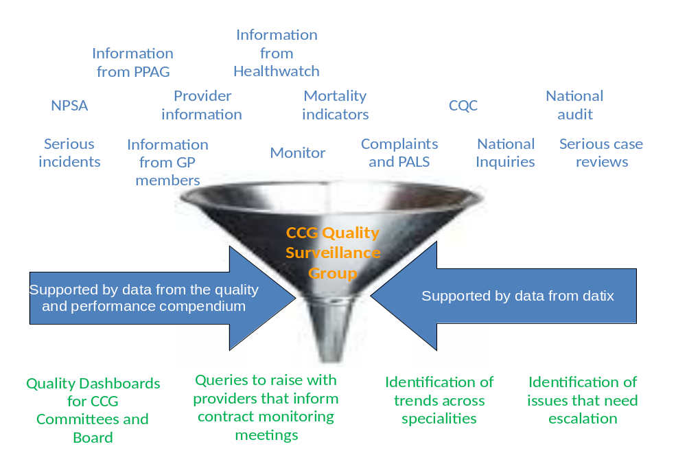
6.11 With the introduction of more real time data available in relation to quality such as published complaints reports, information on safe staffing, and information published under the transparency agenda this process will be developed further to ensure this information is captured and fed into the early warning system process.
6.12 The CCG has also purchased and is rolling out a system to allow us to capture real time concerns about other providers as identified by our GP members, members of the CCG Patient and Public Advisory Groups and Healthwatch. The implementation of this system across all GP practices will allow a further level of detail in relation patient safety. There is also collaboration with the Local Authority regarding the processes that are in place to monitor nursing home placements.
6.13 We work closely with the Local Authority in coordinating our response to serious case reviews and domestic homicide reviews against statutory timescales. The CCG ensures there is full cooperation with the statutory function of the safeguarding boards and compliance with statutory duties of the role particularly in work with providers.
6.14 The CCG coordinates reports and quality assures responses from across the health economy, providing expert input to panels. An important role is the, dissemination of findings, influencing commissioning decisions, informing media management and monitoring the impact of learning.
Patient experience

6.15 Measuring improvement in patient experience is a difficult task. Patient experience is subjective and involves multiple factors. The development of the Friends and Family Test has helped the CCG gain a tangible feel for how patients experience care in the acute sector. The real benefit of this has been the additional questions providers have included in this test allowing them to identify the areas of the patient experience that were not optimal and more importantly put plans in place to address these.
6.16 The information from the Friends and Family Test gathered this year gives us an indication of patient experience in the acute provider. The CCG will use this as a baseline to measure, monitor and improve patient experience in this setting. This measure gives the CCG the ability to measure improvement in patient experience but will not be looked at in isolation. All providers are required to work to address patient concerns and complaints and improve patient experience. To fully understand and improve patient experience all of this data needs to be looked at and analysed. This will be done as outlined in the CCG early warning system and Quality Surveillance Group and actions identified within this forum, these actions will then be scrutinised and agreed through the CCG Quality Committee and taken forward with our providers from there.
6.17 The CCG is committed to delivering the EDS2, and as part of this ensuring the quality of care experienced by vulnerable groups of patients will be improved. There are logistical challenges in achieving this which we are addressing. All providers are required to gather data about their patients in relation to the protected characteristics. As a CCG we have requested that this data be included in any report about patient safety, complaints or patient experience. This needs to be strengthened moving forward but is hampered by national electronic systems for capturing patient data which does not allow for data collection against all the protected characteristics. Providers have plans in place to improve the collection of this data against the 9 protected criteria and this will be monitored and built on. This information will be analysed by the CCG Quality Surveillance Group and actions identified within this forum, these actions will then be scrutinised and agreed through the CCG Quality Committee and taken forward with our providers from there.

6.18 A preventative framework for nursing and residential homes has been developed and will be implemented across nursing homes in Manchester. This aims to improve the governance processes and quality in the homes to improve patient safety and outcomes. The integration of the Quality Boards for the City and Local Authority further develops the links in relation to joint working, monitoring and sharing. By integrating these Boards intelligence can be shared as risks emerge to ensure that control measures are implemented at an early stage to improve outcomes for patients.

6.19 In addition to the patient and community experience information we gather from providers through contractual arrangements, considerable information is gathered through the public engagement work delivered by the CCG itself and the complaints and PALS information we gather as commissioners of services. This is gathered in many formats including social media, surveys, film and meetings with community of interest specific voluntary sector groups. This is reported through to relevant committees including the quality committee, alongside provider generated data. We also have within the structure of the organisation, a Patient and Public Advisory Group, chaired by the Lay rep for PPI, which feeds in community experiences. On top of that, we receive and consider reports from voluntary sector bodies, some of whom we commission, about the experiences and preferences of the communities they represent. During 2013/14 we have implemented a DATIX risk management system within which we are now storing patient experience data. This enables triangulation with other indicators of quality such as complaints and serious incidents.
6.20 The Provider Quality Dashboard that the CCG currently has in place is reported on quarterly at the CCG Board. Included on this dashboard are the results from the Friends and Family Test and narrative in relation to what the provider has done based on the feedback from patients. Performance against this will continue to be monitored and reported against. These papers are in the public domain.

7. Finance and Activity

7.1 The CCG’s actual allocations for 2014/15 and 2015/16 and the assumed resources for 2016/17 to 2018/19 as per the CCG’s 5 year financial plan are outlined in Table 3 below.
Table 3: CCG allocations 2014/19
 | 2014/15 | 2015/16 | 2016/17 | 2017/18 | 2018/19
Growth rates | 2.14% | 1.7% | 1.7% | 1.7% | 1.7%
 | £000s | £000s | £000s | £000s | £000s
Opening Recurrent Allocation | 230,958 | 235,901 | 231,298 | 235,230 | 239,229
Growth | 4,943 | 4,010 | 3,932 | 3,999 | 4,785
Sub-total | 235,901 | 239,911 | 235,230 | 239,229 | 244,014
Better care fund |  | 3,943
Better care fund transfer |  | (12,564)
Total recurrent allocation | 235,901 | 231,290 | 235,230 | 239,229 | 244,014
Running cost allocation | 5,029 | 4,516 | 4,505 | 4,492 | 4,516
Prior year surplus | 2,352 | 2,433 | 2,313 | 2,352 | 2,392
Total allocations | 243,282 | 238,239 | 242,048 | 246,073 | 250,922

7.2 Table 3 shows the reduction in allocations for the Better Care Fund pooled budget contribution which is shown at the value announced by NHS England for the 2015/16 planning period.
7.3 The running cost allocation has been adjusted in line with population changes in 2014/15, resulting in a decrease of £51k from 2013/14 and reflects the 10% reduction required in 2015/16 as per the guidance. The figures for the other years are indicative figures released by NHS England in February 2014.
7.4 Based on our total allocations and forecast expenditure, if we do nothing, our total financial gap will be as follows:
 | 2014/15 | 2015/16 | 2016/17 | 2017/18 | 2018/19
Financial planning gap | 4,570 | 8,622 | 13,598 | 15,089 | 15,858

7.5 It must be highlighted that detailed plans have been produced for the first two financial years and for subsequent years these are based on more high level assumptions.
7.6 The CCG in its financial planning has ensured that resources have been set aside to meet the requirements of NHS England’s planning guidance (with the exception of the underlying surplus) known as the “business rules” including:
- 1.0% surplus in each financial year
- 0.5% contingency
- 1% non-recurrent “call to action” fund for 2014/15 and additional 1% contingency in future years
- 1.5% non-recurrent headroom in 2014/15 and 1% in 2015/16 and future years.

Investment and Impacts

7.7 The overall activity shift that is required to be delivered by the LLLB programme across Manchester (though recognising that investment will be required in out of hospital services) is shown in Table 4.

Table 4: Out of hospital activity shift assumptions

STRATEGIC TARGETS
Manchester CCGs (Gross % shift based on 2013/14 M8 Forecast SLAM outturn)
 |  |  | TARGET REDUCTIONS - 5 YEAR PERIOD
POD | Agreed target shift %* | Indicative average prices | Target shift required 2014/15 to 2018/19 | Indicative tariff cost of activity shift | North  (All Trusts) | Central  (All Trusts) | South  (All Trusts)
POD | Agreed target shift %* | £ | Activity | Indicative cost £ | Activity | Activity | Activity
A & E | -10.0 | £97 | 26,998 | £2,606,679 | 8,927 | 11,415 | 6,655
EL | -8.0 | £1,043 | 4,001 | £4,172,506 | 1,501 | 1,243 | 1,257
NEL | -20.0 | £1,733 | 11,098 | £19,231,730 | 4,228 | 3,546 | 3,325
OP | -16.0 | £101 | 78,998 | £7,964,718 | 25,481 | 25,957 | 27,560
TOTAL - ALL CCGs |  |  | 121,095 | £33,975,633 | 40,137 | 42,161 | 38,797
* The targets are based on review of NHS Comparators information for NHS Manchester in 2012/13.
The Central Manchester specifics are detailed in table 6.
7.8 These target reductions are consistent with those modelled as part of Healthier Together (Table 5). Work has been undertaken to ensure that assumptions remain consistent between the various aspects of planning wherever the scope of modelling is similar. At this stage, the planned efficiencies are based upon acute hospital based activity, valued at circa £34m for Manchester, of which £11m is for Central Manchester. An assumption has been made that up to 50% of this will need to be reinvested in community services in order to sustain the acute activity shifts.

Table 5 - CCG BCF transfers

Better Care Fund Allocation 2015/16 | North | Central | South | Total
(Indicative Figures) | £k | £k | £k | £k
CCG contributions
Carers breaks and reablement | 1,815 | 1,735 | 1,450 | 5,000
NHS funding transfer/integrated care | 7,576 | 6,886 | 5,922 | 20,384
 | 9,391 | 8,621 | 7,372 | 25,384
New social care transfer (from NHS England - formerly PCTs) | 4,160 | 3,943 | 4,116 | 12,219
Total transfer to MCC | 13,551 | 12,564 | 11,488 | 37,603
Effect of BCF on CCG growth monies:
Growth 2014/15 | 5,318 | 4,943 | 4,312 | 14,573
Growth 2015/16 | 4,315 | 4,010 | 3,499 | 11,824
Total two year growth | 9,633 | 8,953 | 7,811 | 26,397
CCG transfer (excl NHS England additional) | 9,391 | 8,621 | 7,372 | 25,384
Net CCG growth remaining after BCF | 242 | 332 | 439 | 1013

7.9 The CCG has undertaken an exercise with its key partners represented on the Provider Partnership Board to prioritise investment funding for 2014/15 to deliver the shift required under the Better Care Fund. The list of investments includes the following, though not all projects are funded for the full year:

- Practice Integrated care teams (Case Study 1)
- Intermediate care scale up projects e.g. COPD, End of life, CHC, homecare
- Locally commissioned services – dementia, homeless, heart failure
- Homelessness drop in service
- Marie Curie Planned Care
- Alternatives to transfer
- Proactive elderly care team
- Community IV (Case study 4)
- Responsiveness and availability ( e.g. Case study 1)
- Continuing Healthcare
- Dementia Management Enhanced Service (Locally Commissioned Service)
- Care Homes Primary Care Model
- Living with Pain Service (community service)

7.10 The above list totals around £3.6m (though the full year effect is around £5.2m) of which £2.7m will be delivered by the Provider Partnership Board using a pre-alliance contract.

7.11 The CCG has assumed that the cost of the investments, which will be sustained, will be funded from the transfer of NHS resources to the citywide pooled budget from 2015/16, though this will be subject to agreement by the Health and Wellbeing Board from 2015/16. The CCG is developing additional plans to ensure the shift required in 2015/16 is delivered.

7.12 One of the means by which we seek to manage the financial challenges facing the CCG is through Quality, innovation, productivity and prevention (QIPP). We have a robust programme that manages the initiatives put forward to deliver improvements against this agenda. The QIPP requirement for the CCG over the next 5 years is shown in section 5.4 and amounts to £15.4m over the 5 years. A key element of the delivery of the requirements will be the deflection of activity from secondary care, and it is expected that our investment programme and LLLB will contribute around 70% of our QIPP requirements over the 5 years. Table 6 sets out the assumptions in activity terms around growth, activity shift and deflection from secondary care over the 5 year period.

Table 6: 5 year activity growth and deflection assumptions
5 year impact | A&E | Non Elective | Outpatients | Elective | Total
Growth | 10.0% | 10.0% | 3.5% | 13.0%
Activity growth | 11,415 | 1,771 | 5,693 | 1,942
Deflections target | 10.0% | 20.0% | 16.0% | 8.0%
Activity deflections | (11,415) | (3,546) | (25,957) | (1,243)
£ deflections | £1,102,166 | £6,143,951 | £2,617,013 | £1,296,170 | £11,159,300
Net growth % | 0.0% | -10.0% | -12.5% | 5.0%
Net growth activity | 0 | 1,775 | -20,264 | 699

7.13 The investment programme includes projects that were in place already together with some new schemes. The shift in activity as a result of this investment programme (adjusted for those schemes already in place where the activity has already been reduced) is described in Table 7. These activity deflection targets have been agreed with our major provider.
Table 7: Anticipated activity shift from secondary care
2014/15 Activity Impact | A&E | Non Elective | Outpatients | Elective | Total
5 year target | (11,415) | (3,546) | (25,957) | (1,243)
Deflections as per new investments | (7,161) | (2,451) | (605) | 0
£ deflections | £543,000 | £2,581,000 | £91,000 | 0 | £3,215,000
Shift yet to be resolved | 4,254 | 1,095 | 25,352 | 1,243
% shift on target | 37.3% | 30.9% | 97.7% | 100.0%

7.14 A further tranche of investments will be agreed around Autumn 2014 and there may potentially be additional funding from the Better Care Fund to the value of £3m to enable further schemes to be developed. These investments will need to be prioritised to focus on the shift required.
7.15 All investments made by the CCG will need to be monitored to ensure the projected shift is delivered. To manage the financial risk, the CCG has entered into a risk share with North and South Manchester CCGs to offset pressures arising out of city-wide services. In addition, at Greater Manchester level, the CCGs have agreed a risk share arrangement around transformation projects.

8. Organisational Development

8.1 Our workforce and organisational development strategy is intended to support workforce commissioning, planning and development to meet the vision and priorities within the CCG. It provides the direction and framework needed for us to move the workforce along the path that supports the aims and focus of the vision for the CCG. If we can establish the right foundations based on the right workforce, it will take us a long way towards seeing the vision for CCG becoming a reality.

8.2 We aim to develop equal and consistent workforce planning and organisational development interventions for primary care with an emphasis on workforce adaptability, transformation and partnership working. We will work to ensure we have a workforce which is flexible and adaptable, is able to work in new and different ways which are responsive to changing and improving services and provide a seamless experience for patients. In the future, workforce development will be increasingly important in ensuring sustainability. With new delivery models emerging there will be a requirement for new thinking, leadership, service innovation and investment in a workforce that is capable of delivering.

8.3 Our organisation will require staff that are clinically and managerially skilled to the highest level to deliver the range of service improvement programmes i.e. will need a transferable workforce with portable skills to help reduce health inequalities. We will need to a clear picture of workforce shortages affecting Central Manchester, to better inform integrated workforce planning, opportunities for modernisation, commissioning and creative attraction, retention and succession strategies.
8.4 Our OD themes take into account the need to continue to develop workforce capability, motivation, engagement and organisational systems, processes and governance while also improving organisational efficiency. The success of our workforce and OD interventions will depend on;
- An underlying integration and understanding of how we continue to enable our people to be engaged, supported and confident in what they do
- Continuing to shift work from a process to an outcome focus
- Having a shared and cohesive sense of purpose across the organization

8.5 Our key themes are:
- Leadership and Management Development
- Engagement
- Leading and delivering effective change
- Individual and Team Capability
- Improving Organisational Efficiency

Working with partners
8.6 General Practice recruitment remains high priority, as the growing shortfall in trainees pursuing this career is compounded by the significant numbers approaching retirement. Analysis of data drawn from the national HSCIC annual return suggests some variation in Practice workforce per head of population in some localities and a reduction in overall numbers entering the profession, despite the significant expansion programme. This data source also suggests an ageing profile across both GPs and Practice Nurses, risking sufficient capacity to maintain high quality service delivery, whilst undertaking transformational education and training. In addition, the increased role many GPs have in commissioning of services inevitably impacts on participation rates and reduces clinical workforce.

8.7 We recognised that addressing the absence of robust workforce data for general practice is fundamental first step to comprehensive and intelligent workforce planning. We are currently working with Health Education North West in undertaking a detailed data capture at Practice level to get a better understanding of the workforce to assist us in our workforce plans and future succession planning.
8.8 We are also engaging with our key providers regarding service commissioning plans and providers plans for workforce assurance purposes. Providers will be sharing plans with us and as the lead CCG where appropriate we will sign off provider plans as evidence of triangulation for assurance of the two and five year plans around finance, activity and workforce.

Leadership Development

8.9 Leadership Development remains a high priority for us. Working with the Leadership Academy and other providers we have implemented a leadership programmes for our board, clinical leads and CG managers and staff. The programmes are aimed at;
- Developing high potential leaders
- Building future capability / skills requirements
- Developing next generation of leaders and support succession planning
- Retain talent within the business

Risk Management
8.10 The strategic plan has a number of key risks relating to it. There are also unknown risks which could present themselves in the coming years. The CCG has a robust system of risk management where we proactively identify and assess risk, put in place plans to mitigate risks and to review risks individually and for the organisation as a whole. This system works at a staff member, team, committee and Board level and is an ongoing process.

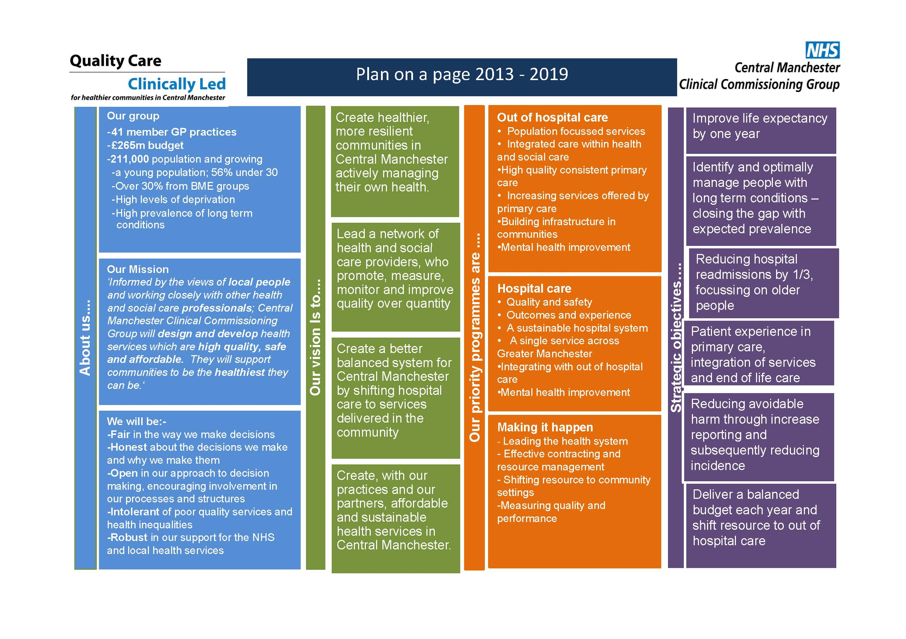
Appendix 2

http://www.england.nhs.uk/wp-content/uploads/2014/06/mo-dash-supp-info.pdf

