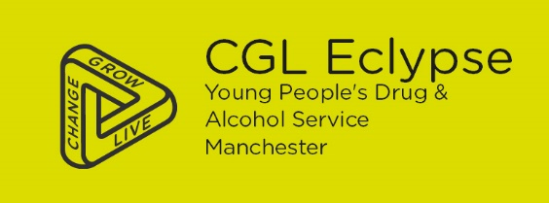

Hi all,

I wanted to inform you of Eclypse’s CGL new training (train the trainer): WHAT IS THE DEAL, Young People & Drug Dealing. The training will aim to raise awareness of substance misuse, crime, language used, what is county lines and vulnerable young people who are targeted or attracted to this negative lifestyle.
The training is really interactive and aims to help us initiate difficult discussions with young people.
There are only limited number of sessions, and we would like to offer it to people who are working with young people ensuring sustainability.
WHEN:
So far we have the below dates:
- 30th of January 2020 @ 13:00- 15:30pm
- 12th of February 2020@ 13:00- 15:30pm
- 11th of March 2020@ 13:00- 15:30pm
WHERE?
41 Thomas Street, NQ, M4 1NA
Ring us for further information 0161 8392054
HOW:
Please email us: manchestertraining@cgl.org.uk or just ring us on 0161 8392054

Kind regards

