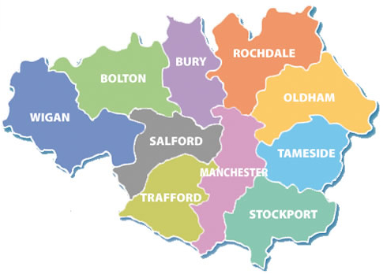
Greater Manchester Older People’s Network
Me and My Home:
Our Housing Manifesto

Most people want to age well at home, remaining part of their community, connected with family and friends. We believe that decision makers in Greater Manchester across planning, housing, health and care need to reflect this aspiration and set it as an underlying objective, for all their policies, and then work together to ensure that all older people have access to a decent home in later life.
We believe that
everyone should have access to a decent home, whatever their age, including in later life.

Good housing is fundamental to health and wellbeing. An adequate supply of affordable housing maintenance, decent quality, well-designed, accessible ordinary housing, as well as specialist and supported housing, can enable many more older people to live healthier lives in their own homes for longer. NHS plans to deliver more health care at or closer to home will be more difficult to achieve if older people’s homes are unsuitable.

Our Housing Manifesto has come out of our own experience and a workshop with Ambition for Ageing’s Greater Manchester Older People’s Network, MACC and Care and Repair England who support action by older people’s groups to improve housing and related services for an ageing population. Participants were older people from across Greater Manchester who are keen to see their aspirations incorporated into housing and integration strategies across Greater Manchester.
We were given the chance to answer just three simple questions:
- What do I need to enable me to live independently and well in my home?
- What should housing for older people be like?
- What should housing for older people be like in the future?
Our Housing Manifesto is the outcome of this workshop.

Our headline asks:
Improve existing housing
- We need access to free independent and impartial advice about all our housing options across all tenures. This needs to be available early and to everyone and not just in crisis situations to enable people to plan ahead.
- We need access to trustworthy, reliable and affordable repairs and maintenance including handyperson services and home improvement agencies for all housing sectors.
- We need easy access for all to adaptations and aids that are delivered quickly and efficiently across all tenures without the obligation to move if our home is adaptable.
- We need support for those home owners with limited resources to maintain and keep their homes warm, safe and in good repair so they can remain safe, well and independent.
- We need advice and access to the new technologies such as telecare which enable people to remain in their own homes.
Neighbourhoods and communities
- We want closer links between health and housing so that our health and independence is maintained so would like to see health professionals trained so they can offer a housing assessment, to be an integral part of the integration of housing, health and social care systems.
- We want housing strategy and planning to respond positively to the housing needs of older people living in the community and see the needs of our ageing population addressed in main documents and strategies.
New Housing
- We want ALL new build properties to be accessible for all and designed for a lifetime.
- An ageing society means we need more imaginative housing options for older people of all tenures, both mainstream and specialist housing to meet the range of diverse needs in later life.
Specialist Housing
- We want housing specifically for older people to be available in localities so people can maintain social and family connections in familiar neighbourhoods.
Engagement
- Older people are experts through experience and want to be engaged and involved in planning, developing and delivering housing, housing services and strategies for later life.
What we know:

Where people live – their homes and neighbourhoods – is pivotal to their wellbeing, health and quality of life. Homes that are in good repair – that are safe, warm, comfortable and accessible – help people to live independently and well for longer, actively involved with family, friends and the rest of society.

A home is not just about the bricks and mortar, although this is important, but also about being part of neighbourhoods and communities. “Home” is the hub of life. And living independently in a home of our choice is the simple aspiration of most older people.

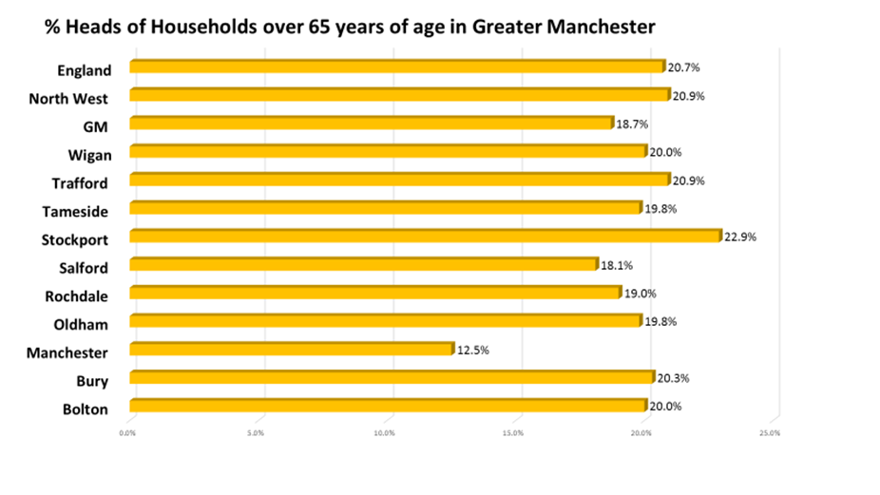
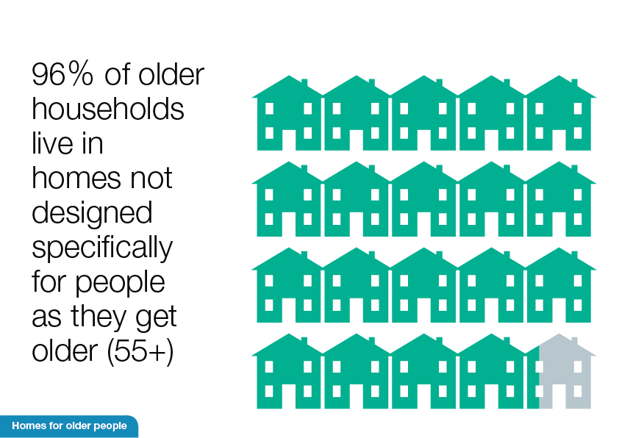
There are1 million people aged over 65 in Greater Manchester who make up 18.7% of all households or 216,500 households and these numbers will grow faster as our population ages.

The mainstream existing stock is where the vast majority (96%) of older people live and wish to continue to live. Currently 90% of older people live in general housing, i.e. non-specialist housing, within communities where they have lived for many years, have built relationships and connections, and have expressed no desire to move.

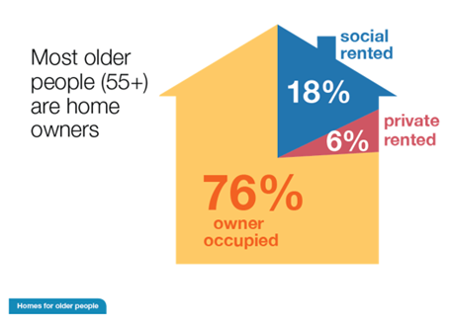
Across England, 76% of older people are owner occupiers. Across GM this figure is slightly higher. While it is true that some older people choose to move into rented specialist housing, there is little that is attractive or affordable for home owners to move to. The majority of new housing being built is aimed at first time buyers and doesn’t include the sort of features desired by older home owners, such as additional storage or space. Located with access to transport and services, proximity to familiar neighbourhoods and family are all considerations that can act as attracting older buyers.

Improve existing housing
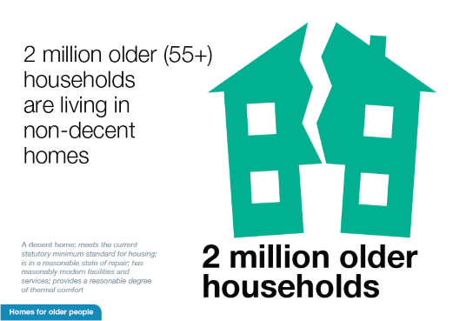
For a number of years there has not been any survey done of the housing stock condition. We are unsure of the state of repair of our local housing stock but nationally we know that older people living in non- decent homes costs the NHS through hospital admissions, falls in additional GP visits in the region of £1.4 billion per year. Any repairs or maintenance, particularly for low income older home owners can only improve both their health and wellbeing but help to maintain the standard of the local housing stock.

We need access to free independent and impartial advice about all our housing options across all tenures. This needs to be available early and to everyone and not just in crisis situations to enable people to plan ahead. Housing should be part of all retirement planning but we need information before we can make suitable plans.

Adaptations are the way to enable people to remain in communities close to existing networks of support and to remain socially connected. Improving the speed and delivery of adaptations will increase the prospect that people can remain independent for longer.

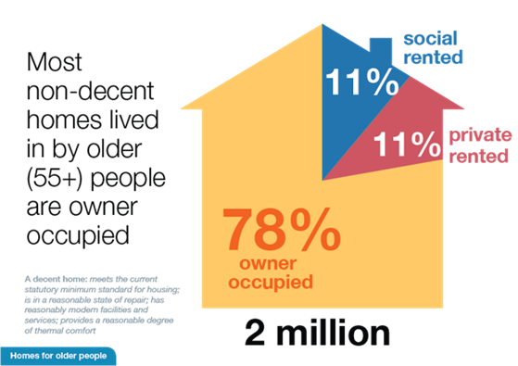
For older home owners living on fixed incomes and those without family support or experience of dealing with repairs or maintenance, the need for support to engage reliable, trustworthy and affordable maintenance or handyperson services is vital. However this is not a service that is available across all authorities in Greater Manchester but is widely acclaimed where it does exist. We would like to see it available to all. Media coverage of older people being exploited by unscrupulous tradespeople serves to heighten the anxiety about getting jobs done.

Where homes have been built or adapted to include accessible features these enable older people to retain their independence, in a supportive neighbourhood and remain part of their community for much longer.

Adaptations
In England, 93% of homes lack basic accessibility features and would benefit from being adapted. Over three quarters of a million people aged 65 and over need specially adapted accommodation because of a medical condition or disability and 145,000 of them report living in homes that do not currently met their needs.
Greater Manchester has received £26,821,868 for Disabled Facilities Grants in 2017/18. How these are delivered varies from one authority to another but quick delivery enables older people to remain at home for longer and enable care to be delivered safely in their home.

We appreciate that local housing associations vary in their willingness to adapt their properties for various reasons but if they all kept a register of adapted properties – an accessible housing register – then it may be possible for people to remain in their communities if they need an adapted property.

Issues also arise around planning, adaptations and large scale extensions in private housing. This is exacerbated in conservation and greenbelt areas. While these protected spaces are important, they can also seem unsupportive to a householder who is trying to improve the accessibility of their home and enable them to maintain their independence in their community. Local authority planning officers have a constant struggle to respond appropriately to such requests and need additional guidance.

The home is the most common place for falls. One in three people over 65 and one in two over 80 in England and Wales have fallen at least once each year. Well designed or adapted homes reduce risk of falls
40% of the NHS budget in the UK is spent on caring for older people over 65 years.
Ensuring that all older people (especially those with a medical need) have access to a decent, suitable home in later life is critical to healthy ageing. Ageing well at home results in wider benefits for:

- The NHS – through reduced GP visits and hospitalisation
- Social care – through extending safe, independent living and delaying need for more expensive residential care
- Individuals – through improved quality of life and reduced worry for families and carers

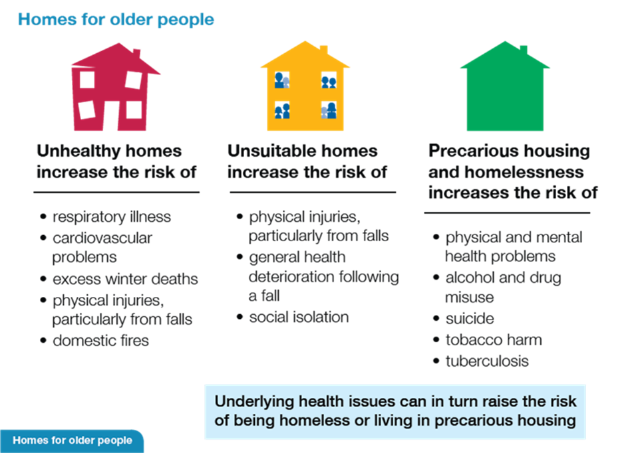

Homes for healthier ageing
Not everyone ages in good health. An estimated four million older people in the UK (36% of people aged 65-74 and 47% of those aged 75 plus) have a limiting longstanding illness. This equates to 40% of all people aged 65 plus in the UK. How long we live, and how long we live in good health, are very unequal. There is a large disparity between healthy life expectancy across Greater Manchester.

Good housing is fundamental to health and wellbeing. NHS plans to deliver more health care at or closer to home will be more difficult to achieve if older people’s homes are unsuitable.

An adequate supply of decent quality, well designed, accessible ordinary housing, as well as specialist and supported housing, can enable many more older people to live healthier lives in their own homes for longer

Neighbourhoods and communities
We want closer links between health and housing so that our health and independence is maintained so would like to see health professionals trained so they can offer a housing assessment.

We want housing strategy and planning to respond positively to the housing needs of older people living in the community and see the needs of our ageing population addressed in main documents.

New Housing
New build properties need to be accessible for all and designed for a lifetime. In the long term this will lead to savings for both health and social care. One of the key features for GM is the cost of new homes. Many of the new homes for sale cost more than the homes people are living in because of lower market values in the North. Taking on an additional mortgage in later life in most cases is not available or affordable as people are living on relatively low incomes.

An ageing society means we need more imaginative housing options for older people of all tenures, both mainstream and specialist housing to meet the range of diverse needs in later life. We are not a homogenous group and the housing options available needs to reflect our diversity.

One option would be to make a commitment to building healthy, sustainable housing for the whole population and then to task a knowledgeable committee to create a set of updated standards. Such a committee might also be tasked at the same time to develop a 'Good Housing for Ageing' Design Quality Mark (as suggested by APPG (Housing & Care) HAPPI reports) and drawing on examples of design excellence e.g. University of Sheffield’s DWELL report.

Few local authorities include planning suitable housing for older people, including specialist and/or supported accommodation, in their local plans and all too often it is a separate issue rather than one associated with building a community of support for the whole life course.

There are two key factors affecting people’s access to housing that meets their needs:
- Lack of knowledge about options – whether that be to adapt their current home or to move either to a better general home or specialist housing. The other alternatives are not widely known about so many people presume they ‘stay put’ because there isn’t a bungalow in their neighbourhood which they can afford or believe that ‘when they time comes’ they will end up in residential care – their last stop before the end.
Moving into rented accommodation either in the private or social rented sector is not always seen as a secure option but is attractive to those home owners who no longer want the responsibility of repairs and maintenance.
Shared ownership is not widely available even if people want to go down the route. Most of the products available were designed both physically and financially with first time buyers in mind. Full-repair leases may not be attractive to those who are trying to ‘simplify’ their housing situation. If shared ownership included a ‘step-down’ model of home ownership they might be more attractive to older people.
- Costs – both of moving and for new accommodation when the majority of people live in low value housing are priced out of many new developments specifically for older people. Where people have owned their own home, additional costs for service and support charges may come as a shock which goes back to the issue about lack of knowledge. Also included in the costs are the physical and emotional expense of moving. It requires a lot of energy and support to enable the oldest older people to move successfully.

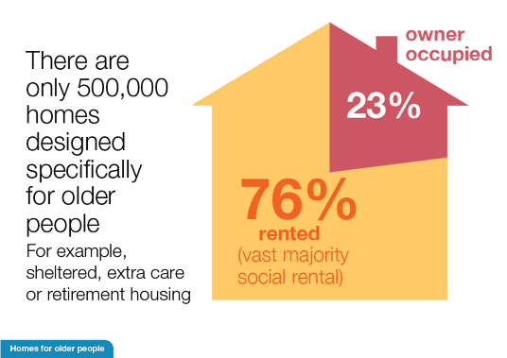
Specialist Housing
Nationally we know that there are just 500,000 specialist units of accommodation for older households compared with 9.5milion older households (head of household 55yrs+). We appreciate that extra-care housing is the new model of supported housing for older people but there is not enough of it and it is not available in every locality. It is not wanted or needed by everyone. People are anxious about being able to afford it if they are home owners.

The desire of older people, if asked, is to remain within their community so the provision of specialist housing is desired within neighbourhoods so that relationships can continue. This has considerable impact on their wellbeing.

There is a lot of change taking place in minority communities who don’t always find appropriate or suitable accommodation to meet their needs in later life. We feel more engagement with their housing needs will help them maintain their independence for longer.

Engagement
Older people are experts through experience. They want to be engaged and involved in planning, developing and delivering housing strategies and solutions for later life.

The 2017 Housing White Paper states:
Government plans to introduce a new statutory duty to produce guidance for local planning authorities on how their local development plans should meet the housing needs of older and disabled people.

The Greater Manchester Spatial Framework is an opportunity to incorporate this ambition for the future population of Greater Manchester.

In conclusion
Most people want to age well at home, remaining part of their community and involved with family and friends. Housing is fundamental to achieving this aspiration.
We believe that decision makers across planning, housing, health and care need to reflect this aspiration, setting it as an underlying objective for all their policies, and then working together to ensure that all older people have access to a decent home in later life.

We invite you to work with us to achieve this in Greater Manchester.

________________________________________________________________

References
‘Fixing Our Broken Housing Market’ DCLG Feb 2017
- Giving communities a stronger voice in the design of new housing to drive up the quality and character of new development, building on the success of neighbourhood planning;
- Encouraging the development of housing that meets the needs of our future population;
- Making better use of land for housing by encouraging higher densities, where appropriate, such as in urban locations where there is high housing demand; and by reviewing space standards.
- Helping the most vulnerable who need support with their housing, developing a sustainable and workable approach to funding supported housing in the future;

‘The Future of Ageing in Greater Manchester’ Feb 2017 GMCA and New Economy
Twenty years from now in Greater Manchester:
- 1.1m people will be aged over 50, accounting for 37% of the population
- 650,000 people will be aged over 65, with the fastest population growth among older cohorts (85+)
- While the overall GM population is set to grow by 13% by 2039 to reach 3.1 million, it will be driven by growth in the number of older people:
- Currently 93.6% of over 50s in GM are from White ethnic groups, with 4.4% from Asian ethnic groups, 1.2% from Black ethnic groups and 0.8% mixed race or other ethnicities.
- Already, 114,000 over 50s in GM are likely to experience social isolation. With a 66% rise forecast in the number of people aged over 75 living alone, this issue could grow significantly, resulting in increased demands on health and other services
- 21% of people currently treated for substance misuse in GM are aged over 50; this figure rises to 34% for alcohol services alone. A rise in the older population could create significant additional demand for treatments such as these.

Additional Resources:
RTPI https://www.theplanner.co.uk/news/10-of-uk-councils-have-housing-policy-for-the-elderly-%E2%80%93-research

LGA https://www.local.gov.uk/housing-our-ageing-population

Older People’s Housing Champions https://housingactionblog.files.wordpress.com/2017/05/housing-champions-housing-manifesto-final-20172.pdf

Public Health England https://www.gov.uk/government/publications/improving-health-through-the-home/improving-health-through-the-home#infographics

