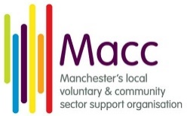**** 

**GMOPN**

**Greater Manchester Older People’s Network**

**Are we getting there? Age-Friendly Transport across Greater Manchester**

**Agenda**

10-10:30     Arrivals and coffee

10:30 – 10:40 Introduction (Liz Jones, GMOPN)

10:40 -10:50 The Housing Manifesto – The Story so far: Wendy Cocks (Care and Repair)

10:50 – 11:05 Age-friendly Transport: Mark Hammond (Ambition for Ageing)

11:05 -12 Are we getting there? - Group discussions and feedback

12 – 1 Lunch

1 Andy Burnham (Mayor of Greater Manchester)

1:20 – 2 Panel discussion - Chaired by Paul McGarry, (Greater Manchester Ageing Hub)

Stephen Rhodes (Customer Director, TFGM), John Hannen (Programme Manager, Ambition for Ageing), Elaine Unegbu (Action Group member, GMOPN)

2- 2:05 Summing up and looking forward (Liz Jones, GMOPN)

2:05 -2.45 Refreshments and opportunity for Networking