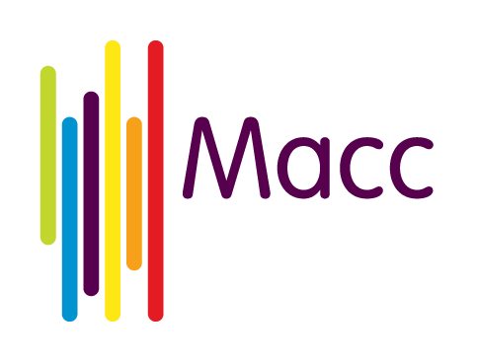
Hate Crime Awareness Grant Application Guidance

General Guidance
Answer all the questions on the application form. Your application should be typed in English in black Arial Font 12pt. Where possible, please email your application in a word document, however applications received via post or scanned and emailed will be accepted.
Some sections have a word count. Where these are part of a scored section, you will be assessed on the quality of what you write not on the quantity. However, answers that are short (less than 50% of the word count) are unlikely to contain sufficient information to score highly.
Any words in excess of the word count will not be assessed, however you can use bullet points and lists and you do not need to write in whole sentences as long as the meaning is clear.
Do not attach further information to the application form, unless specifically requested, as it will not be considered.

Activities
It is up to you to decide how you describe in this application, a larger set of activities of which you are applying for part funding or a discrete set of activities for which you want full funding.
The activities that you describe in this application can be a new set of activities or a continuation and/or increase in an existing set of activities.
In all cases, you will have to be able to account for any money you receive from CSP and be able to tell us what you have achieved with the grant that CSP awards to you so please include as much detail as you can.

Detailed Guidance Notes
You do not have to be a formal group with a constitution to apply for this funding but for the purposes of this funding programme, you will be required to have a bank account in the name of your group or organisation. The account must be a group account with more than one signatory and not an Individual’s account. If you have any questions about this please contact Oliver at Macc on 0161 834 9823 or oliver@macc.org.uk before submitting your application.

Section 2: About Your Project

2.1 Tell us about your proposed activities
Describe the activities clearly and how many people you expect to be involved in each of the activities. This funding is to raise awareness about what Hate Crime is, how and where to report it and how your report will be handled as well as celebrating diversity in your community. Please explain about what you will do for your event, who will be involved, i.e. who do think will be attending- young people, older people, people of different cultures and religions etc. Also, please explain what format the event will take. For example, is this a workshop session, open discussion, questions and answer panel or dram production etc. We also want to know what area of hate crime you will be focusing on and why. There is no right to wrong answer; we just need as much information as you can provide to enable the assessors to review your application as fully as possible.

2.2 Who will benefit from your activities and how will they be involved?
Please be as specific as you can be about who will significantly benefit from the activities giving numbers where possible, names of organisations and types of communities who will be represented. Events can often have a wide-ranging impact, for example, if the event is for children or young people, they can often take the information they have learned back to their family members who can also benefit from this knowledge. Therefore, the impact is not just for those who attended but the wider community too. If this is similar to your project , please explain this. We want to know how people will benefit from the activities so if project is holding user consultation groups; volunteering feedback forms; management committee feedback or consultation days to find out what people think of this event, please include this on your application form.
We also want to know who will be involved in running and developing it this event. If the event is developed and delivered by volunteers only, paid staff only or a combination of both or members of the community getting together, please include this.
If your activities mainly work with people in specific wards within Manchester then please include the names of these wards.
Tell us if your activities are with specific groups of people such as:
- Older people (over 50)
- Youth
- Children
- Disabled people
- Black and Minority Ethnic people
- Women
- Religious groups
- Lesbian, gay and / or bisexual people
- Trans people
- Carers
Please tell us what neighbourhood in Manchester your event will be held in, what the community impact of your event will be and have this will an impact on raising awareness of hate crime or celebrating diversity in your community.
2.3 Explain when and where your event or activity will take place
Please tell us the time of your event and if this event will be closed to the public. We are happy to help promote your event if you provide us with the promotional material. We will need to know the date of your event as this will be asked for as part of the assessment of your application. If you do not have a date for your event at the time you submit your application, please let us know as soon as possible as this this may affect your application.
Safeguarding policy-we will require all successful grant holders to provide a current safeguarding policy so please have this available to email to us when requested. If your group or organisation does not have a safeguarding policy, please contact us as we can offer support you to develop one.
Insurance Liability- we will require all successful grant holders to provide a current Insurance Liability certificate so please have this available to email to us when requested. If your group or organisation does not have any insurance to hold this event, please contact us.

Section 3: Your project costs
In this section you need to tell us exactly how you will spend the grant that you are asking for. Break down costs into small groups on each line e.g. refreshments £200, room hire £50 x 3 = £150 etc. If you are using external companies or businesses, please get the best value you can on products purchased. Please provide reasonable costs as part of your budget as this is this will be assessed for realistic costings. If this funding is to part fund an event, please tell us if you have secured the additional funding required. There is no need to provide receipts/ invoices but we would advise keeping financial records. If your budget includes travel costs section please state who this is for (paid staff or volunteers) and if your budget have other costs, please state what these include.
Please note that the Community Safety partnership team provide boxes of hate crime promotional merchandise to support hate crime awareness events so if your budget includes costs for similar items the panel may not agree to fund these, boxes can be obtained free from the Community Safety partnership team.

Section 4: Declaration
The main contact for the project needs to sign and date the form. If you are using a referee organisation they must also sign here. We do require a signature, this could be a written, scanned or be electronic signature. If you will be sending a separate signed page after submitting your application, please let us know as we unsigned applications may not be accepted. If you are new to working in Manchester or have not applied to this grant programme previously we may not be aware of your organisation or group therefore you will need to provide us with a referee to support your application. The referee organisation should be an established organisation in Manchester. If you are unsure if this relates to your group, please contact Oliver Cranfield at Macc for more information on 0161 834 9823 or at oliver@macc.org.uk.

