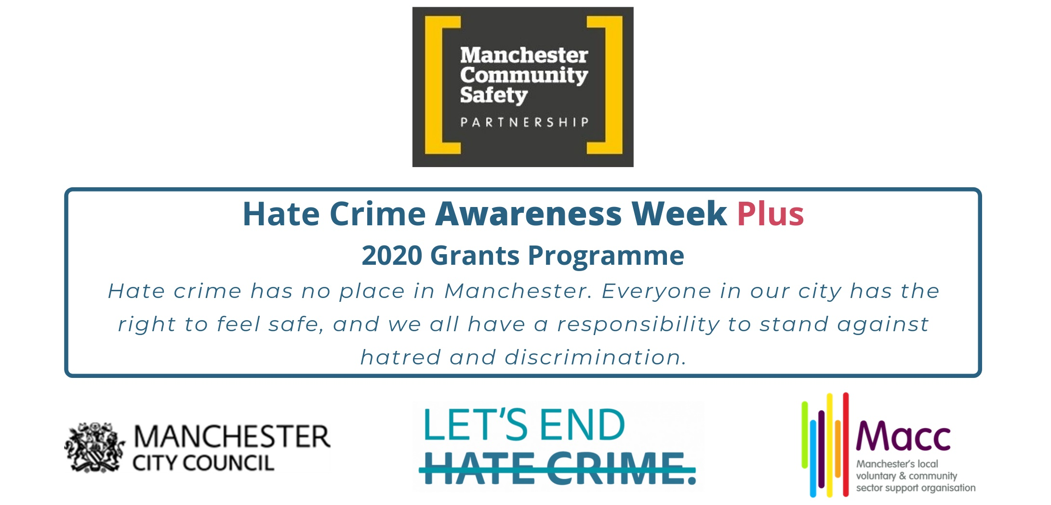
GRANT APPLICATION FORM

Contents

Please read this form before completing it. Fill out all sections and use font size Arial 12.

Section 1 About you

Section 2 About your project

Section 3 Your project costs

Section 4 Declaration

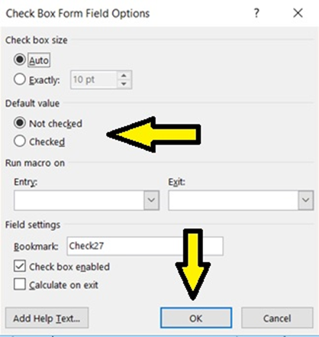
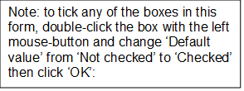

Section 1: About you
1.1 Organisation Name
1.2 Contact Details |  | Lead Contact |  |  |  |  | Secondary Contact
Name:
Role in organisation:
Telephone number (must be different for the two contacts):
Email address (must be different for the two contacts):
Organisation postal address (including postcode)
1.3 What type of organisation are you?  (tick all that apply) |  |  |  | X |  | Organisation Number (insert number where applicable)
Unincorporated Association |  |  |  |  |  | Not applicable
Company Limited by Guarantee
Registered Charity
Charitable Incorporated Organisation
Community Interest Company
Community Benefit Society
Cooperative Society
Other (please specify):
None – we’re not constituted |  |  |  |  |  | Not applicable
1.4 Does your group support a particular section of the community? (Insert X as appropriate)
Black, Asian or Minority Ethnicity: |  |  |  |  | Carers:
Children or Young People: |  |  |  |  | Disabilities:
Lesbian, Gay, Bisexual or Trans+: |  |  |  |  | Older People:
Religious Groups: |  |  |  |  | Women:
Refugees / Migrants: |  |  |  |  | Offenders / Ex-offenders:
Alternative Subculture / Lifestyle: |  |  |  |  | Other (please state):

Section 2: About your project
2.1 What will the event involve? Include your main activities. How many employees / volunteers will organise and deliver it? Is the event to be open or closed to the public? Is it a one-off event or part of a larger programme of work? (200 words max.)
2.2 When and where will the activity take place? Where possible, include exact or approximate dates, venue names / addresses and neighbourhoods of Manchester. (100 words max.)
2.3 Who do you intend to attract to your event, how many and where in Manchester do they come from? What sort of impact do you envisage for attendees and wider community? Please relate your answer to the programme aims, i.e.: raising awareness of what hate crime is and increasing the reporting of hate crime incidents. (200 words max.)
Does your project involve working with children or vulnerable adults? Yes No
(If you are applying for funding to work with children or vulnerable adults, you will need a Safeguarding Policy)
Do you have a Safeguarding Policy? Yes No
(If your application is successful, we will ask to see a copy of this policy)
Does your organisation have a valid public liability insurance policy certificate to cover the project/event? Yes No
(If your application is successful, we will ask to see a copy of the certificate)
Section 3: Your project costs
3.1 You can apply for a grant of £500. State what you will use the grant for:
Expenditure (please itemise) | Amount
 | £
 | £
 | £
 | £
 | £
Total cost (inc VAT) | £
Hate Crime Awareness Grant amount applied for | £500.00
3.2 If the cost of your activity is more than you have applied for, have you secured the rest of the funding you need? | Yes No
Where will the rest of the funding come from? (Please state)

Section 4: Declaration
I declare that the information given on this application form is accurate to the best of my knowledge and that I am authorised to submit this application.

I understand that I must notify Macc of any significant changes to the application and that misleading information can invalidate this application.
Data Protection: the General Data Protection Regulation (GDPR) and Data Protection Act 2018 protects personal data. The purpose of the Act is to protect the rights and privacy of individuals to ensure that ‘data controllers’ cannot process personal data without their knowledge and, wherever possible, cannot process personal data without their consent.

The Act requires Macc and Manchester City Council to register the fact that we hold personal data and to acknowledge the rights of ‘data subjects’. For the purposes of this grants programme, ‘data subjects’ are the trustees, staff and volunteers of the applicant organisation. They have the right to copies of the data we hold about them and to know that we are processing it lawfully.

For the purposes of this grants programme and GDPR, Macc and Manchester City Council are ‘data controllers’.

Macc re-registers its Information Commissioner Office reference (Z9595019) annually on 10 September. Manchester City Council re-registers its Information Commissioner Office reference (Z6942262) annually on 18 July.

We will use the personal data that you have provided only for processing your grant application. We will not disclose it to any other organisation for any purpose other than in relation to suspected fraud or statutory requirements for disclosure.

For more information on how Macc processes data, go to https://bit.ly/2KEBsf1.

For more information on how Manchester City Council processes data, go to https://bit.ly/2WYnGdJ.
Signatory
This must be the lead contact named above. I understand you may contact me during the grants selection process and I confirm I am authorised by the organisation for this purpose and that you may rely on any further information supplied by me.
Name (actual signature is not required): |  | Date:
Before submitting this form, please check that you have answered every question.
The deadline for applications is midday on Wednesday 13 November 2019.
Please email your completed form to grants@macc.org.uk.

