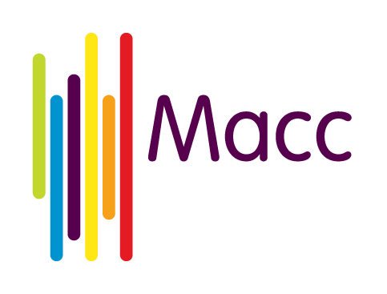
Mini-grants programme 2018 main conditions
To be eligible to apply for this funding you will need to be a Manchester-based VCSE organisation. You can only apply if a separate Manchester-based VCSE organisation has agreed to work on the project. A mini-grants application form must not be submitted if a working arrangement between the two organisations has not been decided.
Due diligence
Successful applicants will be subject to basic due diligence checks before mini-grants are paid, to confirm that they are currently active in Manchester and financially solvent.
When asked, your organisation will be asked to provide the following:
- A copy of the Constitution / Memorandum and Articles of Association for your organisation
- A copy of the most recent bank statement for your organisation, dated no earlier than December 2017
- A list of names and home addresses of trustees or equivalent
- And either:
- Signed annual accounts (must be dated April 2017 or later), or
- An up-to-date income and expenditure statement that matches the balance in your organisation’s bank statement
PLEASE NOTE: Due diligence documentation will not need to be provided if your organisation has received a grant through Macc since 1 April 2017.
Mini-grant conditions
- This funding must only be used for the project activity described in your mini-grant application. You will tell us promptly about any changes to information you have provided to us and will make sure that the information we hold is true and up to date
- You will get written agreement from Macc before making any changes to the aims, structure, delivery, duration or ownership of the activity
- If you spend less than the whole grant on the activity, you will return any unspent amount promptly
- The funding will be awarded to the applicant as stated on the application form. These monies cannot be given or moved to another or different organisation
- As a condition of funding, awards of up to £500 must as a minimum be matched by the applicant with an in-kind contribution of volunteer hours or an equivalent amount of funding
- You will need to provide Macc with an end of project report in the form of a good-news story. Stories can be written and supported with photographs or can be a short video or both. Successful applicants will be provided with guidance on how to produce good-news stories for their projects.
- You will acknowledge the grant publicly where appropriate and as practical in any published documents that refer to the activity
- Your organisation will act in a fair and open manner without distinction to race, religion, age, disability, gender, sexual orientation and in compliance with all relevant legislation
- You will make sure that your governing members are aware of the terms and conditions of this grant whilst the agreement remains in force
- You will ensure that while this agreement is in force you are correctly constituted and regulated to deliver the activity as stated in your organisational governing documents
- You agree to meet all laws regulating the way in which you operate, the work you are to carry out and the staff you employ or the goods you buy
- If your activity involves work with children, young people or vulnerable adults you will take all reasonable steps to ensure their safety and comply with all relevant laws and good practice throughout. We may ask for proof of safeguarding policies and procedures
- You will maintain adequate insurance at all times
- You agree that Macc accepts no liability for any consequences, whether direct or indirect, that may come about from your running of the activity, the use of the grant or from a withdrawal of our grant
- You will not sell, give away or borrow against any of the activity assets that we fund without first receiving our written consent
- We reserve the right to share information about applicants with other grant providers and statutory agencies where we have reasonable grounds to act on concerns raised around dishonesty
- If we become aware that this activity has provided significantly misleading or inaccurate information during the period of the grant agreement, we reserve the right to end this funding agreement and repayment of the funding will be required

