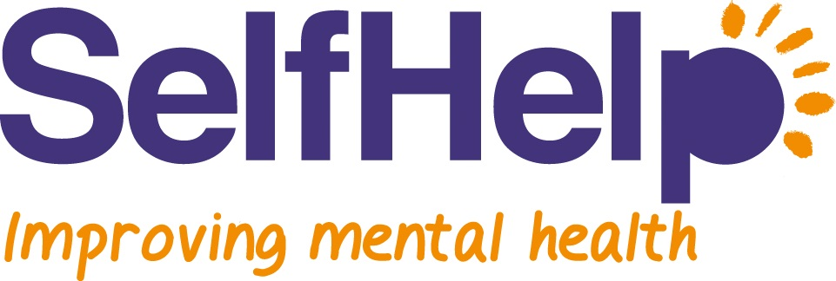
Recovery Workshop Application Form
PRIVATE & CONFIDENTIAL

Name: ..........................................................................................................................

D.O.B: ...........................

Gender: ........................

Address: ......................................................................................................................
.......................................................................................................................................
.......................................................................................................................................

Postcode: ..............................

Tel no.: ....................................................

Mob no.: ..................................................

Email address: ............................................................................................................

Do we have permission to leave a message via: (please tick where appropriate)

Voicemail Message in person

SMS Email

Do you have any physical health problem(s)? Yes/No

If yes, please state: .....................................................................................................

Do you have any mental health problem(s)? Yes/No

If yes, please state: .....................................................................................................

GP Name and Address: ..............................................................................................

............................................................................................

Why do you want to attend the Recovery Workshops?

How did you hear about the Recovery Workshops?

Can you attend the Rough Guide Recovery Workshop/Course starting on 17th January 2019 at Kath Locke Centre?

Please return form to:

Self Help, First Floor, Oakland House, 76 Talbot Road
Manchester, M16 0PQ

Or peertopeer@selfhelpservices.org.uk

