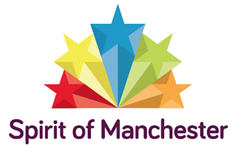
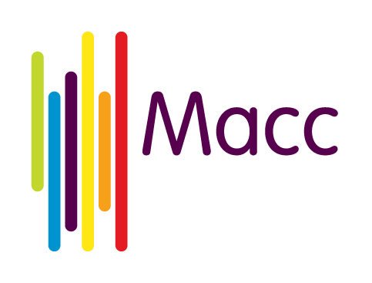
Mini-Grants Programme Eligibility
Macc believes Manchester is a city which shows the world that communities can come together. This true Spirit of Manchester is of a city which rejects division and hatred and celebrates all that unites us, cherishing our shared experiences and shared values.
This year’s Spirit of Manchester Fund programme will provide mini-grants of between £250 and £500 to help bring together two or more different communities within Manchester. The programme aims to support community cohesion by bringing people from these communities together to understand, appreciate and positively value each other.
Community cohesion is about growing together in harmony rather than in conflict. It is linked to core values of equality and diversity and the understanding that cohesion grows when we recognise, respect and value the diverse nature of our communities and the people who live, work and study in this city.
Communities are any groupings of people that are united by some form of social characteristic: age, ethnicity, disability, religious or cultural background, sexual orientation or gender, or a geographical location such as a street, estate, neighbourhood or ward. Individual communities can often be united by a combination of these characteristics and people often feel that they belong to more than one community.
To be eligible to apply for a mini-grant, you must be a voluntary, community or social enterprise (VCSE) organisation that is rooted in a local community of place or identity in Manchester. You must be able to name in your bid a separate VCSE organisation that works with different communities and has agreed to work with you.
We are hoping for lots of different ideas about projects: the mini-grants can fund a broad range of activities including arts, culture, environment, health, learning, social events and sports. Simple ideas like sharing a meal together are welcome too. Above all, projects should bring people together and create or nurture something that is shared by the communities and helps promote understanding and appreciation of each other.
The amount applicants bid for must be matched with an in-kind contribution of volunteer hours or an equivalent amount of funding.
Macc recognises that projects funded by the mini-grants will be small-scale and short-term. However, we would like to see project partners commit to growing the relationship further after the funding has ended. After the activity funded by the mini-grant finishes, the VCSE organisations will be asked what steps have been planned to continue bringing the identified communities together.
Activity that can’t be funded by a mini-grant
The mini-grants programme is unable to fund:
- activities outside the city of Manchester
- contributions towards larger projects or fundraising appeals
- ongoing running costs
- the work of individuals
- projects that promote a particular political or religious viewpoint
- events that focus on one community

