Spirit of Manchester Mini-Grant 2016 Case Study:
Irish World Heritage Centre and Manchester Jewish Museum Joint Volunteer Event

On Monday 5th September 2016 the Irish World Heritage Centre and the Manchester Jewish Museum came together to explore their shared diasporic histories and to discuss the specific skills, knowledges and experiences they share in North Manchester particularly and as long established communities in Greater Manchester. We are near neighbours in North Manchester and have a history of working together intermittently over the years on related projects, like the annual Cheetham Festival. We are also organisations that are facing some similar challenges relating to an ageing cohort in both our volunteer profile and our core client groups. Broadly stated, we also share a social mission to support and educate; to protect as well as develop critical engagements with history, heritage and culture for the larger social good of fostering inclusive models of citizenship.

The Spirit of Manchester scheme gave us an opportunity to engage our volunteer cohorts in discussions about strategies for managing change (in our organisations) and our Diasporas. We wanted to use the event to think through shared experiences and challenges. For example, we are both organisations managing the recent or impending movement into a new building and at the same time, thinking through how we deliver history, heritage and culture to the diversity of our client groups in our new facilities, while negotiating diverse challenges to those changes as we proceed.

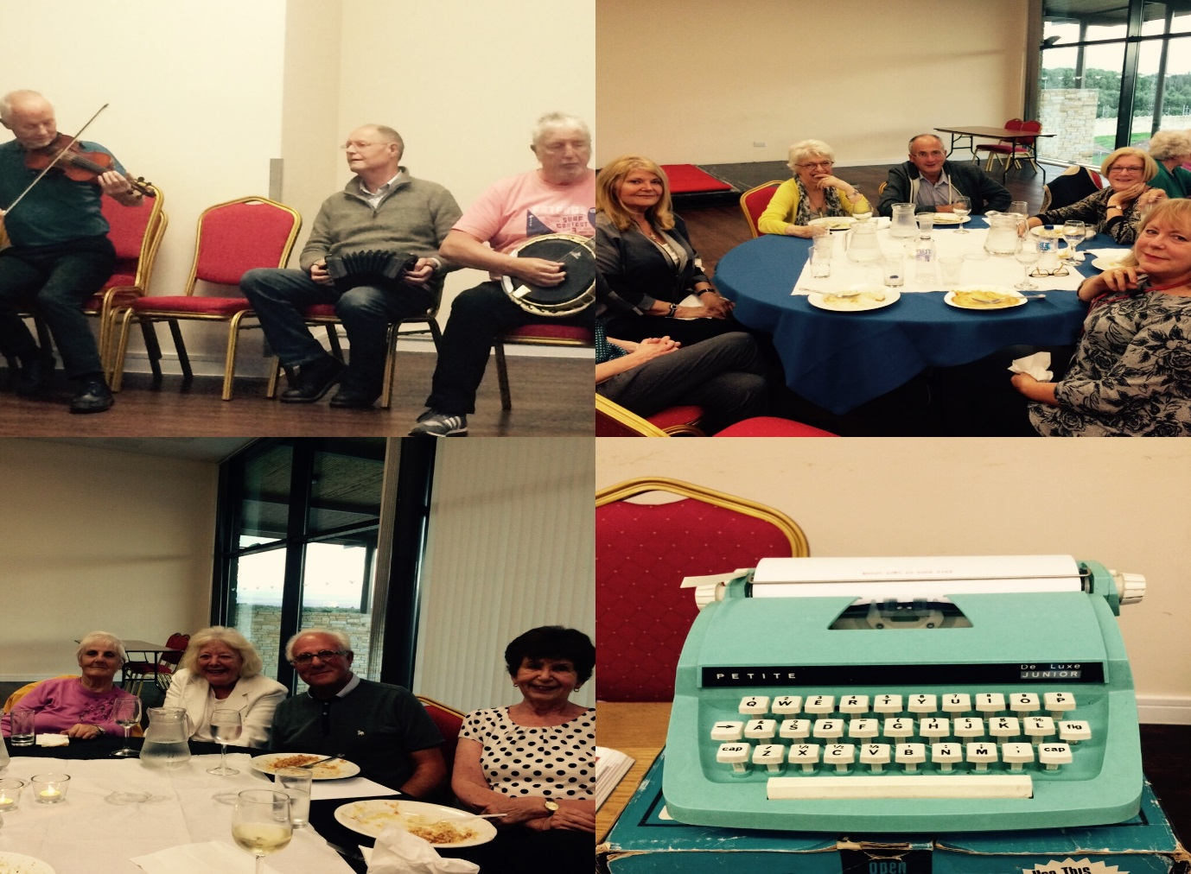

We opened the joint event with a preview of a visiting Culture Ireland sponsored exhibition, ‘Acton Town to Cork City’, exploring migration histories and memories with an introduction by our visiting artist, Marcella Reardon. We used this discussion to open dialogue around shared experiences between and across our diasporic histories in North Manchester and to address also, the experience of those of mixed Irish-Jewish heritage, identity or relations. We arranged a shared meal and during the meal, we introduced ourselves and our skills and interests in more detail. Gareth (Learning Manager, MJM) and Lucy (Volunteer Co-Ordinator, MJM) outlined plans, developments and opportunities for collaboration at MJM and Julie (IWHC) outlined events and opportunities at the IWHC. At IWHC, for example, we are keen to develop our Community Allotment and to open up opportunities for partnership and resource sharing around food (growing), gardening, cultural education and well-being and to build the allotment and its facilities as resource and educational opportunity for cross-generational learning.

The resident groups at the IWHC entertained us entirely spontaneously with a segment of Irish traditional music and dance which also moved our discussion to the question of how to develop initial activity delivered by MJM and IWHC in the area of the Community Choir. The event has helped to cement engagements between our organisations and offered us some opportunities to think through how we might work together or apart to build engagement across several areas of our cultural and education activity. It was also a good opportunity to reflect on what has been achieved thus far for our organisation, what the value of our organisations might be among and for our different constituencies. Central to this has been the commitment and engagement of our volunteers who are the living links across change in our respective organisations and it was good to be able to discuss their experiences. Having the opportunity to come together in this way also builds trust, renews enthusiasm for cross-cultural engagements and makes visible different ways of working with our communities around cultural engagement and volunteer development and support.

Report by:
Julie Mullaney Irish World Heritage Centre
Gareth Redston Manchester Jewish Museum
Lucy Thompson Manchester Jewish Museum

