This report summarises the end of programme submissions received from the four projects that were each funded with £500 from the 2017 mini-grants programme.
Project 1 Can-Survive UK (working with Fit After Cancer Treatment [FACT])
This mini-grant was used in Moston during May to September to pilot six two-hour Women Only Wednesdays and Men Only Thursdays cancer support group sessions. They particularly tried to target, though not exclusively, the local BME population. The sessions comprised various therapeutic activities tailored to meet the needs of attendees. The project enabled Can-Survive UK to work with FACT who specialise in providing fitness activity-related support to this client group. The project’s costs included venue hire and refreshments, publicity, service user travel and facilitator hours.
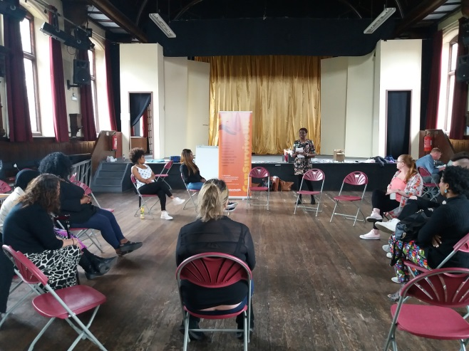
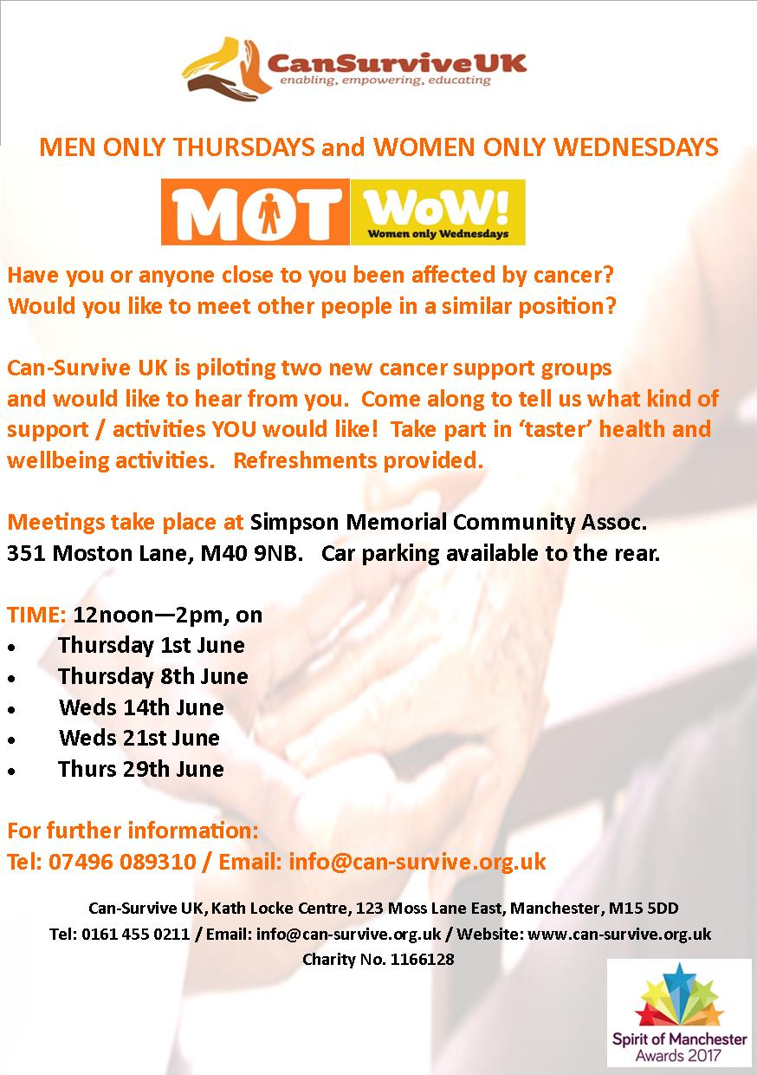
Marcella Turner, Founder and Chief Operating Officer of Can-Survive UK, who ran the activities, described the difficulties involved in developing this pilot activity:
“I was disappointed (because) the take up (of sessions) was not as I anticipated or expected. However through conversations with various other agencies/individuals, it would appear that engaging with community members appear to be more challenging in North Manchester in comparison to Central and South Manchester. The experience of speaking with individuals in Moston and the surrounding areas did give Can-Survive UK a wider overview of the experiences of BME people living with cancer and their expectations as to wider support.”

Project 2 Fit After Cancer Treatment [FACT] (working with Can-Survive UK)
This mini-grant was used to fund three new fortnightly healthy activity need-assessment sessions for people living with cancer that took place at Miners Community Art and Music Centre in north Manchester. The project provided FACT, in partnership with Can-Survive UK, with the resources to attempt initial inroads into providing new support activities in north Manchester.
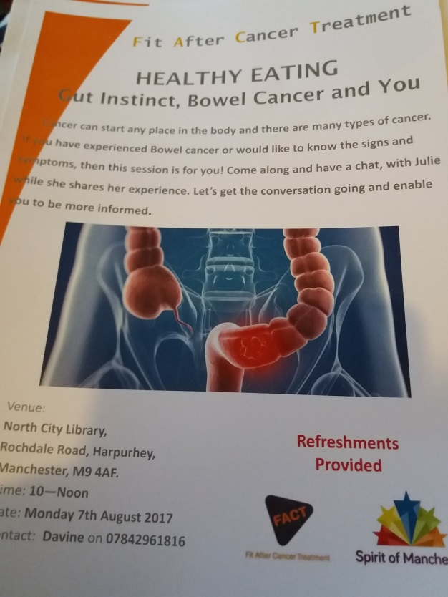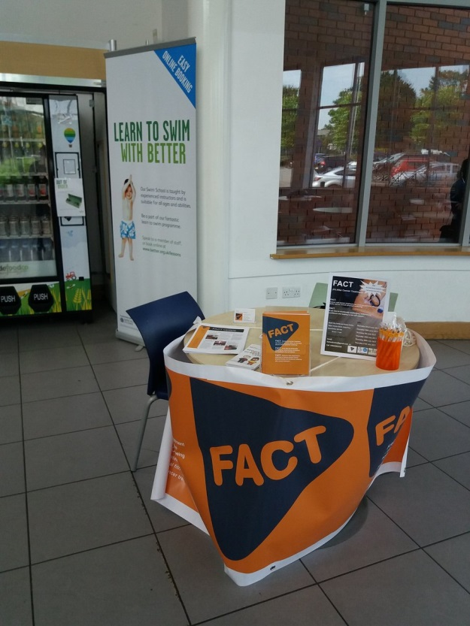
However, there was a lower than expected take-up of FACT’s sessions. Project Officer Davine Ford said:
“There is an overpowering feeling of ‘hopelessness’ in the North (amongst) community members themselves. Whilst undertaking this pilot (I) took to the streets of Moston and Harpurhey to carry out research. From the 63 people interviewed, 96 % stated that there was no reason to try and survive in their current living conditions. There is a need for even more collaborative work to take place in the North of Manchester (so) service users (can) get the assistance they need. There is a great deal of work needed to change people’s mind-sets but this can only be achieved when they receive practical support for the things that impact on their lives daily.”

Project 3 Friends of Crumpsall Park (working with Friends of Herristone Park)
This mini-grant was used to acquire litter-picking equipment / supplies for use by volunteers from Friends of Crumpsall Park and Friends of Herristone Park in north Manchester. Monies were also used to support a children’s environment event held at Crumpsall Park on 23 July.
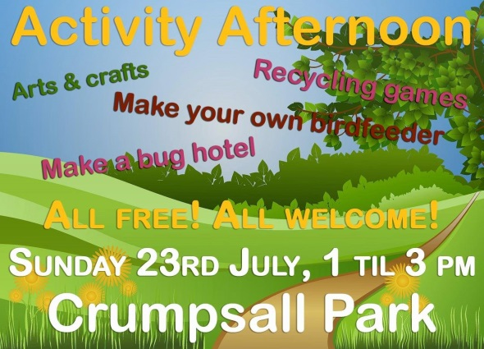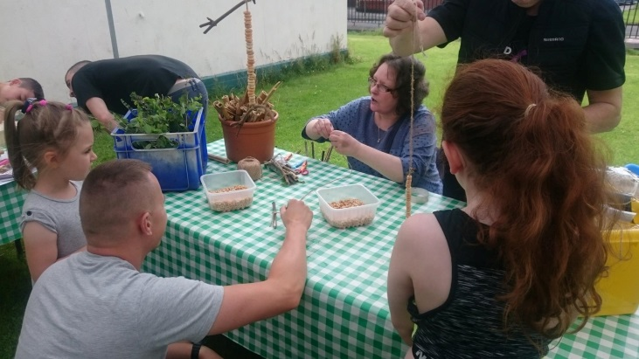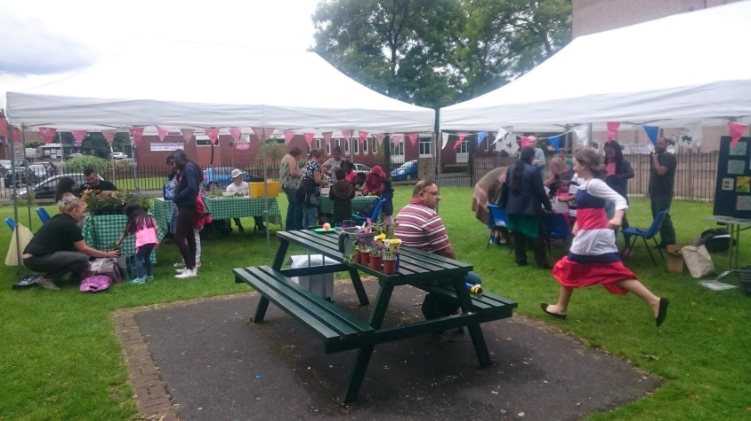
Much is done by the local community to keep the public park and nearby streets tidy in order to encourage greater use of the park by residents and visitors. Litter-picking drives are growing as a regular volunteering opportunity.
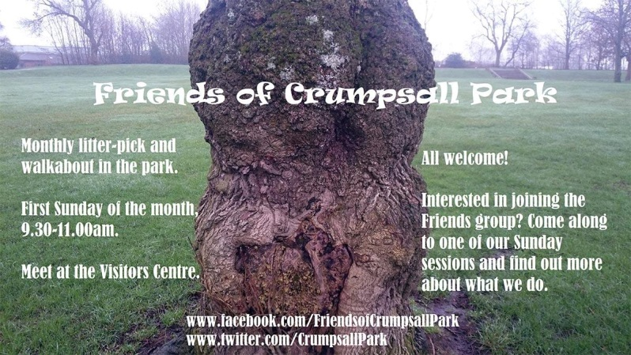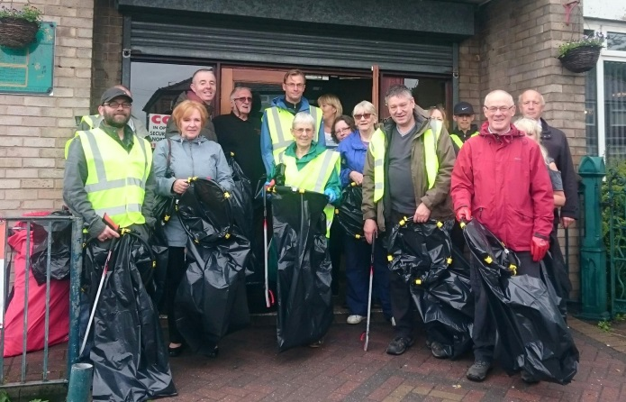

Project 4 Whitemoss Club for Young People (working with volunteers from The Body Shop Enriching Communities initiative)
This mini-grant was used to help conclude the development of a community memorial garden adjacent to Whitemoss Club for Young People in the Charlestown ward of north Manchester.
The mini-grant enabled the club to acquire a large umbrella and wooden table suitable for outdoor use and able to seat eight people. Club volunteers worked together with Body Shop volunteers to refresh flower planters and assemble and site the table and umbrella.
The project went well enabling the memorial garden to be completed ready for local people to use during the summer months.
