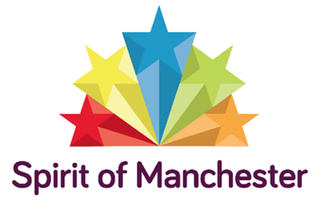
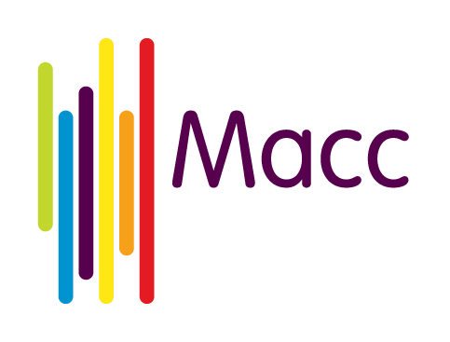
Spirit of Manchester 2019 Mini-Grants Programme Eligibility
Applicant eligibility
To be eligible to apply for a Mini-grant, you must:
- be a voluntary, community or social enterprise organisation with some form of constitution
- be operating in Manchester
- have your own bank account
- have an annual turnover under £100,000
We are particularly interested in receiving applications from groups for whom this would be their first bid or from organisations representing minority communities of interest / identity.
Project eligibility
This year’s £3,500 Spirit of Manchester Mini-grants Programme will provide Mini-grants of between £250 and £500. We want to hear from groups wanting to do something that will benefit their community, e.g.:
- Support local people to feel connected and more active in their communities / encourage participation of local people in community projects
- Support people to have better quality of life, e.g. improved mental and physical wellbeing
- Enable people of all ages to develop new skills and knowledge
- Promote partnership working between community groups
We are hoping for lots of different ideas about projects. The Mini-grants can fund a broad range of activities including arts, culture, environment, health, learning, social events and sports. Simple ideas like sharing a meal together are welcome too. Above all, projects should bring people together to benefit their community.
IMPORTANT - Activity that the Mini-grants cannot fund
The Programme is unable to fund:
- activities outside the city of Manchester
- contributions towards existing projects or fundraising appeals or ongoing running costs
- the work of individuals
- projects that promote a particular political or religious viewpoint
- proposals that do not explicitly address aim(s) of the programme (e.g.: the bullet points in the previous Project eligibility section above)

