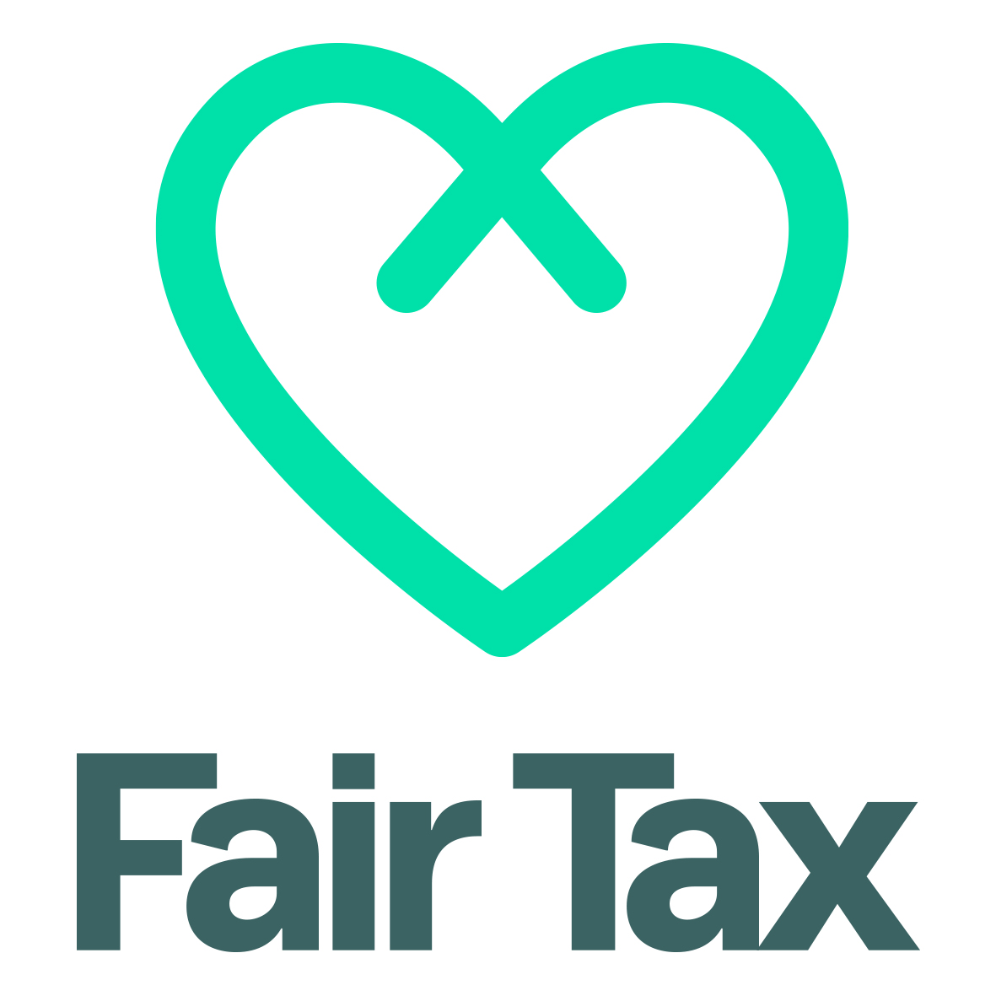

Template for writing a tax policy

Produced by Fair Tax Mark Ltd for Manchester Community Central.

What is the Fair Tax Mark?
Fair Tax Mark is an independent accreditation scheme helping companies and organisations to show that they are good corporate taxpayers.
It is a non-profit social enterprise managed by Ethical Consumer Research Association (ECRA) in collaboration with members of Tax Research UK. It also has a technical advisory group that helps to develop its assessment criteria.
To find out more, visit www.fairtaxmark.net

Why have a tax policy?
A tax policy informs how a company or organisation arranges its financial affairs. In that sense, all organisations have a tax policy but it is not always written down. At the Fair Tax Mark, we encourage organisations to adopt and publish a tax policy as it tells people what the organisation's objectives are with regard to tax and explains the motivations behind their financial decisions.

Tax policy template
The following tax policy template has been developed by a group of tax and accounting professionals and tax justice campaigners.
We advise organisations to publish their tax policy on their website and refer to it in their financial statements:
The company/organisation agreed a tax policy on [DATE]. These financial statements have been prepared in accordance with that policy, which can be found at [web address].
A statement of tax policy should cover the following issues:

1. A commitment to paying the right amount of tax
This is a straightforward statement and might be fulfilled by a statement in the following form:
We are committed to paying all the taxes that we owe in accordance with the spirit of all tax laws that apply to our operations. We believe that paying our taxes in this way is the clearest indication we can give of our being responsible participants in the society.
Such a statement reflects the idea of an organisation being granted a ‘licence to operate’ by those places in which it trades.

2. What seeking to pay the right amount of tax means
The following statement might meet this requirement:
We will fulfill our commitment to paying the appropriate taxes that we owe by seeking to pay the right amount of tax (but no more), at the right rate, in the right place and at the right time. We aim to do this by ensuring that we report our tax affairs in ways that reflect the economic reality of the transactions we actually undertake in the course of our trade.
The commitment made here is twofold. The first is an assurance that tax will not be paid voluntarily, and it is entirely reasonable that this assurance be provided to shareholders and others.
The second is to avoid misrepresenting the true nature of the transactions the company or organisation undertakes when it is reporting its trading for tax purposes.

3. Approach to tax planning and tax avoidance
All organisations are presented with tax choices when deciding how to structure their affairs. The tax laws of almost all countries are designed to provide that choice. Tax planning is about making appropriate choices from those that the law makes available. Tax avoidance is about inappropriate use of the choices that are made available to secure tax advantages that it is clear that parliament never intended to provide. This distinction is reflected in the following statement:
What we will not ever do is seek to use those options made available in tax law or the allowances and reliefs that it provides in ways that are contrary to the spirit of the law. Nor will we undertake specific transactions with the sole or main aim of securing tax advantages that would otherwise not be available to us based on the reality of the trade that we undertake.
The aim here is to make clear that the company or organisation will clearly have to make decisions about its tax affairs and to state that this is a reasonable and responsible thing to do, but to then set out the criteria that it will use when making those decisions.

4. What the company/organisation will not do
There are some matters that all organisations will want to rule out of consideration when it comes to tax. They may be statements of what might be obvious, but they set out very clearly where the organisation stands on certain issues. The following reflects two obvious issues of this sort:
The company/organisation will never undertake transactions that would require notification to HM Revenue & Customs under the Disclosure of Tax Avoidance Schemes Regulations or participate in any arrangement to which it might be reasonable anticipated that the UK’s General Anti-Abuse Rule might apply.

5. Policy on tax haven usage
Tax haven usage has become a totemic indicator of tax abuse and as such probably needs special reference in any statement on tax policy. The following statement is consistent with the principle of economic substance inherent on the statement already made:
We believe tax havens undermine the UK’s tax system. As a result whilst we will trade with customers and suppliers genuinely located in places considered to be tax havens we will not make use of those places to secure a tax advantage, and nor will we take advantage of the secrecy that many such jurisdictions provide for transactions recorded within them.

6. Relationship with HM Revenue & Customs and other tax authorities
It is now customary for companies to comment upon their desired relationship with the tax authorities with whom they deal in their financial statements. The following statement might be appropriate:
Our accounts will be prepared in compliance with this policy and will seek to provide all that information that users, including HM Revenue & Customs, might need to properly appraise our tax position. We will review this policy with our accountants annually to ensure that it is complied with.

Example statement on tax policy
The above recommendations would give rise to the following statement of tax policy:
We are committed to paying all the taxes that we owe in accordance with the spirit of all tax laws that apply to our operations. We believe that paying our taxes in this way is the clearest indication we can give of our being responsible participants in society.
We will fulfill our commitment to paying the appropriate taxes that we owe by seeking to pay the right amount of tax (but no more), at the right rate, in the right place and at the right time. We aim to do this by ensuring that we report our tax affairs in ways that reflect the economic reality of the transactions we actually undertake in the course of our trade.
What we will not ever do is seek to use those options made available in tax law or the allowances and reliefs that it provides in ways that are contrary to the spirit of the law. Nor will we undertake specific transactions with the sole or main aim of securing tax advantages that would otherwise not be available to us based on the reality of the trade that we undertake.
As a result the company/organisation will never undertake transactions that would require notification to HM Revenue & Customs under the Disclosure of Tax Avoidance Schemes Regulations or participate in any arrangement to which it might be reasonable anticipated that the UK’s General Anti-Abuse Rule might apply.
We believe tax havens undermine the UK’s tax system. As a result whilst we will trade with customers and suppliers genuinely located in places considered to be tax havens we will not make use of those places to secure a tax advantage, and nor will we take advantage of the secrecy that many such jurisdictions provide for transactions recorded within them.
Our accounts will be prepared in compliance with this policy and will seek to provide all that information that users, including HM Revenue & Customs, might need to properly appraise our tax position. We will review this policy with our accountants.

Updated June 2020
updated June 2020 annually to ensure that it is complied with.

