Grant Guidance – Stephen Lawrence Day Activities
Background: Stephen Lawrence Day
Following a number of strategic discussions between the government, Baroness Doreen Lawrence and the Stephen Lawrence Charitable Trust, the Prime Minister announced that the government will work with the Trust to establish a lasting legacy in Stephen’s name, celebrated with a national Stephen Lawrence Day. The inaugural Day will be on the 22nd April 2019.
‘We will use this Day to encourage and support young people in achieving their dreams, and to reflect on Stephen's life, death and the positive change he has inspired.’
– Prime Minister, Theresa May
Stephen Lawrence was not able to fulfil all of his dreams and ambitions. His premature death prevented him from ‘living his best life’. The aim of Stephen Lawrence Day, a national day which has been endorsed by major political parties, is to provide children and young people with the opportunity to hear about and learn from Stephen’s story. This is a national programme supported by the Home Office and Department for Education.
The Stephen Lawrence Day will provide an opportunity for schools, youth and community groups, charities and others to come together to deliver a range of positive activities including; school-based activities, programmes to encourage young people to turn their back on the recent increases in serious violence, and activities ‘beyond the school gate’ to promote community integration for young people who are at risk of offending.
The day will focus on the theme of ‘Live Our Best Life’. Please refer to Guiding Principles Communities Day (appendix 1).
The Stephen Lawrence Charitable Trust is welcoming a limited number of applications from individual community organisations to deliver social action activities focusing on identified risk factors for serious crime and violence in line with the Stephen Lawrence Day communities guiding principles. Please refer to Identified Risk Factors Document (appendix 2).
Amount of funding available: Up to £400 for a day of activities.
Activities Scope and Focus
The activities must focus on:
- Young people from the most disadvantaged and vulnerable backgrounds
- Urban/inner city or coastal areas where there is clear evidence of deprivation which impacts on young people and local communities
We will consider funding activities which work in any one or more of the following areas:
- Young people from BAME communities
- Young people affected by and seeking to turn away from serious crime and violence
- Young people with disabilities
- Girls affiliated with or affected by gangs
- Education, training and employability
- Community integration and social mixing
Funded activities will need to demonstrate one of the following:
- A strong understanding of your target beneficiaries and the challenges facing young people in your local community.
- A unique and fresh approach to engaging the target beneficiaries and to addressing the issue of youth crime and serious violence.
Application process
Please provide a one-page response addressing the areas below.
Name of activities:

Organisation applying for funding:

Charities Commission number/ company number:

- Activities summary - What activities do you propose to deliver on Stephen Lawrence Day? (22nd April 2019) Include costs of activities.
- What area will the activity address? How has the need been identified?
- Activities location - Where will you deliver these activities?
- Who are your target beneficiaries? What are their specific needs?
- How does your proposed activity fit within our guiding principles (sub-themes 1-4)?
- How will your activities be delivered? Who will run it?
- How will you track the impact of your activity?
- What (if any) are the potential risks identified in running the activities? How will they be minimised?
In addition to the above, the following must also be included with the application:
- Safeguarding policy
- Equal opportunities policy
- Detailed budget
Submitting the application
Please submit your completed application and relevant supporting documents to Chelsea Way on Chelsea@stephenlawrence.org.uk by Friday 22nd March 2019.
Please note that this invitation to submit an application does not guarantee the grant will be awarded.
The Steering Group expect to make a decision by end of March.

Appendix 1: Guiding Principles
The purpose of the Stephen Lawrence Day Communities Project is
- to engage those that are delivering effective social action projects with the potential to create positive change for their local communities and young people through Stephen’s Story and its relevance to them and their lives.
- to provide small grants for communities to deliver activities and events to mark Stephen Lawrence Day.
The projects will focus on the theme of ‘Live Our Best Life’.
Four key sub-themes underpin the proposed focus for schools / communities as set out in the table below.
Live Our Best Life: What does it mean and look like? | Democracy and Justice | Living in Diverse Societies | Hope from Tragedy: A Creative and Powerful Legacy
Attitudes and Behaviours: Resilience, Courage, Respect and Tolerance.  Striving for an inclusive society – bridging communities and young people.  Making voices heard within local communities.  Increasing the capability of communities to take action on the issues that matter to them. | Space and Belonging – building more inclusive and collaborative communities.  Enabling young people to use their voice for creating positive change within their community.  Building on the efforts of Stephen’s family and their tireless pursuit of justice to create safer communities.  Empowering groups within the community to effectively deliver early action in the prevention of crime and serious violence. | Race, History and Identity: understanding and respecting your own and other cultural identities, backgrounds and local communities.  Communities working together to create a culture where each individual is respected and valued, leading to a decrease in crime and violence.  Facilitating collaboration between communities and mainstream services.  Action for positive change – contributing positively to British society.  Equipping communities with the resources to respond to issues that matter to them.  Fulfilling individual and community potential. | The Stephen Lawrence Charitable Trust was founded on the premise that inequality must be tackled in all its forms. This includes inequality of access, and of opportunity, wherever it occurs.  National Police Cadet Service and other Youth-Led organsiations – Positive peer pressure: using the power of young people’s influence on one another to encourage social integration.  Young people are involved in decision making – locally and nationally.  Celebrating achievements and a more inclusive society.  Everyone plays a role in social change and community integration.

Live Our Best Life: What does it mean and look like?
- Supporting early stage social action projects and providing communities with a national platform to showcase their work through the Stephen Lawrence Day website, capacity building support and Small Grants Scheme.
- Empowering communities to respond to issues that matter to them, guided by early intervention programmes related to Serious Crime and Violence.
- Identifying community groups delivering early intervention projects for all ages.
Democracy and Justice
- Encouraging more young people to take part in social action within their community.
- Using the power of young people’s influence on each other to deliver a learning resource in partnership with the National Police Cadet Service and other youth led organisations.
- Using a range of toolkits and training opportunities to develop community groups’ knowledge of the sustainability and scale of their projects.
Living in Diverse Societies
- Showcasing new models for how society can respond to community challenges.
- Engaging with umbrella organisations to encourage Stephen Lawrence Day activities across a wide range of groups.
Hope from Tragedy: A Creative and Powerful Legacy
- Providing a hub for communities to share their knowledge, understanding and best practice via the Stephen Lawrence Day website.
- Recognising and rewarding outstanding contributions – Community Prizes (year 2).

Appendix 2: Identified risk factors for Serious Crime
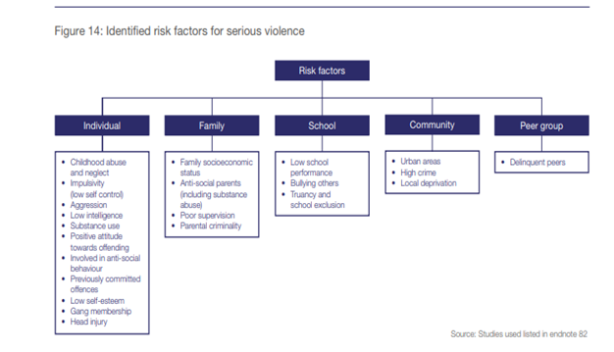
(Source: Home Office, Series Crime and Violence Strategy, 2018)

