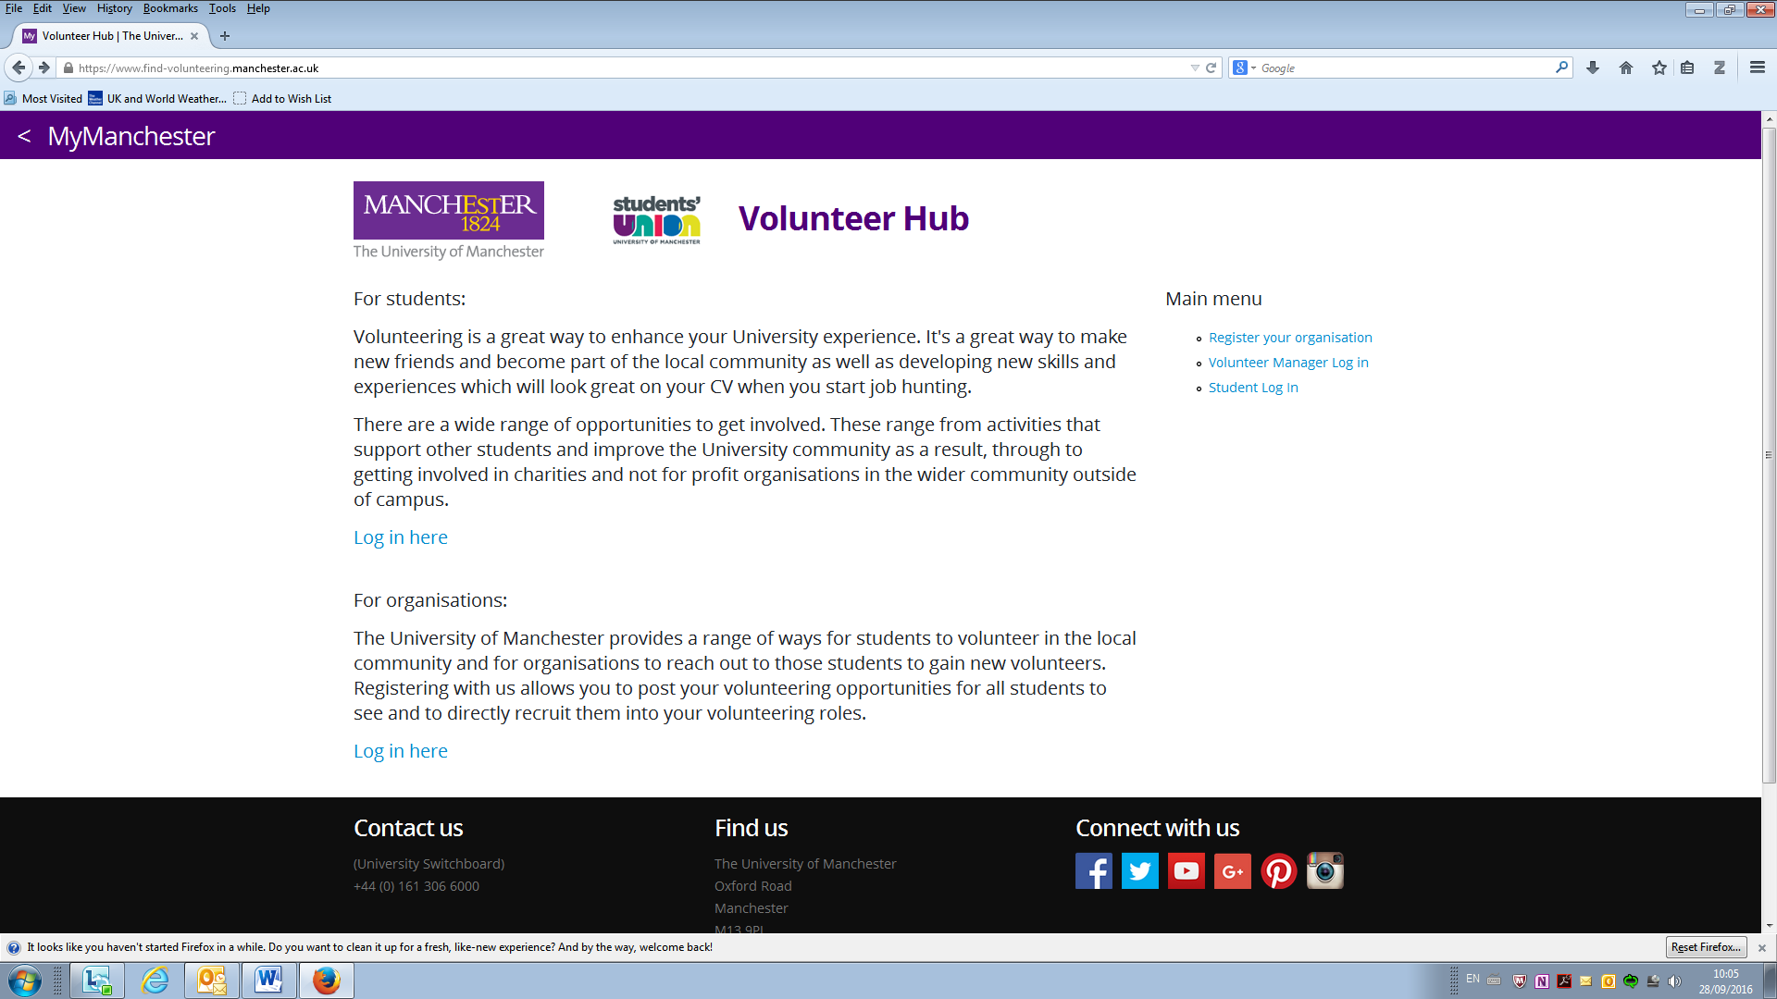

Volunteer Hub can be accessed from our website: www.manchester.ac.uk/getvolunteers or directly via https://find-volunteering.manchester.ac.uk/.

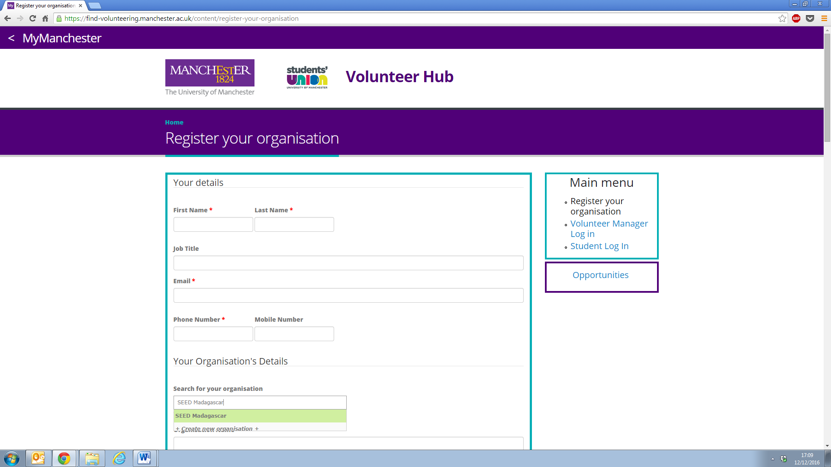

Start typing your organisation’s name in the search box to check if it’s already registered. If so, click on your organisation when it appears and the second part of the form should populate. Add your own details to add yourself as a contact for that organisation. If you’re registering your organisation for the first time, complete the whole form to create a record for your organisation and yourself as a contact.
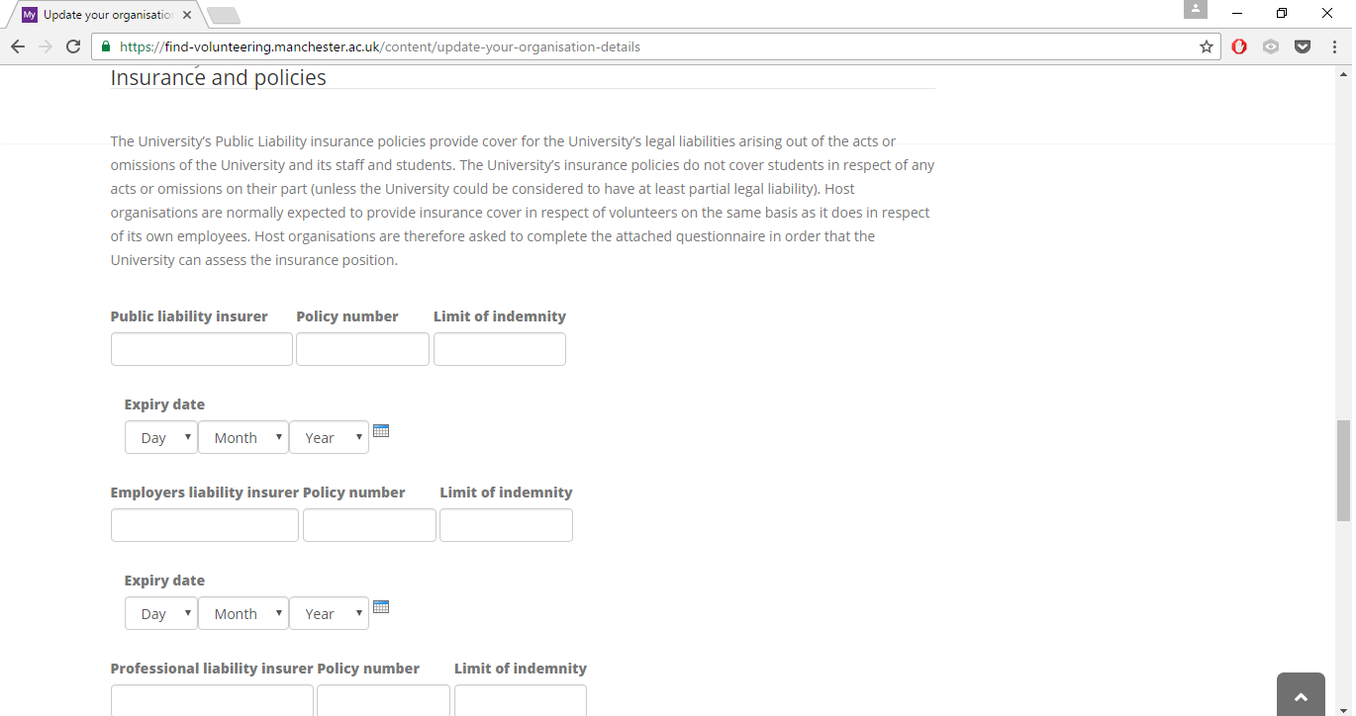

We ask all organisations to provide details of their current Public Liability insurance policy. You will be able to upload these details during registration, or you can come back to add them later. You can also add your organisation logo (encouraged!).

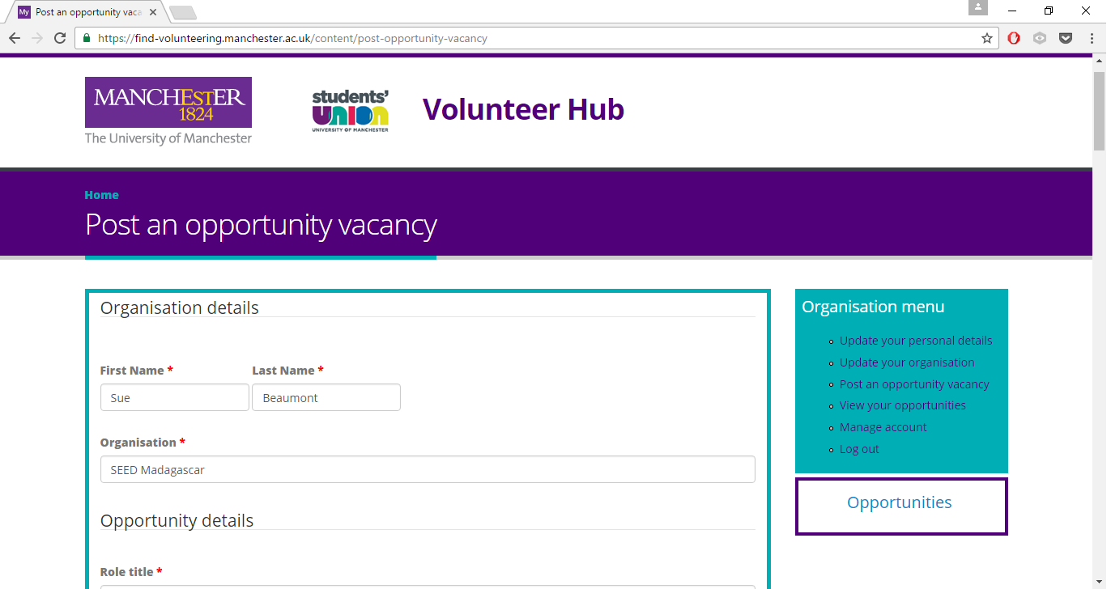

Opportunities take 3-5 working days to be approved (you need to add details of your current Public Liability insurance policy to your organisation record before any opportunities can be approved).

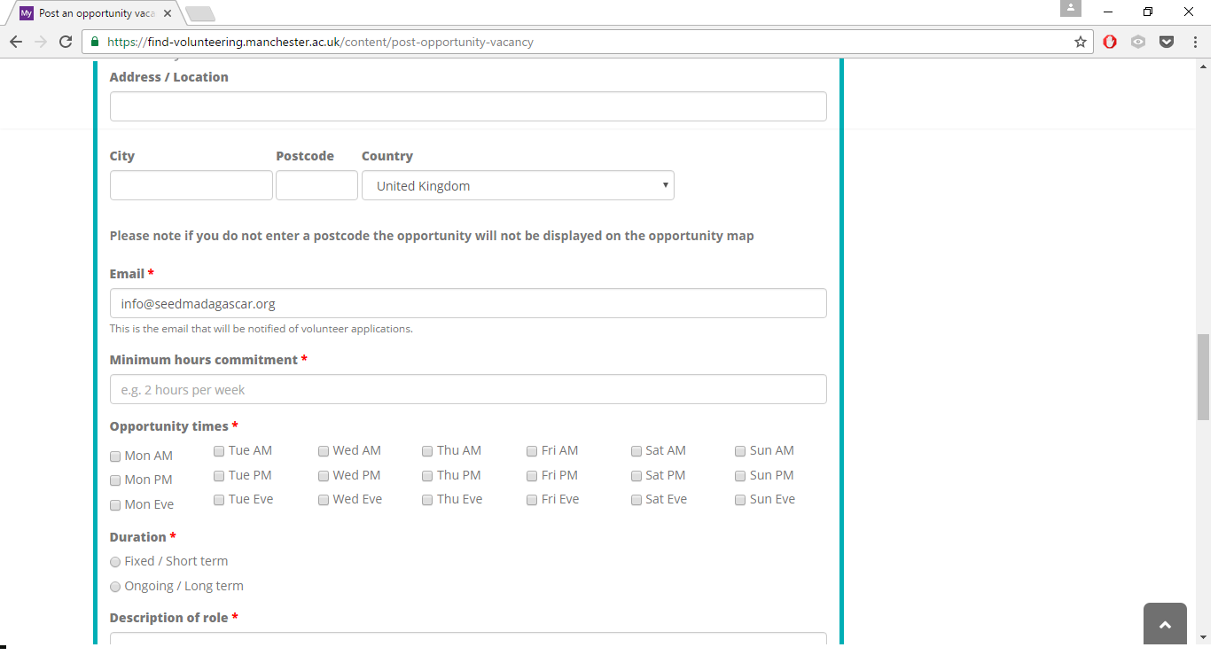

The most successful adverts have plenty of detail about the volunteering role, including: location (for students to search using map view), timings and commitment, and an informative description of what you are asking volunteers to do. You can also add a photo if appropriate.

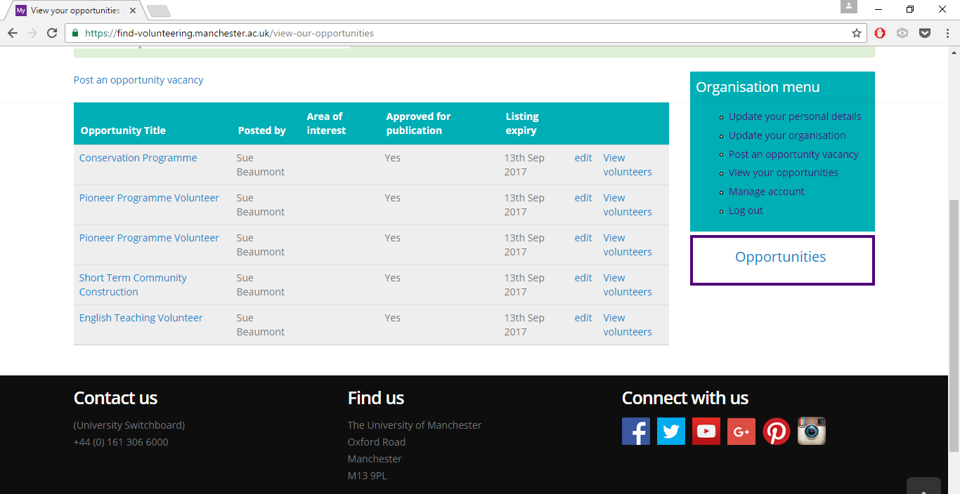

You can see a full list of the opportunities you have advertised and within each you can see which students have applied for each role. Whenever a student applies you will get an email notifying you that you have a new applicant so you can go into the system and get in touch.
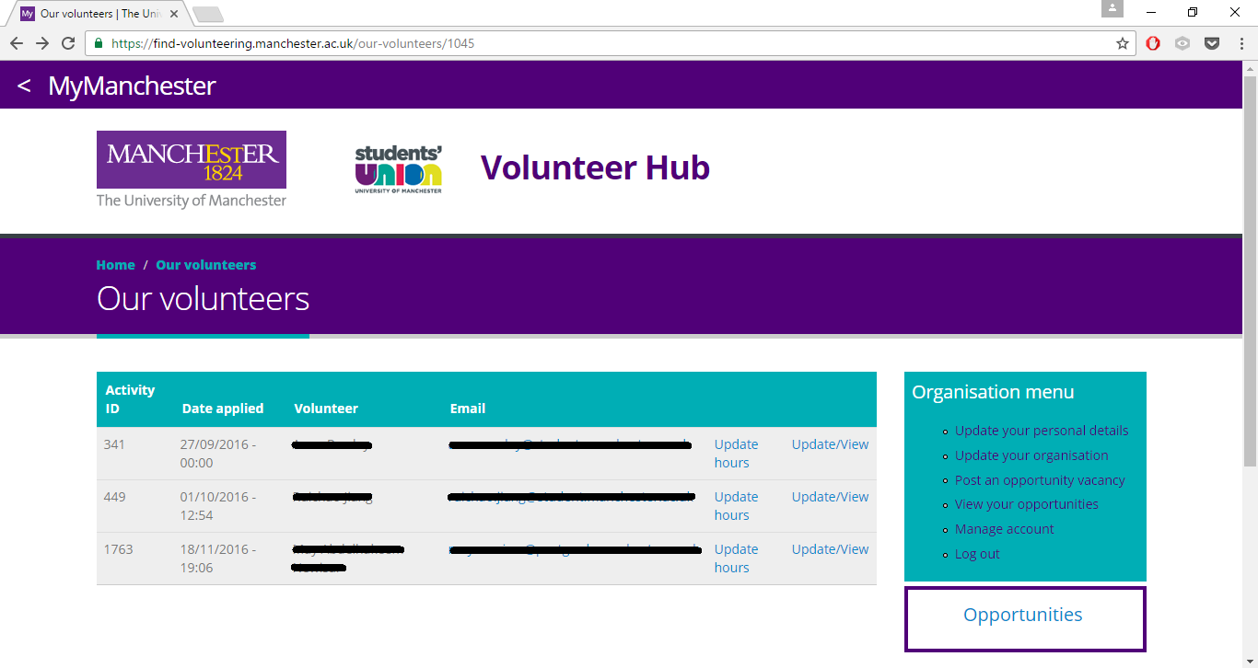

Once you have accepted a volunteer you are able to add a volunteer’s hours to their account.

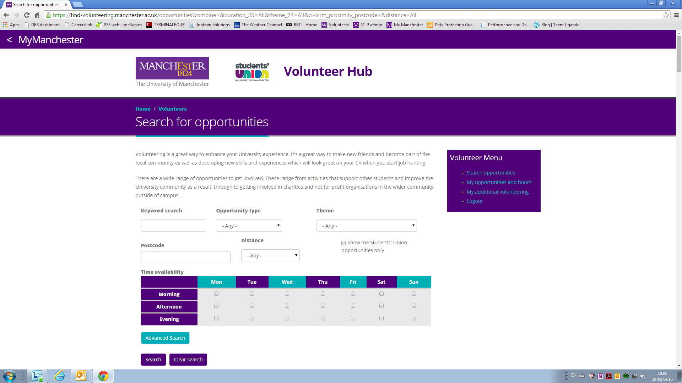

Students can search by a range of opportunities including whether an opportunity is long-term or short-term, the theme (University-wide volunteering themes), distance from a postcode and their availability. The advanced search also allows filtering by associated skills and specific causes/areas of interest.

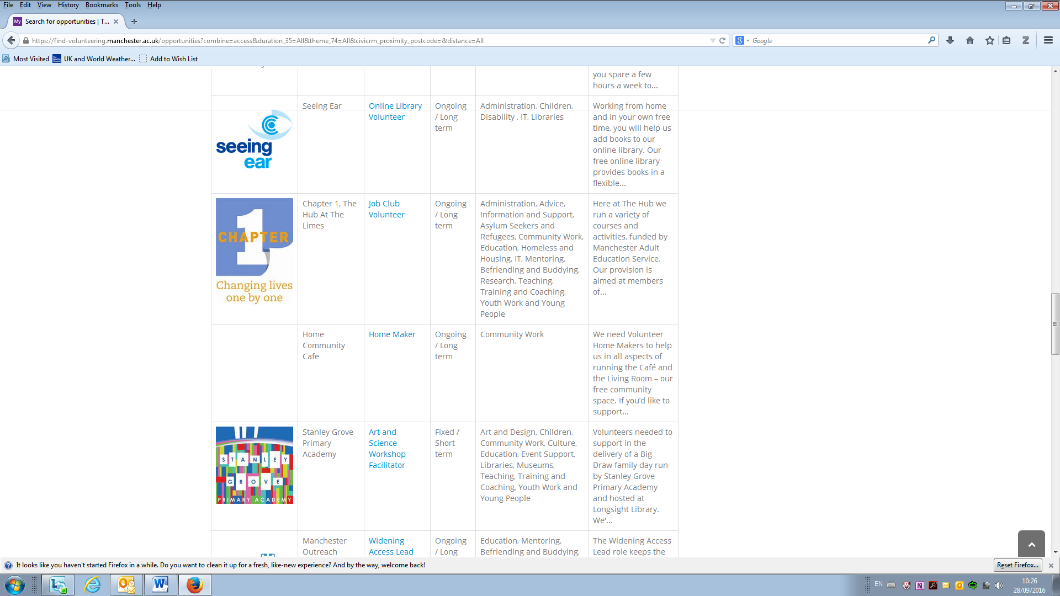

The filtered search brings up the relevant opportunities with basic information for students to consider.

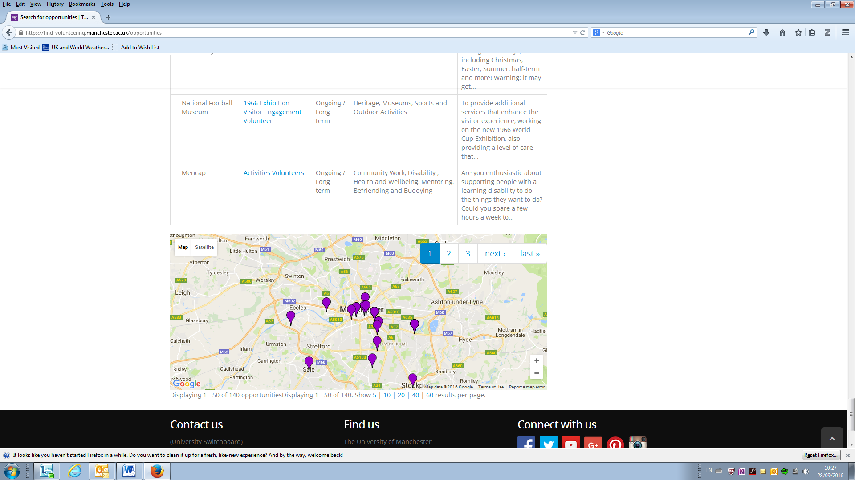

The opportunities also display on a map so that students can see where the opportunities are in relation to the University/their home.

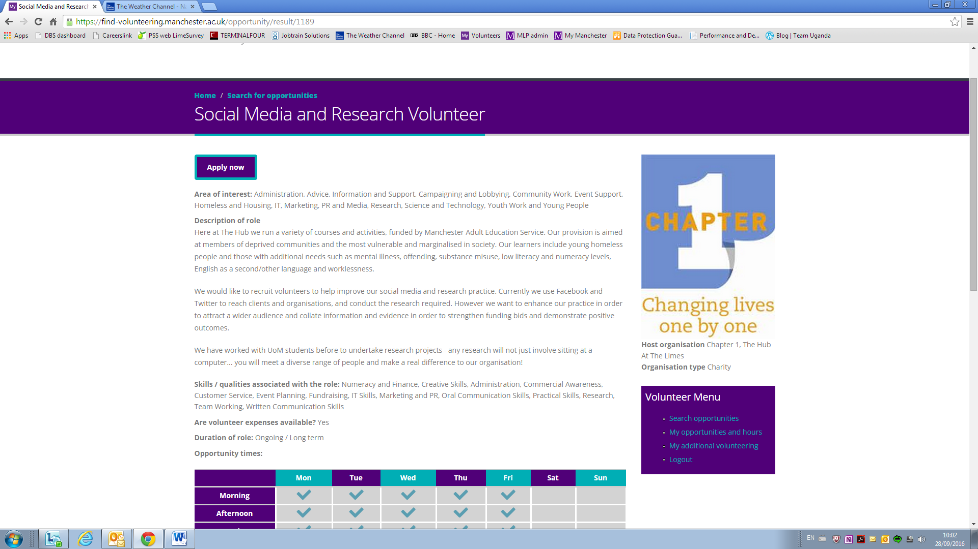

Students can click on their filtered results to see the full description of their chosen opportunity. If they wish to apply they do so directly through the site. The opportunity is also plotted on a map so that students can see where the opportunity is based.

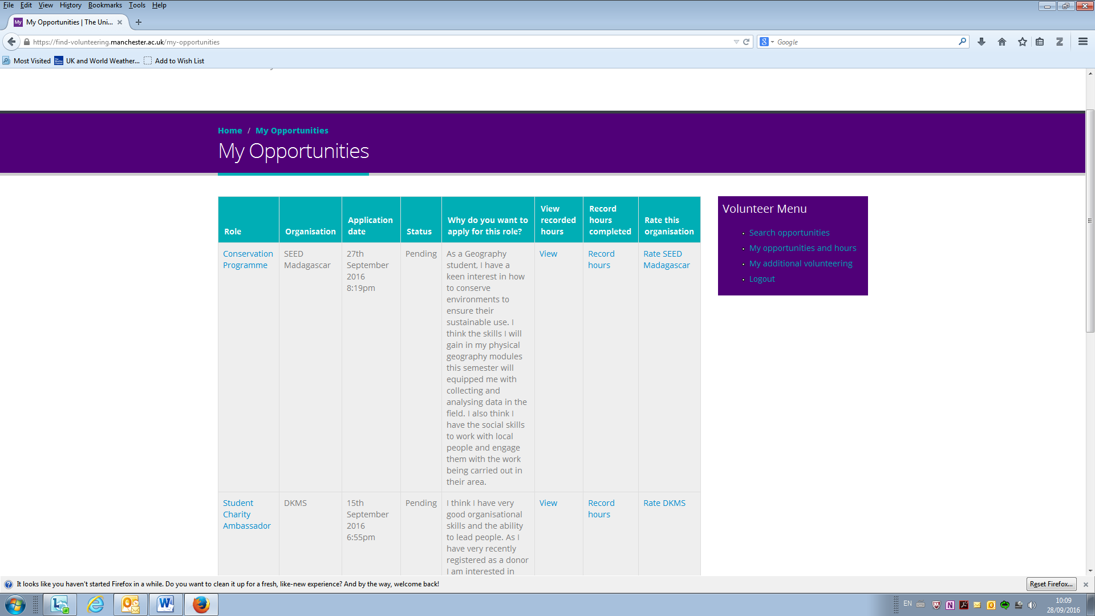

Students can see a full list of what roles they have applied for and the status of those roles. This will also show the hours the organisation has recorded as completed. They also have the opportunity to provide feedback on an organisation they have been volunteering with.

