Hello,

These are instructions on how to support someone getting onto ZOOM for the first time who might need a helping hand.

What is ZOOM?
ZOOM is an online programme that will allow you to join in with The Cares Family Social Clubs online during this period of lockdown - as well as lots of other activities run by the amazing organisations across Manchester. Through ZOOM you can connect with us and other neighbours and volunteers.

Before inducting someone:
- Get the basics of an account set up on their behalf

Step 1
Go to your email inbox and you should find an email from Zoom.
Open the email and click on the big blue ‘Activate Account’ button which will take you to a ‘Welcome to Zoom’ page.
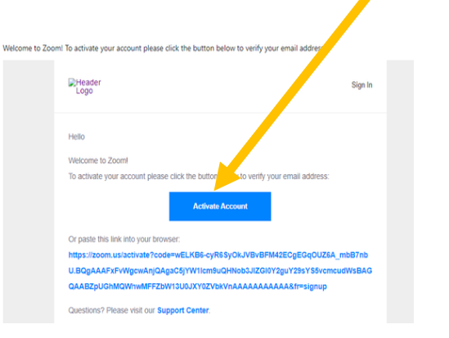

Please note: it might ask you if you are signing up on behalf of a school. Please tick ‘no’.

Step 2
Fill in your name, surname and create a password. The password needs to have:
- At least 8 characters
- At least 1 letter (a,b,c…)
- At least 1 number (1,2,3…)
- Include UPPER CASE and lower case characters
It’s OK to write this down on a piece of paper so you don’t forget it.
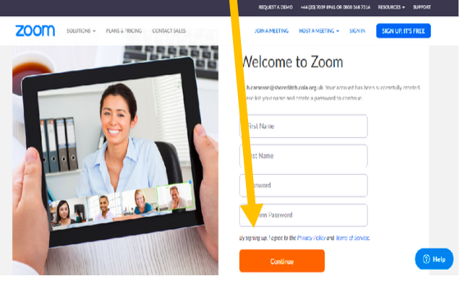
Press the big orange ‘Continue’ button.
(It may ask you to click in the ‘I’m not a robot’ box, if it does, that’s fine).

Step 3
You will now find yourself on an ‘Invite Your Colleagues’ page. You do not need to do this so click the light grey button ‘Skip this Step’
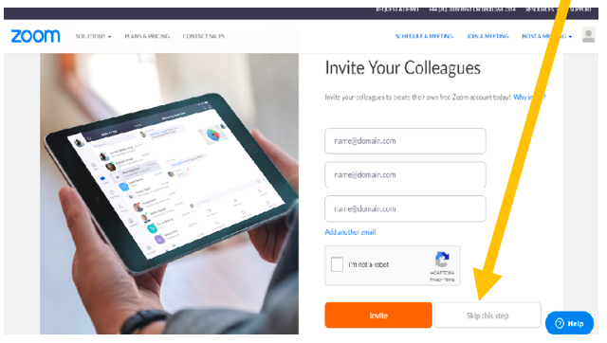

Step 4
On the final page, there is a button that says ‘Start Meeting Now’, click on that and it will download the Zoom programme to your computer.
(ZOOM should show to be downloading on the bottom left-hand side of your screen).

Step 5
Once Zoom has downloaded, click to open the programme and follow your computer’s instructions to install it.
(Depending on the make of your computer, it will usually be an ‘ok’ or ‘continue’ or ‘accept’ button that will pop up).
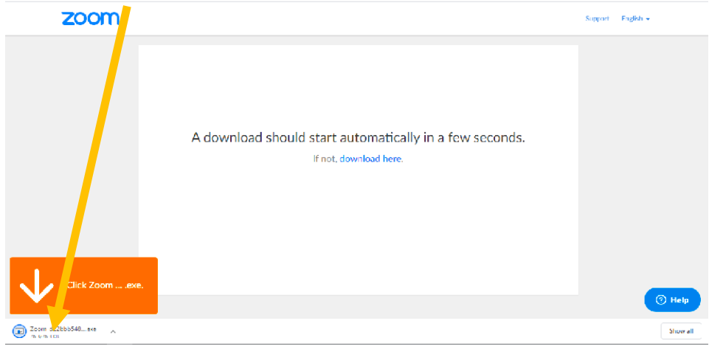

Step 6
Zoom should now open a small window in the centre of your screen.
Click the blue ‘Join a Meeting’ button.

Step 7
This will bring up a Join Meeting box. Your volunteer will email you a ‘Meeting ID’ to enter here, along with a ‘password’ to enter.
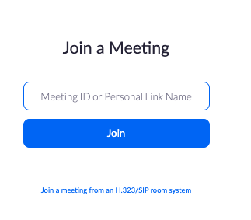
Now, you can chat with your volunteer over ZOOM!

